CSS GENDER STUDIES
RN
The Revision Notes
CSS Gender Studies — the whole subject for the last three weeks, all seven topics in one volume
WHAT THIS DOCUMENT GIVES YOU
◆ The whole syllabus for the last three weeks — every theory, argument frame, fact and law — in about 5,000 words per topic
◆ Every topic opened by an at-a-glance box: its weight, its question families and what is due
◆ Four key diagrams per topic, redrawn simply, each with the questions it serves
◆ An answer plan for every past descriptive question, 2016 to 2026
◆ A three-week revision timetable, the paper at a glance, the due list and the links between topics
Federal Public Service Commission · CSS Competitive Examination · Optional paper, 100 marks
Written for CE-2027 onwards · Record: CE-2016 to CE-2026 · Facts current to October 2026

Contents
HOW TO BUILD THE CONTENTS
The contents list below fills itself in. When Word asks "This document contains fields that may refer to other files. Update the fields?", click Yes.
If it does not ask: right-click the grey contents area → Update Field → Update entire table → OK. On a Mac, Control-click the same area. Or press Ctrl + A, then F9 (Windows), to update every field at once. Repeat after any edit, before you export to PDF.

Right-click here and choose Update Field to build the contents.

How to Use This Volume

What this volume is
These are the Revision Notes for the last three weeks before the CSS Gender Studies paper. They are deliberately fuller than a one-page summary. Each topic gets about 5,000 words, enough to hold every theory, every argument frame, the essential data and laws, and an answer plan for every question the examiner has set. They are not a substitute for the Knowledge Bases, which teach the subject from zero. They are what you read once the teaching is done, to keep the whole subject in your head at once.
Every topic chapter is built the same way:
1. At a glance. The topic's syllabus heads, its weight in the paper, the families of questions it produces, and what has never been asked and is therefore due.
2. The revision sheet. The whole topic, heading by heading, in short bulleted lines. Each line carries a term, a thinker with a date, a law or a figure, and the key words are in bold. Every heading ends with a line to take — the judgement you will write in your conclusion.
3. The key diagrams. Four diagrams that carry most of the topic, redrawn simply enough to draw from memory in two minutes. Each is followed by the past questions it serves.
4. Every past question as an answer plan. The skeleton of each model answer in the Question Answers: the introduction, the numbered headings in order, the evidence for each, and the conclusion.
Table 1 · The seven topics in this volume.
Topic | Title | Syllabus head | Weight, 2016–2026
T1 | Gender Studies and the Social Construction of Gender | I, II | 16.5 visits · 28 MCQs
T2 | Feminist Theories and Practice | III | 7 visits · 26 MCQs
T3 | Feminist Movements — the West, the United Nations and Pakistan | IV | 9.5 visits · 22 MCQs
T4 | Gender and Development | V | 17.5 visits · 19 MCQs
T5 | Status of Women in Pakistan | VI | 8.5 visits · 19 MCQs
T6 | Gender and Governance | VII | 8.5 visits · 14 MCQs
T7 | Gender-Based Violence and the Three Case Studies | VIII, IX | 10.5 visits · 12 MCQs

EXAMINER'S EYE · HOW TO REVISE FROM THESE NOTES
Never just read. For each heading of a revision sheet, cover it, say it aloud, then check. For each diagram, draw it on a blank sheet before you look. For each answer plan, read only the question, say the plan from memory, then compare. What you cannot recall is what you revise next. Reading feels like learning, but recalling is what you will do on the day.

The three-week timetable
The plan gives the heavy topics (T4 and T1) two days each in the first pass, then a second pass from memory, two full mock sittings, and a light final day.
Table 2 · A three-week revision timetable.
Day | Topic | What you do
Week 1 | First pass | Read, recall aloud, draw — the four heaviest topics
1 | T4 · Gender and Development | Revision sheet, headings 1–8, recalled aloud
2 | T4 | Rest of the sheet; the four diagrams; say every answer plan aloud
3 | T1 · Gender Studies and construction | Revision sheet, recalled aloud
4 | T1 | Diagrams; answer plans; write one answer in thirty minutes
5 | T7 · Gender-based violence | Sheet, diagrams, plans; learn the laws timeline
6 | T3 · Feminist movements | Sheet, diagrams, plans; the six phases in Pakistan
7 | Review | Redraw all sixteen diagrams of T1, T3, T4 and T7; one timed answer
Week 2 | First pass completed | The three lighter topics, timed answers and the first mock
8 | T5 · Status of women | Sheet, diagrams, plans; refresh every number with its source and year
9 | T6 · Gender and governance | Sheet, diagrams, plans; the quota history by heart
10 | T2 · Feminist theories | Sheet, diagrams, plans; one thinker and one book per school
11 | T4 and T1 | Two timed answers on questions you have not practised
12 | T7 and T3 | All answer plans aloud; one timed answer each
13 | T5, T6 and T2 | All answer plans aloud; one timed answer
14 | Mock 1 | Part II in full: four questions in two hours, with answer maps
Week 3 | Second pass | Everything from memory, the due list and the second mock
15 | T4 and T1 | Write each revision sheet's headings from memory, then fill the gaps
16 | T7, T3 and T5 | The same
17 | T6 and T2 | The same
18 | All seven | Draw all 28 key diagrams from memory; check against the notes
19 | The due list | Plan an answer for every item on the due list below; refresh the dated data
20 | Mock 2 | A complete paper — MCQs and four questions in three hours
21 | Light day | The at-a-glance boxes, the anchor dates and the lines to take. Then rest.

The Paper at a Glance

How the paper is set
The paper carries 100 marks in three hours. Part I has twenty MCQs for twenty marks, answered on a separate sheet in at most thirty minutes. Part II has seven questions, numbered 2 to 8, of which you attempt four, each worth twenty marks. One question is usually split into short notes.
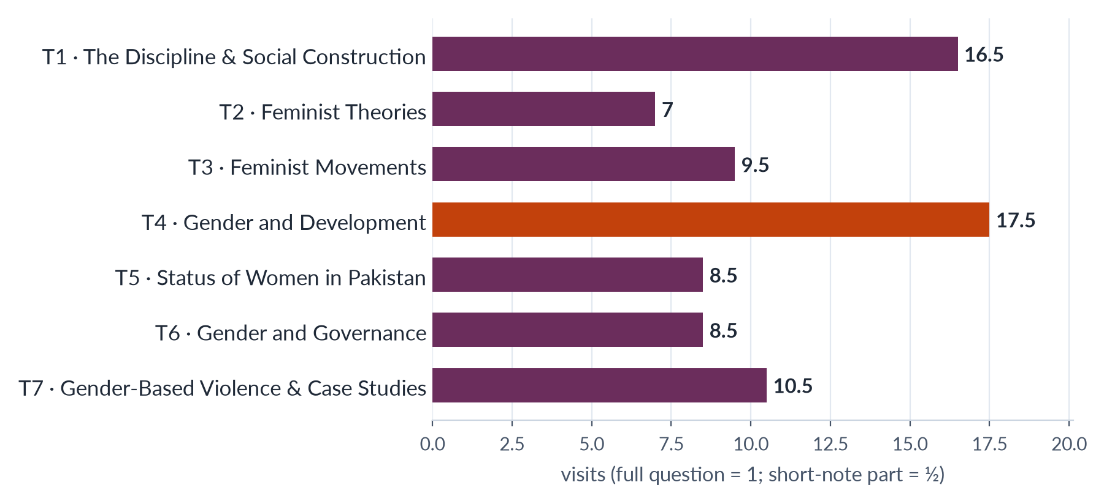
Figure 1 · How much each topic weighs: total visits, 2016–2026 (the heaviest in coral).
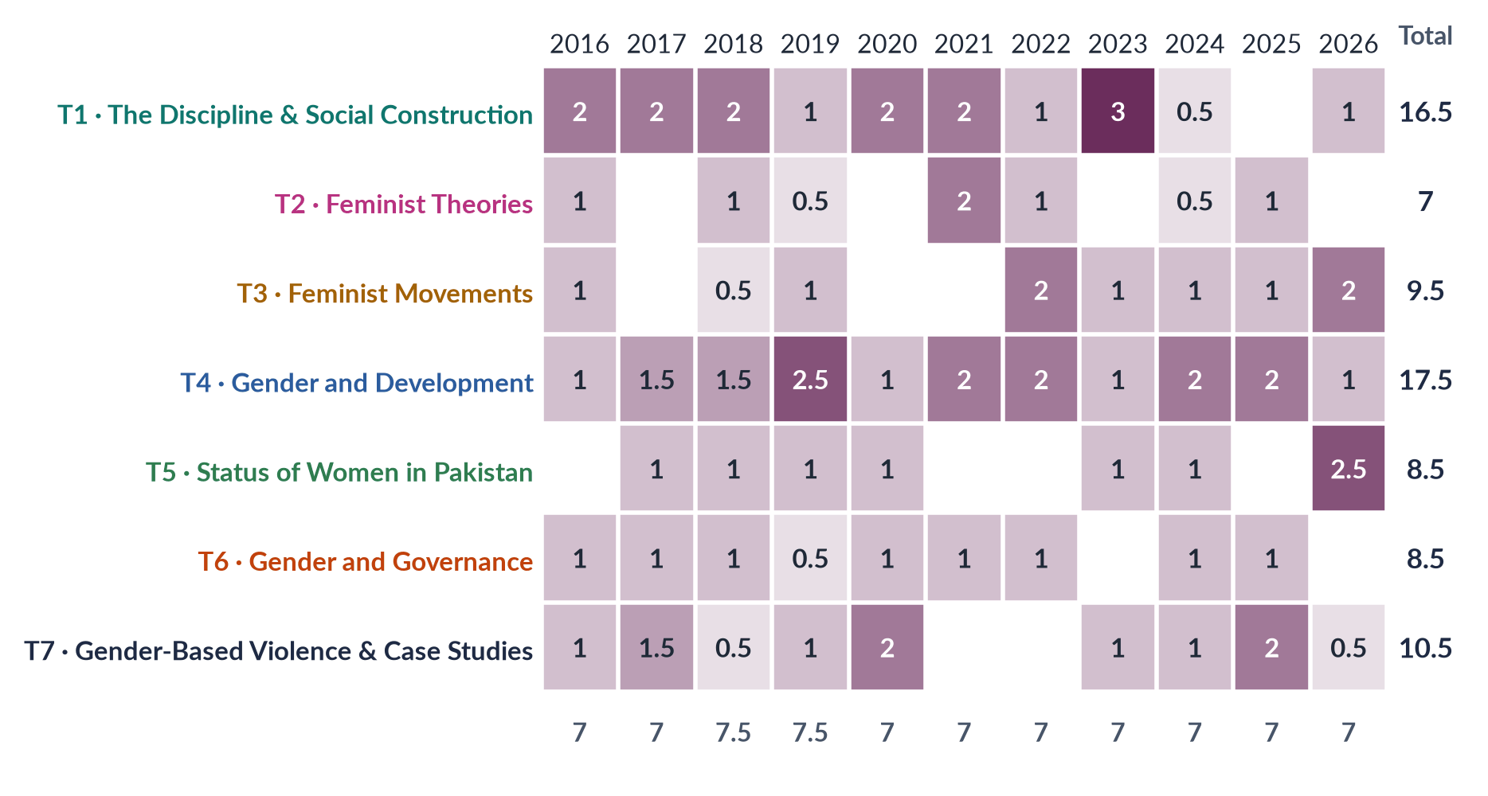
Figure 2 · The heat map: visits to each topic, year by year (a full question = 1, a short-note part = ½).

The time plan
Table 3 · A working time plan for the three hours.
Stage | Minutes | What you do
Part I (MCQs) | 20–25 | Answer all twenty; mark doubtful ones and return to them; never leave a blank
Choosing | 8–10 | Read all seven questions twice; choose the four where you have theory and Pakistan evidence
Answer maps | 4 × 3 | For each question, a quick map: introduction, numbered headings, evidence, diagram, conclusion
Writing | 4 × 30 | About 30 minutes per answer: 1,000–1,300 words
Review | 5–8 | Underline key terms; check names, dates and numbers; number the headings clearly

The frame of every scoring answer
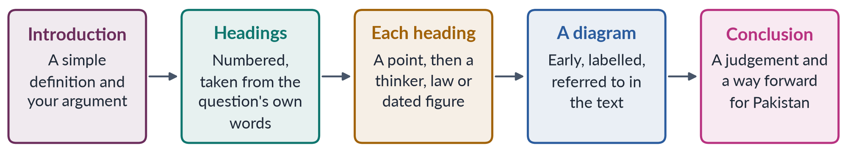
Figure 3 · The frame of a scoring answer.
REMEMBER · FIVE HABITS THE EXAMINER REWARDS
1. Decode every limb. "Define, discuss and differentiate" is three tasks; answer all three under separate headings.
2. Evidence inside the point. Every heading carries a name with a date, a law with its year, or a figure with its source.
3. Pakistan in every answer. Even a Western-theory question ends with what it explains in Pakistan.
4. One diagram at least. The key diagrams in these notes are chosen because they fit the questions that repeat.
5. A judgement, not a summary. End with a line to take — each revision sheet gives one for every heading.

What is due
The record shows a clear pattern: the examiner returns to the families that repeat, but every year adds at least one question from a line never yet asked in full. Prepare an answer plan for each line below.
Table 4 · The due list: syllabus lines never yet asked as a full question (or silent for three years).
Topic | Lines that are due
T1 | The discipline half — Women's versus Gender Studies, autonomy and integration, status in Pakistan — silent since 2023
T2 | Liberal feminism; men's feminism
T3 | The UN conferences and CEDAW as a full question (only MCQs so far)
T4 | World-system theory on its own; gender mainstreaming; the SDGs; the care economy
T5 | Women's education; family law and the MFLO 1961; women in politics; climate impacts on women
T6 | Defining governance; women as voters; the South Asian experience
T7 | Acid attacks; workplace harassment; cyber violence; the ecological model; a comparison of the three case studies

The links between topics
The same ideas serve many questions. Learn each once, in its home topic, and carry it across.
Table 5 · Ideas that cross topics.
Idea | Home | Also earns marks in
Intersectionality (Crenshaw 1989; Collins 1990) | T2 | T5 marginalised groups (2026); T7 root causes; T1 the move from Women's to Gender Studies
Social construction; performativity (Butler 1990) | T1 | T2 postmodern feminism; T7 masculinities and violence
Hegemonic masculinity (Connell 1987, 1995) | T1 | T7 masculinity studies (2026); T2 men's feminism and men's movements
Patriarchy (Millett 1970; Walby 1990) | T2 | T7 root causes of violence; T5 status of women
CEDAW (1979; Pakistan 1996) | T3 | T5 law and human rights; T6 Article 7 and quotas; T7 General Recommendation 19
Beijing Platform (1995) | T3 | T4 gender mainstreaming; T6 Critical Area G; T7 Critical Area D
Boserup (1970) and WID | T4 | T5 women's employment; T1 why a discipline was needed
Moser's triple role; Hochschild's second shift | T4 · T5 | T5 the double burden (2019); T4 globalisation
Hudood Ordinances (1979) and WAF (1981) | T3 | T5 law; T7 laws on violence
Global Gender Gap Report (2025: 148th of 148; 2026: 143rd of 145) | T5 | T1 significance of Gender Studies; T6 political empowerment
Reserved seats and the LFO (2002) | T6 | T3 phase five of the movement; T5 women in politics
Honour-killing law (2016) | T7 | T5 law and human rights; T1 the honour-killing example of two lenses
Malala Yousafzai | T7 | T5 girls' education
NGO-isation | T3 | T4 donor-driven projects and the WAD critique
Structural violence (Galtung 1969) | T7 | T5 the enforcement gap; T4 dependency and world-system

Topic 1 · Gender Studies and the Social Construction of Gender
AT A GLANCE · TOPIC 1 AT A GLANCE
Heads I and II of the syllabus. Second-heaviest topic: 16.5 visits (16 full questions and one short note, 2016–2026). Four discipline families — Women's vs Gender Studies, multidisciplinary nature, autonomy vs integration, status in Pakistan — have been asked fourteen times between them, often two in one question. The construction half is rising in difficulty: theories (2016), deconstruction and language (2020), natural or social (2021), is sex constructed (2024), queer theory and the transgender law (2026). The discipline half has been silent since 2023 and is due.

1. What Gender Studies is
- Gender Studies — the study of how society makes femininity and masculinity, how this shares out power, money and chances, and how gender mixes with class, religion, race, age, disability and sexuality. It uses many disciplines.
- Sex — body differences (chromosomes, hormones, organs). Gender — the roles, behaviour and power society attaches to sex.
- Scope (what it covers) — identity and the body; family and home (marriage, care, inheritance, violence at home); work and economy (paid and unpaid work, pay gap); politics and law; culture (religion, language, media, education); violence; global changes (colonialism, globalisation, migration, climate).
- Aims — make the invisible visible; explain inequality (not just describe it); question what looks "natural"; produce complete knowledge; guide policy; empower. Praxis = joining study with action.
- Why the discipline was needed — four blind spots:
- Androcentrism (treating men as the normal human) — e.g. Carol Gilligan (In a Different Voice, 1982): theories built on boys ranked girls' "ethic of care" (moral thinking based on relationships) as weaker.
- Uncounted work — Marilyn Waring (If Women Counted, 1988): GDP (a country's measured income) ignores unpaid cooking, cleaning and care.
- Unanswered questions from the women's movement (pay, violence, power).
- "Add women and stir" — adding a chapter on women without changing old frameworks — was not enough.
- Features — uses many disciplines; committed to justice; questions who makes knowledge; looks at intersectionality (overlapping disadvantages); compares societies.
- Joan Scott (1986) — gender is "a primary way of signifying relationships of power" = a main way of showing who rules whom.
- Significance — academic (complete knowledge); policy (CEDAW = UN women's rights treaty, Pakistan joined 1996; SDG 5 = gender equality by 2030; gender budgeting = checking a budget's effect on women and men); social (words for hidden harms); Pakistan (143rd of 145, Global Gender Gap 2026; women in labour force 24.4%, LFS 2024–25; women's literacy about 53%, Census 2023).

2. Women's Studies versus Gender Studies
- Women's Studies — the field that puts women at the centre of study. Called "the academic arm of the women's movement". Women as subject (studied), knowers (their experience counts) and beneficiaries (research helps them).
- Origins — first course at Cornell (1969); first programme at San Diego State (1970); US National Women's Studies Association (1977); India's report Towards Equality (1974).
- Why it became Gender Studies (1980s–90s) — (1) the idea of gender grew: Oakley (1972), Rubin's "sex/gender system" (1975 — how society turns biological sex into social roles), Scott (1986); (2) men's studies: Connell, Gender and Power (1987); (3) queer theory (c. 1990); (4) critics said "woman" meant only white Western women: bell hooks (1981), Mohanty (1984); (5) aid agencies moved from WID to GAD.
- Differences —
- Subject: WS = women; GS = gender relations (women, men, gender-diverse people).
- Key idea: WS = "woman" and oppression; GS = gender as made by society and a relation of power.
- Origin: WS = late 1960s movement; GS = 1980s–90s theory.
- Aim: WS = make women visible, end subordination; GS = explain the whole gender system.
- Politics: WS = woman-centred feminist; GS = wider, includes masculinities and sexualities.
- Viewpoint: WS = by and for women; GS = many viewpoints including men's.
- Theories: WS = liberal, radical, socialist feminism; GS = adds constructionism, queer theory, intersectionality.
- Pakistan: WS = the 1989 centres; GS = today's departments.
- Examples — honour killing: WS studies the victims and failures of justice; GS also studies ghairat (honour), manhood, family bargaining over "forgiveness", and the law until the 2016 amendment. Maternal health: WS = women's experience; GS = also husbands' and mothers-in-law's control over clinic visits.
- Shared — feminist roots; rejection of male-centred knowledge; many disciplines; aim of change.
- Relationship — growth / dilution (Tania Modleski, Feminism Without Women, 1991: "gender" can hide women again) / partnership ("Women's and Gender Studies"). Line to take: partners in one project.

3. The multidisciplinary nature
- Multidisciplinary = several disciplines side by side. Interdisciplinary = disciplines mixed into one approach (e.g. care economy, intersectionality, gender budgeting). Transdisciplinary = work beyond the university with communities.
- Why many disciplines — gender is everywhere; problems are complex (Pakistan's 24.4% women's labour participation needs economics, sociology, law, transport planning, psychology, politics); founders came from many subjects; to criticise a discipline you must work inside it.
- What each adds:
- Sociology — roles are made by society; Ann Oakley, The Sociology of Housework (1974): housework is real, unpaid work.
- Anthropology — gender differs by culture; Margaret Mead (1935): Arapesh (both sexes gentle), Mundugumor (both fierce), Tchambuli (women in charge); Sherry Ortner (1974): women linked with "nature", men with "culture"; Michelle Rosaldo (1974): women's confinement to the home.
- Psychology — identity; Sandra Bem (1974): androgyny (having both masculine and feminine traits); Gilligan (1982).
- History — "her-story"; Gerda Lerner, The Creation of Patriarchy (1986): male rule had a beginning.
- Economics — Ester Boserup (1970): development ignored women farmers; Waring (1988); feminist economics and time-use surveys.
- Political science — Carole Pateman, The Sexual Contract (1988): the "social contract" hid women's subordination.
- Law — Catharine MacKinnon (1979): sexual harassment is sex discrimination; CEDAW (1979); Pakistan's harassment law (2010).
- Biology and medicine — sex, intersex, women's health; Pakistan: 186 maternal deaths per 100,000 live births (2019).
- Literature, language, media — Elaine Showalter: gynocriticism (studying women writers); Robin Lakoff (1975); Laura Mulvey (1975): the "male gaze" (films made as if for a male viewer).
- Development and religious studies — WID → GAD; Moser, Kabeer; Amina Wadud, Fatima Mernissi (re-reading Islamic texts).
- Strengths — full picture; new ideas; useful for policy; many methods. Weaknesses — "no core"; single-discipline teachers; number vs story methods; no clear home → the autonomy debate.

4. Autonomy versus integration
- Source — Gloria Bowles and Renate Duelli Klein, Theories of Women's Studies (1983) (on the FPSC reading list). They said integration without a separate base waters down feminist study.
- Autonomy = Gender Studies as a separate department with its own teachers, courses, degrees, budget and research ("a house of its own").
- For: room for new theory; depth (degree to PhD); protection from being dropped; respect and visibility; independent critical voice; a home for researchers and activists.
- Risk: ghettoisation = being pushed into a small, ignored "women's corner"; costly; donor-dependent.
- Integration (mainstreaming) = adding gender to every subject — law, medicine, economics ("changing everyone else's house").
- For: gender matters to all subjects; reaches every student; avoids the ghetto; changes the subjects themselves; cheaper; involves men.
- Risk: dilution = gender reduced to one token lecture ("add a lecture and stir"); depends on a few teachers; loss of expertise.
- The answer — dual strategy = a separate centre that trains specialists and carries gender into other departments (trains their teachers, shares their courses). Policy version: Beijing Platform (1995) "twin track" = gender mainstreaming (checking every policy for its effect on women and men) plus special measures and women's ministries.
- What the debate gave the field (2021) — (1) a clear identity: a subject and a critique of all knowledge; (2) feminist epistemology (how we know) — Sandra Harding (1986): is science truly objective or male-biased?; (3) institutions — departments, degrees, journals, NWSA; (4) curriculum transformation (rewriting courses, 1980s); (5) a model for gender mainstreaming; (6) self-criticism, which opened the field to Black, postcolonial and queer critics. Limits: rivalry; token integration; donor dependence.
- Pakistan — autonomy first (1989); integration weak. Plan: medicine (maternal health), law (family law, inheritance, pro-women laws), economics (unpaid care, gender budgeting), education (textbooks), engineering and planning (safe transport, toilets), civil-service training. Local integration also answers the "Western agenda" charge.

5. Gender Studies in Pakistan
- Before the universities — Shirkat Gah (1975) and the Aurat Foundation (1986): research on women's rights and work; Women's Action Forum (1981): challenged the Hudood Ordinances (1979 laws on sexual offences that harmed women); Mumtaz and Shaheed, Women of Pakistan (1987): first history of the movement.
- 1989 — the Ministry of Women's Development set up Women's Studies centres at Quaid-i-Azam University (Islamabad), Karachi, Punjab (Lahore), Peshawar and Balochistan (Quetta). Centre of Excellence in Gender Studies = QAU (MCQ 2016). Most later renamed "Gender Studies".
- Achievements — degrees to PhD; research on violence, law, politics, work, health; journals (Pakistan Journal of Gender Studies; Alam-e-Niswan); trained staff for the National Commission on the Status of Women (2000) and commissions; policy input — National Policy for Development and Empowerment of Women (2002), Gender Reform Action Plan (early 2000s); evidence for laws on harassment (2010), acid (2011), honour killing (2016), violence at home (Punjab 2016; Islamabad 2025); CSS subject from CE-2016.
- Problems — three kinds — financial (short donor projects); intellectual (Western books, little local theory, mostly English, weak data); political (resistance; "Western/anti-family agenda"). Also: few trained teachers; ghettoisation; weak policy links; poor libraries outside cities; no integration.
- "Western agenda" reply — local roots of women's activism; Pakistani problems measured with Pakistani data; Muslim scholars' own gender scholarship.
- Way forward — steady HEC funding; PhD training; local research, theory and Urdu books; integration (dual strategy); links with NCSW, Bureau of Statistics, Women's Parliamentary Caucus; involve men; research on minority, rural and disabled women.

6. Constructionism and its theories
- Essentialism = women and men have a fixed natural essence (Aristotle: the female as an incomplete male; Victorian science). Social constructionism = gender is made by society (upbringing, language, institutions, law, religion, daily life). Historicizing constructionism = telling the history of this idea.
- The history in one line — Wollstonecraft (1792: weakness from lack of education) → Mill (1869: women's "nature" is "an eminently artificial thing") → Mead (1935: three societies) → Beauvoir (1949: "One is not born, but rather becomes, a woman"; woman as "the Other") → Money (1955: coined "gender role") → Berger and Luckmann (1966) → Garfinkel (1967: "Agnes" — gender is a daily achievement) → Stoller (1968: sex vs gender identity) → Oakley (1972: sex biological, gender cultural) → Rubin (1975) → Foucault (1976: power produces talk about sexuality) → Kessler and McKenna (1978: we assign gender from clues) → West and Zimmerman (1987) → Butler (1990) → Lorber (1994).
- Berger and Luckmann (The Social Construction of Reality, 1966) — externalisation (people create arrangements) → objectivation (they look like solid facts) → internalisation (new generations learn them as natural).
- The seven theories of how gender is made:
1. Psychoanalytic — Freud: child copies the same-sex parent; Chodorow (1978): because mothers do the childcare, girls learn to care and boys learn to separate — mothering reproduces gender.
2. Social learning — Bandura, Mischel (1966): reward, punishment and copying ("brave like a man").
3. Cognitive-developmental — Kohlberg (1966): child works gender out in stages — identity (2–3: "I am a girl"), stability (4–5: "I will be a woman"), constancy (6–7: "I stay a girl whatever I wear").
4. Gender schema — Bem (1981): a mental map sorts things into "for boys" and "for girls" and filters what the child notices.
5. Doing gender — Goffman (1979: gender displayed in poses); West and Zimmerman (1987): gender is done in daily interaction and people are judged for doing it "wrong".
6. Performativity — Butler (1990): repeated acts create the appearance of a gender inside us; repeat differently and gender changes.
7. Structural — Lorber (1994: gender as an institution); Connell (a gender order of power, work and feeling); Risman (2004: gender as a social structure at individual, interaction and institution levels).
- Agents in Pakistan — family (freedom for boys, housework for girls); school (textbooks); religion and community; media (dramas, adverts); state and law (male head of household).
- Critique — ignores the body; makes people look passive; relativism (if all is made, what is unjust?); male dominance is widespread; too abstract (Nussbaum, 1999). Answer: interaction — biology gives raw material, society builds roles.

7. Deconstructing "gender" and gendered language
- Deconstruction — Jacques Derrida (1967): thinking is built on pairs of opposites (reason/emotion, culture/nature, public/private) where one side is ranked higher; deconstruction exposes the ranking. Feminists note the "higher" side is linked with men.
- "Gender" comes from Latin genus ("kind"). Eight meanings: (1) grammar (Urdu kitaab feminine, qalam masculine); (2) a polite word for sex; (3) social roles (Oakley); (4) identity — inner sense of self (Stoller); (5) performance — something we do (West and Zimmerman; Butler); (6) institution/structure (Lorber; Risman); (7) relation of power (Scott); (8) policy label — mainstreaming, budgeting (risk: loses political meaning).
- The masculine/feminine pair — reason/emotion, strength/weakness, culture/nature, public/private, independence/dependence, leadership/obedience. It is ranked (masculine valued and paid more), not natural (everyone has both — androgyny), unstable (changes with time and place).
- "Language is gendered" means language reflects, passes on and can change the gender ranking. Theory: language shapes thought (moderate Sapir–Whorf); Robin Lakoff (Language and Woman's Place, 1975: women taught hedges like "sort of" and tag questions like "isn't it?"); Dale Spender (Man Made Language, 1980: men control word meanings — e.g. no word for "sexual harassment" before the 1970s).
- Forms, with examples — generic masculine (male words for all: "mankind", "chairman"; Urdu masculine plural for mixed groups); marked terms (woman as exception: "lady doctor", "actress"); semantic derogation (women's words lose respect — master/mistress, bachelor/spinster; Muriel Schulz, 1975); insults and sayings ("choorian pehen lo" = put on bangles, i.e. coward; "aurat ki aql" = woman's wit, i.e. foolishness; "zan, zar, zameen" = women, gold, land as causes of fights); names ("Mrs"; "ghar wali"); excusing violence ("honour" killing; "she provoked him"; "eve-teasing"); talk patterns (men interrupt — Zimmerman and West, 1975; "rapport talk" vs "report talk" — Tannen, 1990).
- Effects — invisibility; stereotypes; lower value; violence made normal; silencing.
- Change — inclusive words (chairperson, humankind); UN guidelines; new words (harassment, femicide, glass ceiling); Pakistan: harassment Act (2010), "in the name or pretext of honour" (2016), khawaja sira (2018); "Aurat March" makes aurat a word of pride. Caution: words alone are not enough.

8. Queer theory and "sex"
- Problematizing sex = asking whether "sex" is really a simple natural fact, or partly shaped by society.
- Queer theory (c. 1990) — from AIDS activism and Queer Nation (1990, which reclaimed "queer" from an insult) and from scholars: Teresa de Lauretis coined the term (1990–91); Judith Butler, Gender Trouble (1990); Eve Sedgwick, Epistemology of the Closet (1990); built on Foucault (1976). Not "a new term for gays and lesbians" (MCQ 2023).
- Claims — categories have a history (Foucault: "the homosexual" as a type of person was a 19th-century medical idea); heteronormativity (assuming two opposite genders and that only heterosexuality is normal); identities are fluid and performed; take apart pairs of opposites; study the edges to see how the norm is made.
- Yes, sex is partly made — Laqueur (Making Sex, 1990): Europe moved from a one-sex model (female body as an inside-out male body) to a two-sex model in the 18th century, partly for social reasons; intersex variation (bodies not fitting the usual pattern) — estimates 0.018% (Sax, 2002) to 1.7% (Fausto-Sterling) depending on definition; doctors assigned intersex babies by social tests; sports keep changing sex tests (Semenya); Butler: sex may be "always already gender" (we see bodies through gender categories).
- No, sex is biological — reproduction needs two kinds of cells (eggs and sperm); most people fit clearly; sorting bodies is not creating them; real consequences (pregnancy, women's sport, women-only spaces); too abstract (Nussbaum).
- Middle position — bodies are real; how we sort them and what they mean is social. Islamic law: the intersex person = khuntha, with detailed rules — variation recognised within a two-sex framework; hijras/khawaja siras had roles at the Mughal court.
- Evaluation — adds: history of categories, exposes heteronormativity, visibility for intersex and gender-diverse people, case for change. Critics: abstract, Western, may dissolve "women", may ignore poverty and health.

9. Masculinities and femininities
- Masculinity = behaviour and ideals society expects of men (strength, courage, hiding emotion, providing, authority). Femininity = behaviour and ideals society expects of women (modesty, care, beauty, obedience, sacrifice). Both are plural, relational (defined against each other), ranked and changeable.
- Connell (Gender and Power, 1987; Masculinities, 1995) — every society has a gender order (a pattern of power among masculinities and femininities).
- Hegemonic masculinity = the most honoured way of being a man; justifies men's power over women and other men. "Hegemony" (from Gramsci) = rule through consent and admired ideals.
- Complicit = most men, who do not match the ideal but gain from it — the patriarchal dividend (the advantage all men get from women's subordination).
- Marginalised = men placed lower by class, ethnicity or race.
- Subordinated = men looked down on as "unmanly" (gay, effeminate, many khawaja siras).
- Emphasised femininity = femininity built around pleasing and serving men; honoured but never on top.
- Pakistani ideals — the ghairat-mand (honour-bound) man who controls "his" women; mockery of the joru ka ghulam ("wife's slave"); the sharif aurat (respectable woman) who guards izzat (honour); beauty rules (fair skin); the double burden (earning plus all housework).
- Natural or social? (2021) — biological/evolutionary (testosterone; E. O. Wilson, 1975) = mainly natural; psychoanalytic (Freud; Chodorow) = social but deep; learning and cognitive (Bandura; Kohlberg; Bem) = social; Connell = social and political; performative (Butler) = social and changeable. Evidence: Mead's three societies; change over history (World Wars; warrior vs Sufi ideals of manhood); change in Pakistan. Verdict: interaction — biology gives tendencies, but the form and ranking are social.
- Where traditional roles come from (2023) — (1) biology and childbirth (a starting point, not destiny); (2) economy — Boserup (1970): plough farming made sharper gender roles; Alesina, Giuliano and Nunn (2013) confirmed it; factories created the "breadwinner" ideal; (3) property — Engels (1884): men controlled women to pass property to their sons — "the world historical defeat of the female sex"; (4) religion and culture (interpretations, honour codes); (5) law, state and colonialism (Victorian ideals of women at home; chador aur chaar-diwari in the 1980s); (6) upbringing and media. These sources support each other.
- Costs of the dominant masculinity — violence against women; men's poor health; breadwinner shame; hidden feelings ("mard ko dard nahi hota" = a man feels no pain); hostility to difference. Change: caring fathers; HeForShe (UN Women, 2014).

10. Nature versus culture
- Nature vs culture (nurture) = do gender differences come from biology (genes, hormones, brain, evolution) or from society (upbringing, expectations)? Gender development = how a child comes to have a gender identity and role.
- Nature side — hormones (testosterone); CAH girls (exposed to male hormones before birth) prefer boys' toys on average (Berenbaum and Hines, 1992–); average differences in strength and physical aggression; sociobiology (Wilson, 1975) and evolutionary psychology (Buss); evolutionary neuroandrogenic theory (Lee Ellis: evolution and male hormones explain men's higher violent crime everywhere — MCQ 2018).
- Culture side — Mead (1935); change over history (women's work in the World Wars; women now most university students in many countries); "Baby X" (Condry and Condry, 1976: the same crying baby seen as "angry" if called a boy, "afraid" if called a girl); socialisation; the brain changes — Cordelia Fine, Delusions of Gender (2010); Daphna Joel (2015): brains are a "mosaic", not male or female.
- David Reimer — injured in 1966; raised as a girl on John Money's advice; never felt female; lived as male from his teens; died 2004. Lesson: neither pure nurture nor forcing a gender on a person.
- Sherry Ortner (1974) — every culture ranks culture above nature and links women with nature (bodies, home) → women ranked lower; this link is itself cultural.
- Interaction (modern view) — biology gives tendencies; culture shapes, strengthens or reverses them; each affects the other. Policy: remove social barriers and meet bodily needs (maternal health). Pakistan: literacy ~53%, women judges, pilots, a chief minister (2024) — change without any change in biology.

11. The transgender debate
- Terms — intersex (body does not fit the usual pattern; khuntha); transgender (gender identity differs from sex recorded at birth); khawaja sira / hijra (traditional South Asian gender-variant communities with guru–chela, teacher–disciple, structure); gender identity (inner sense of gender); gender expression (how gender is shown); self-perceived gender (legal gender based on one's own statement).
- History — respected roles at the Mughal court → British Criminal Tribes Act 1871 labelled "eunuchs" criminal → exclusion after 1947.
- 2009 — Supreme Court (Dr Muhammad Aslam Khaki case): recognise khawaja siras as equal citizens; separate gender category on CNICs (December 2009); rights to inheritance, education, jobs, vote. Census 2017: 10,418 transgender persons (activists: an undercount).
- 2018 Act — Transgender Persons (Protection of Rights) Act: definitions; section 3 = right to self-perceived gender identity and NADRA registration; bans discrimination (education, jobs, health, transport, public places); section 7 = inheritance by the gender on the CNIC; rights to vote and hold office; protection centres; harassment an offence.
- 2022 controversy — critics (religious parties, Council of Islamic Ideology): possible misuse, same-sex marriage "in effect", conflict with Islamic rules on gender and inheritance; bills for medical boards. Supporters: law misrepresented, medical tests degrading, no evidence of misuse.
- Federal Shariat Court, 19 May 2023 — sections 2(f), 3 and 7 held against Islamic injunctions; gender must match biological sex; intersex persons and khawaja siras keep all citizens' rights. Line drawn between intersex variation (recognised) and identity separate from sex (not recognised).
- Appeal — before the Shariat Appellate Bench of the Supreme Court (first by Farhatullah Babar, July 2023); pending in 2026. Article 203D: an FSC decision under appeal does not take effect until the appeal is decided.
- Theories applied (2026) — constructionism → identity is real (supports section 3); queer theory → self-identification over medical tests; biological view → the FSC's biological sex; intersex variation → accepted by all sides.
- Balanced view — Article 14 (dignity) and Article 25 (equality): protection, education, health, work, inheritance — agreed by the SC (2009), Parliament (2018) and FSC (2023). The disputed question (legal gender by self-perception) involves Article 227 (laws must conform to Islam) — to be settled by courts and parliamentary agreement on evidence. Traps: intersex ≠ transgender; the Act is not simply "repealed"; use respectful terms.

The five answer frames that repeat
Frame | Headings in order
Define and differentiate | Introduction (definitions, origin, thesis) → Women's Studies → Gender Studies → differences table → two examples → shared ground → relationship (partners) → conclusion
Status in Pakistan | Introduction → history (NGOs; 1989 centres) → institutions today → achievements → problems (or strengths–weaknesses–opportunities–threats) → way forward → (the debate, if asked) → conclusion
Autonomy vs integration | Introduction → origin (Bowles and Klein 1983) → autonomy: meaning and case → integration: meaning and case → risks (ghettoisation vs dilution) → dual strategy → what the debate gave the field → Pakistan → view and conclusion
Theories of construction | Introduction (essentialism vs constructionism; Beauvoir) → seven theories, each with thinker, how it works and an example → agents in Pakistan → critique → conclusion (interaction)
Natural or social? | Introduction and thesis → biological view → psychoanalytic → learning and cognitive → Connell → performative → evidence from cultures and history → Pakistan → verdict → conclusion

Ten pieces of evidence for any Topic 1 answer
1. Beauvoir (1949): "One is not born, but rather becomes, a woman."
2. Oakley (1972): sex is biological; gender is cultural.
3. Mill (1869): women's "nature" is "an eminently artificial thing".
4. Mead (1935): Arapesh, Mundugumor, Tchambuli — temperament varies by culture.
5. Scott (1986): gender is "a primary way of signifying relationships of power".
6. Bowles and Klein (1983): the autonomy/integration debate.
7. Connell (1987, 1995): hegemonic masculinity; the patriarchal dividend.
8. Butler (1990): gender is performative; sex may be "always already gender".
9. Pakistan 1989: Women's Studies centres at QAU, Karachi, Punjab, Peshawar, Balochistan.
10. Transgender Act 2018 → FSC judgment 19 May 2023 → appeal pending (2026).

The key diagrams
Four diagrams carry most of Topic 1. Learn to draw each one from memory in under two minutes. A diagram placed early in an answer shows the examiner the whole argument at a glance and earns credit in its own right.
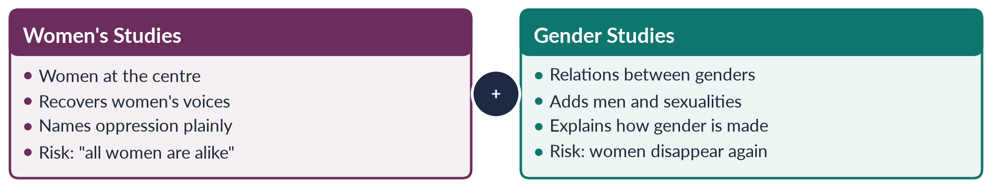
Figure 4 · Women's Studies and Gender Studies — two lenses, one project.
Draw it in: every "Women's Studies versus Gender Studies" question (2017, 2018, 2019, 2023). End on "partners, not rivals".
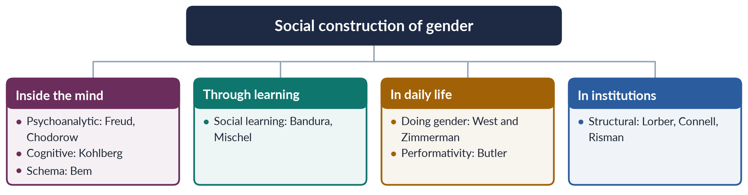
Figure 5 · How gender is made — the theories in one tree.
Draw it in: the theories question (2016), "natural or social" (2021), "is sex constructed?" (2024) and constructionism versus queer theory (2026).
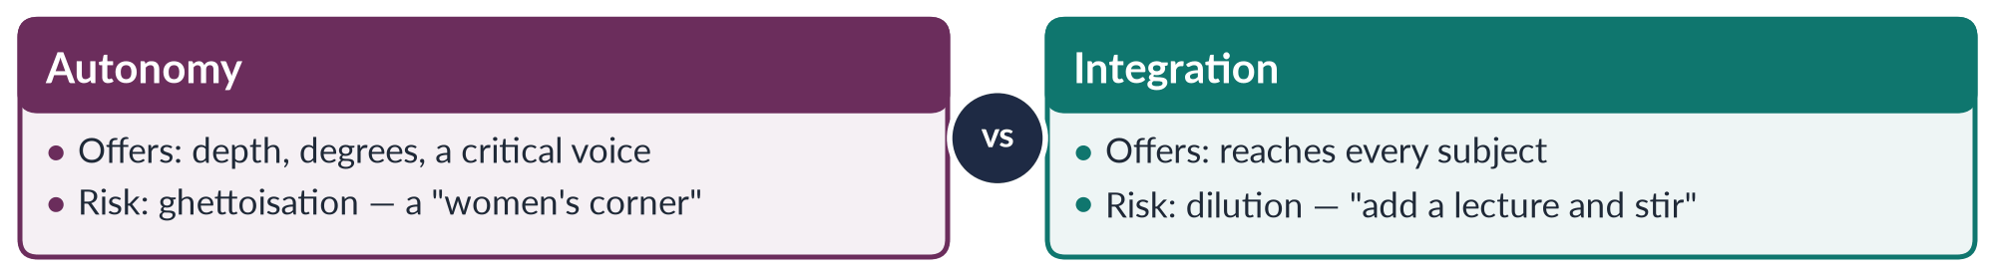
Figure 6 · Autonomy or integration — offers and risks.
Draw it in: 2016, 2017, 2021 and 2023. The answer that scores is the dual strategy: autonomy as the engine, integration as the road.
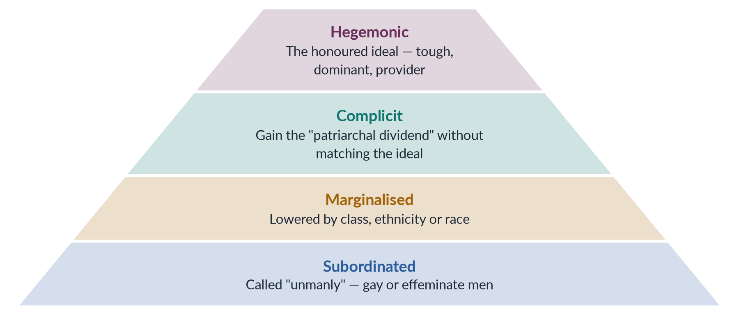
Figure 7 · Connell's ranking of masculinities.
Draw it in: masculinity and femininity (2021, 2023), and Topic 7's note on masculinity studies (2026).

Every past question as an answer plan
Use these plans in the last fortnight: read the question, say the plan aloud from memory, then check. Each plan is the skeleton of the full model answer in T1QA.
2016 Q2 — Status of Women's Studies in Pakistan; your views on autonomy/integration. Define WS (1969–70; "academic arm of the movement"). Origins in Pakistan: Shirkat Gah 1975, WAF 1981, Aurat Foundation 1986, Mumtaz and Shaheed 1987. Institutions: five centres 1989; degrees; journals; CSS 2016. Achievements: research → laws of 2010/2016; NCSW staff; NPDEW 2002. Problems table (funding, faculty, curriculum, data, resistance, ghetto). Debate: Bowles and Klein 1983; autonomy vs integration; ghettoisation vs dilution. View: dual strategy — autonomy as engine, integration as road; answer the "Western agenda" charge through local integration. Conclude: arrived but fragile.
2016 Q6 — Theories of social construction of gender. Sex vs gender; Beauvoir; essentialism vs constructionism. Seven theories, each thinker + mechanism + Pakistani example: psychoanalytic (Chodorow), social learning (Bandura, Mischel), cognitive (Kohlberg's three stages), schema (Bem 1981), doing gender (Goffman; West and Zimmerman), performativity (Butler), structural (Lorber, Connell, Risman). Summary table. Agents. Critique (body, agency, universals). Interactionist conclusion: made, so remakeable.
2017 Q2 — Define and discuss Gender Studies; differentiate WS and GS. Scott 1986 in the introduction. Definition card (construction, power, multidisciplinary, intersection); discipline features (committed, reflexive, intersectional). Scope (seven areas); aims (five). Why it emerged (Gilligan, Waring, movement, "add and stir"). Significance (CEDAW 1996, SDG 5; Pakistan data). WS (Cornell, SDSU, NWSA). Seven-criteria table; causes of the shift; examples (honour killing; maternal health); similarities; Modleski; partners.
2017 Q7 — Comprehensive note on autonomy vs integration. Where should gender knowledge live? Background: rapid growth, insecure position, Bowles and Klein 1983. Autonomy defined + six arguments; integration defined + six arguments. Risks table. Hospital analogy. Dual strategy. Legacy: feminist epistemology (Harding 1986), institutions, curriculum transformation, Beijing twin track. Pakistan: strong autonomy (1989), weak integration; local integration answers "Western agenda". Debate never ends — rebalance in good and bad funding years.
2018 Q2 — Fundamental differences GS vs WS with examples; status of WS in Pakistan. WS origin and aims; GS origin (Oakley, Rubin, Scott, Connell, queer theory). Six fundamental differences as sub-headings, each with an example (subject, concept, politics, standpoint, theory, institutions). One-problem-two-lenses table (honour killing, maternal health, politics). Why the difference is fundamental (documentation vs system). Common ground; Modleski. Status: history, institutions, achievements, challenges, way forward.
2018 Q3 — Essay: sex vs gender, reflecting nature vs nurture. Terms and stakes. Origins: Mill 1869, Beauvoir 1949, Money 1955, Stoller 1968, Oakley 1972. Why feminists needed it ("biology is not destiny"). Nature: hormones, CAH, averages, sociobiology. Nurture: Mead, history, Baby X, socialisation, Fine and Joel. Reimer. Is sex constructed? (Laqueur, intersex range, Butler; critics). Ortner. Interactionism. Pakistan (literacy, judges, pilots, CM) and policy. Conclusion.
2019 Q2 — Differentiate GS from WS; trace historically the need for GS; scope and significance; Pakistan. Difference table. Four dated phases of need: androcentric knowledge (pre-1960s); the movement creates WS (1969–70s; Towards Equality 1974); limits of WS (gender concept, men's studies, queer theory, intersectionality); policy demand (GAD; Beijing 1995). Flow diagram. Scope (seven areas, widening). Significance (academic, policy, social). Pakistan throughout: 1989 centres; gap report 2026; LFPR; laws; CSS 2016; Beijing, CEDAW 1996 and the gender machinery created demand.
2020 Q2 — Deconstruct "gender". Derrida's binaries. Eight meanings, each with a thinker: grammatical (genus; Urdu), synonym for sex, roles (Oakley), identity (Stoller), performance (West and Zimmerman; Butler), institution/structure (Lorber; Risman), relation of power (Scott), policy category. Onion analogy; one girl's life shows all layers. Binary table; hierarchical, not natural (androgyny), unstable (women engineers; Sufi care). Constructed, so reconstructable.
2020 Q4 — "Language is gendered": implication and examples. Implies: reflects, reproduces, can change. Theory: Sapir–Whorf; Lakoff 1975; Spender 1980. Forms with English and Urdu examples: generic masculine; marked terms; semantic derogation (Schulz); insults and idioms; naming; violence in words; conversation (Zimmerman and West; Tannen). Effects table. Change: inclusive terms; new words; Pakistani laws 2010, 2016, 2018; "Aurat March". Caution: not sufficient alone. Wording of laws and notices matters for civil servants.
2021 Q2 — How the autonomy/integration debate contributed to the field. Debate in brief (Bowles and Klein). Then contributions as headings: identity and aims; feminist epistemology (Harding; standpoint); institutions (NWSA 1977); curriculum transformation; interdisciplinarity (care economy, intersectionality); model for mainstreaming (Beijing twin track); reflexivity (move to GS). Flow diagram. Pakistan (1989; NCSW alongside ministry gender units). Limits (rivalry, tokenism, donors). Built its own house and renovated others.
2021 Q3 — Masculinity and femininity: natural or social? Define; "ancient" ≠ natural (slavery, caste). Biological view (testosterone; Wilson). Psychoanalytic (Freud; Chodorow). Learning and cognitive ("mard ko dard nahi hota"). Connell card (four types; patriarchal dividend; joru ka ghulam). Performative. Mead. Historical change. Many "traditions" recent (colonial codification; chador aur chaar-diwari). Pakistani change. Verdict table: interactionist — form and ranking social.
2022 Q2 — Multidisciplinary nature in detail. Multi vs inter vs trans. Four reasons. One heading per discipline with thinker and Pakistani example (sociology, anthropology, psychology, history, economics, political science and law, biology and medicine, literature/linguistics/media, development and religious studies). Child-marriage example. Strengths–challenges table; link to the autonomy debate. Summary conclusion.
2023 Q2 — Status of Gender Studies in Pakistan; views on autonomy vs integration. Near repeat of 2016: say "Gender Studies" and show the evolution. SWOT: strengths (degrees, research, professionals, policy impact incl. Islamabad DV law 2025); weaknesses (money, people, theory, data, ghetto); opportunities (CEDAW, SDG 5, demand, the 2026 gap report, digital); threats (backlash, budgets, co-option). SWOT table. Debate. View: concrete integration plan by discipline (table). Answer the tokenism objection.
2023 Q3 — Differentiate GS and WS; multidisciplinary nature in detail. One-third to the table (with the honour-killing row), two-thirds to disciplines (grid + bullets with dates). Pakistani illustration: 24.4% LFPR needs six disciplines. Interdisciplinary blending (care work; medical evidence in rape trials). Link to the autonomy debate. Multidisciplinarity is the field's method, not a weakness.
2023 Q4 — Define masculinity and femininity; where traditional roles come from. Thesis: biological start, social history. Definition cards; Connell; emphasised femininity; sharif aurat, izzat. Six sources, each evidenced: biology; economy (Boserup, Alesina et al.); property (Engels); religion and culture; law, state, colonialism; socialisation and media. Flow diagram. Sources reinforce each other. Pakistan: change and persistence (LFPR 24.4%). Roles chosen vs imposed.
2024 Q8(a) — Short note: is sex also a social construct? (~600 words.) Oakley's distinction; problematizing. Yes: Laqueur; intersex range (Sax 0.018%, Fausto-Sterling 1.7%); medical and sports decisions; Butler. Boundaries drawn by people. No: binary reproduction; most fit; classification ≠ creation; real consequences; Nussbaum. Khuntha box. Both sides agree on dignity for intersex people and khawaja siras. Conclusion: biological fact interpreted through social categories.
2026 Q2 — Constructionism and queer theory; the transgender debate and the 2018 Act. Constructionism (Beauvoir, Oakley, Berger and Luckmann) and queer theory (Foucault, Butler, Sedgwick, de Lauretis; Laqueur, Fausto-Sterling). Critique (body, abstraction, Western, tension with feminism). Context: Mughal roles; 1871; SC 2009; Census 2017 (10,418). Act 2018 (ss. 3, 7). 2022 controversy (both sides). FSC 19 May 2023. Table: argument → theory → place in debate. Activism; appeal pending; Art. 203D. Balanced view on Arts 14, 25, 227. Agreement already exists on dignity and safety.

Topic 2 · Feminist Theories and Practice
AT A GLANCE · TOPIC 2 AT A GLANCE
Head III of the syllabus. The lightest topic in the descriptive paper — 7 visits (six full questions and two short notes, 2016–2025) — but the second-richest source of MCQs (26 of 140). Every syllabus school except men's feminism has been asked: radical (2016, 2024), Marxist/socialist (2016, 2021), psychoanalytic (2021), postmodern (2019) and "any two schools" (2022); the applied question "which feminism suits Pakistan?" came in 2018. Since 2024 the examiner has moved beyond the syllabus: intersectionality (2025), and MCQs on standpoint theory, strategic essentialism, kyriarchy, the matrix of domination and the patriarchal bargain (2026). Liberal and men's feminism are due.

1. What feminism is
- Feminism — the belief that women and men should have equal rights, dignity and chances, plus the action to achieve it. Two parts: a theory (explains why women are disadvantaged) and a practice (a movement to change it). Hence the syllabus head "Feminist Theories and Practice".
- Definitions to quote:
- Kamla Bhasin and Nighat Said Khan (1986) — "an awareness of women's oppression and exploitation in society, at work and within the family, and conscious action by women and men to change this situation." (South Asian; names three sites; includes men.)
- bell hooks (2000) — "a movement to end sexism (unfair treatment because of sex), sexist exploitation, and oppression." (Targets sexism, not men.)
- Rebecca West (1913) — called a feminist whenever she refused to be "a doormat or a prostitute".
- Feminist perspective — puts gender at the centre of analysis (MCQ 2025): always asks "how are women and men affected differently, and why?"
- The word — French féminisme; Hubertine Auclert used "feminist" in 1882; reached English in the 1890s. The ideas are much older.
- Waves (a metaphor made popular by Martha Weinman Lear, 1968) — first (c. 1848–1920: vote, property, education; Seneca Falls 1848); second (1960s–80s: family, work, body, sexuality); third (1990s: diversity; Rebecca Walker 1992); fourth (c. 2012 on: digital; #MeToo 2017). Waves follow Western history — a map, not a law. (Full history is Topic 3.)
- Common ground of all schools — (1) women are disadvantaged; (2) it is made by society, not nature; (3) the personal and political are linked; (4) women's experience counts as knowledge; (5) change is possible. They disagree on cause, site (where) and cure.
- South Asian and Muslim roots — Tarabai Shinde, Stri Purush Tulana (1882); Sayyid Mumtaz Ali, Huquq-un-Niswan (Lahore, 1898, rights from the Qur'an); Qasim Amin, The Liberation of Women (Egypt, 1899); Begum Rokeya, Sultana's Dream (1905); APWA (1949, Begum Ra'ana Liaquat Ali Khan); WAF (1981). Quaid-e-Azam, Aligarh 1944: "No nation can rise to the height of glory unless your women are side by side with you."
- Myths — not man-hating (targets sexism); not one ideology (a family of theories); not only Western; not always anti-religion (Muslim feminism); not "women becoming men"; not outdated (Pakistan 143rd of 145, Global Gender Gap Report 2026; women's labour-force participation 24.4%, LFS 2024–25).
- The four questions that separate the schools — cause (why?), site (law, family, economy, mind, language?), remedy (reform or transform?), method (laws, protest, revolution, therapy, new language?).

2. Liberal feminism
- Definition — women are as rational as men; their disadvantage comes from unequal laws, customs and opportunities; remedy = reform (equal rights, education, work, political access) within the existing system. MCQ 2023: "men and women should be treated equally" = liberal feminism.
- Roots — liberalism of the Enlightenment: the individual, reason, natural rights, equal citizenship.
- First wave:
- Mary Wollstonecraft, A Vindication of the Rights of Woman (1792) — answered Rousseau's Émile (1762), which said girls should be educated to please men; women seem weak because denied a rational education.
- Olympe de Gouges, Declaration of the Rights of Woman and of the Female Citizen (1791); executed 1793.
- Seneca Falls (1848) — Stanton and Mott's Declaration of Sentiments: "all men and women are created equal".
- J. S. Mill, The Subjection of Women (1869), with Harriet Taylor Mill (The Enfranchisement of Women, 1851) — legal subordination of women is wrong and blocks progress; women's "nature" is "an eminently artificial thing"; 1867 motion to replace "man" with "person".
- Vote: New Zealand 1893; USA 1920; Britain 1918 (partial), 1928 (equal).
- Second wave:
- Betty Friedan, The Feminine Mystique (1963) — "the problem that has no name": unhappiness of educated housewives; the "mystique" = belief that women are fulfilled only as wives and mothers. Co-founded NOW (1966).
- US Equal Pay Act (1963); Title VII, Civil Rights Act (1964, no sex discrimination in jobs); CEDAW (UN women's-rights treaty, 1979; Pakistan joined 1996).
- Later — Susan Moller Okin (1989): the family must be just; Martha Nussbaum (2000): capabilities approach (real freedom to be and do — health, education, safety, work); Zillah Eisenstein (1981).
- Strengths — won the vote, education, equal-pay and anti-discrimination laws; persuasive rights language; practical, works through courts and parliaments; fits CEDAW and SDG 5.
- Criticisms — ignores structures and unpaid care; keeps the state out of the private sphere (family); equality = sameness with a male norm; middle-class bias (hooks on Friedan); individualism.
- Pakistan — Article 25 (equality; no sex discrimination; special provision for women allowed), Article 27 (no sex discrimination in public service), Article 34 (full participation of women); laws of 2006 (Protection of Women), 2010 (workplace harassment), 2016 (honour killing), 2021 (anti-rape), ICT Child Marriage Restraint Act 2025 (age 18); 60 reserved seats; NCSW (2000); Malala (Nobel 2014). Limit: weak enforcement, poverty and custom.

3. Radical feminism
- Definition — "radical" from Latin radix = root. Patriarchy (male power over women) is the oldest, deepest oppression, present everywhere — especially in family, sexuality, body and violence. Remedy: transform society at the root. MCQ 2019: replacing patriarchy = a radical idea.
- Origin — USA, late 1960s; women in civil-rights and anti-war "New Left" movements were sidelined by male comrades. New York Radical Women (1967; Miss America protest 1968 — "freedom trash can", no bras actually burned); Redstockings (1969): "Women are an oppressed class."
- "The personal is political" — Carol Hanisch (written 1969, published 1970): private problems (housework, sex, marriage) are political — shared, and caused by power. Consciousness-raising = small groups sharing experiences to reach political awareness.
- Thinkers:
- Kate Millett, Sexual Politics (1970) — sexual politics = power relations between the sexes; made patriarchy the key concept; found it in family, religion, literature, force. MCQs 2016, 2023: Millett = radical feminist.
- Shulamith Firestone, The Dialectic of Sex (1970, MCQ 2016) — root in biology/reproduction; women a "sex class"; seize control of reproduction; imagined artificial reproduction.
- Robin Morgan, Sisterhood Is Powerful (1970); Susan Brownmiller, Against Our Will (1975) — rape keeps all women in fear; Mary Daly, Gyn/Ecology (1978); Adrienne Rich, Of Woman Born (1976), "Compulsory Heterosexuality" (1980); Catharine MacKinnon (1979) — sexual harassment = sex discrimination; with Andrea Dworkin, anti-pornography campaign (1983).
- Two kinds (Rosemarie Tong) — radical-libertarian (femininity is a trap; aim androgyny; Firestone) vs radical-cultural (female values are better; celebrate the female; Daly, Rich).
- Achievements — rape crisis centres; women's shelters (first modern one, Chiswick, London, 1971); domestic violence made a public crime; sexual harassment law; marital rape recognised; bodily autonomy (right to decide about one's own body).
- Criticisms — treats all women as one (ignores race, class — hooks, Lorde); biological determinism (Firestone); anti-men image; patriarchy too universal to explain change; divisive "sex wars" (1980s splits over pornography); backlash in conservative societies.
- Pakistan — WAF (1981) against the Hudood Ordinances (1979, rape victims at risk of adultery charges); laws on harassment (2010), acid (2011), honour killing (2016), rape (2021); Aurat March (from 8 March 2018) slogan Mera Jism Meri Marzi ("My body, my choice") = bodily autonomy; controversy 2019–20. Line: radical analysis of violence is powerful; argue it in constitutional and Islamic language.

4. Marxist and socialist feminism
- Marxist terms — capitalism (few own the means of production; most sell labour); class (owners/bourgeoisie vs workers/proletariat); exploitation (workers paid less than the value they produce — profit); base/superstructure (economy shapes law, family, ideas); reserve army of labour (workers hired in booms, dropped in slumps).
- Marxist feminism — oppression rooted in capitalism and private property; women exploited as unpaid domestic workers and as a cheap reserve army; gender oppression = form of class oppression; ends when capitalism ends.
- Classical:
- Engels, The Origin of the Family, Private Property and the State (1884) — private property → men want heirs → monogamy imposed on women → "world historical defeat of the female sex"; based on Lewis Henry Morgan, Ancient Society (1877). Cure: end private property; women into paid work.
- August Bebel, Woman and Socialism (1879); Clara Zetkin — proposed International Women's Day, Copenhagen 1910 (first held 1911; UN from 1975, 8 March); Alexandra Kollontai — Soviet communal kitchens and childcare.
- Domestic-labour debate — Margaret Benston (1969): housework is real production; Dalla Costa and Selma James (1972): housework produces the worker; Wages for Housework (1972); Silvia Federici (1975): "They say it is love. We say it is unwaged work." Social reproduction = unpaid work that keeps people alive and able to work (cooking, cleaning, childcare, care of sick and old) — Lise Vogel (1983), Tithi Bhattacharya (2017).
- Socialist feminism — capitalism and patriarchy together; studies paid and unpaid work, class and gender; change economy and family.
- Juliet Mitchell — "Women: The Longest Revolution" (1966), Woman's Estate (1971): four structures — production, reproduction, sexuality, socialisation of children.
- Heidi Hartmann, "The Unhappy Marriage of Marxism and Feminism" (1979) — Marxism "sex-blind"; dual systems (capitalism + patriarchy); male unions' family wage pushed women home.
- Zillah Eisenstein (1979) — "capitalist patriarchy"; Iris Marion Young (1980) — unified systems; Maria Mies (1986) — "housewifisation" (women's work everywhere treated as secondary and cheap); Sylvia Walby (1990) — six structures of patriarchy (paid work, household production, culture, sexuality, violence, state).
- Stance — materialism; two exploitations (paid and unpaid); double burden / "second shift" (Hochschild, 1989); family serves capital; women as reserve army; liberation needs economic independence and socialised care (public childcare, paid leave).
- Criticisms — sex-blind; reduces gender to economics; underplays violence and sexuality; socialist states left women a double burden; wages for housework may fix women at home; dual systems hard to link.
- Pakistan — most employed women in agriculture, much as unpaid family helpers; home-based workers (Sindh Act 2018, first); Lady Health Worker Programme (1994; Supreme Court regularisation order 2012); Sindhiani Tehreek (from 1982, rural Sindhi women); Okara tenants' movement (from 2000, women's groups); BISP (2008, cash to women); Women Democratic Front (2018).

5. Psychoanalytic feminism
- Definition — oppression rooted in the psyche (mind): the unconscious (hidden desires and fears) and early childhood in the family produce "masculine" and "feminine" personalities; change needs new childrearing and new cultural meanings.
- Freud — Oedipus complex (age 3–5): boy desires mother, fears castration, identifies with father → strong superego (conscience); girl discovers "lack", penis envy, turns to father, wants a baby (son) → weaker superego (1925); "Anatomy is destiny" (1924); "Femininity" (1933).
- The attack — Karen Horney, "The Flight from Womanhood" (1926): girls envy men's social power, not the penis; womb envy — men envy women's power to give birth and compensate by achievement and domination; Clara Thompson (1940s): envy of cultural privilege; Beauvoir (1949): body's meaning is social; Friedan (1963), Millett (1970) blamed Freud for keeping women home.
- The re-reading — Juliet Mitchell, Psychoanalysis and Feminism (1974): psychoanalysis is "not a recommendation for a patriarchal society, but an analysis of one."
- Object-relations (mothering) — Dorothy Dinnerstein, The Mermaid and the Minotaur (1976): women alone care for infants → adults fear female power → control women; remedy: shared parenting. Nancy Chodorow, The Reproduction of Mothering (1978): girls stay close to mother → relational self, wish to care; boys separate → masculinity as "not-mother", devalue the feminine; mothering reproduces gender; remedy: dual parenting. Carol Gilligan, In a Different Voice (1982): ethic of care (relationships) vs Kohlberg's ethic of justice (rules, rights).
- Lacan and the French — Lacan: entry into language (symbolic order) under the "Law of the Father"; phallus = symbol of power, not organ. Irigaray (Speculum, 1974; This Sex Which Is Not One, 1977) — woman only a mirror for man; Kristeva (1974) — maternal semiotic (rhythm, feeling) disturbs paternal symbolic; Cixous, "The Laugh of the Medusa" (1975) — écriture féminine ("feminine writing" from the body; MCQ 2024).
- How it explains subordination — men's fear and envy; masculinity built by rejecting the mother; femininity as self-sacrifice; mothering repeats; culture male-centred; oppression internalised (women accept or defend it).
- Correct the 2021 wording — men's need to dominate is deep and unconscious but produced, not "inherent" — so it can change.
- Criticisms — untestable; assumes Western nuclear family; ignores money, law, violence; mother-blaming; heteronormative (assumes mother–father family); abstract.
- Pakistan — son preference; boys moved to male spaces and taught not to cry; mother–son bond and mother-in-law power (Kandiyoti's patriarchal bargain); internalised limits on mobility; value of fathers in childcare and paternity leave.

6. Men's feminism
- Definition — men's support for gender equality (pro-feminism) and analysis of how patriarchy shapes and harms men; aims to change masculinity and male-run institutions.
- History — Condorcet (1790); Raja Ram Mohan Roy (against sati, banned 1829); Frederick Douglass (only African-American signer at Seneca Falls, 1848); Vidyasagar (Widows' Remarriage Act 1856); Mill (1869); Mumtaz Ali (1898); Qasim Amin (1899); Sheikh Abdullah "Papa Mian" (girls' school, Aligarh, 1906); Jinnah (1944).
- Thinkers — R. W. Connell, Masculinities (1995): hegemonic masculinity (the honoured, dominant ideal of manhood) and patriarchal dividend (advantage all men gain); Michael Kimmel (1996, 2008): manhood proved before other men; Michael Messner (1997): men's movements mapped by privilege, costs, differences; bell hooks, The Will to Change (2004): patriarchy wounds men emotionally; Michael Flood: violence prevention with men.
- Men's movements — pro-feminist (NOMAS); men's liberation (1970s, costs of male role); mythopoetic (Robert Bly, Iron John, 1990); men's rights (anti-feminist: custody, "false accusations").
- Campaigns — Montreal massacre (6 Dec 1989, 14 women killed) → White Ribbon (Canada, 1991; pledge never to commit, excuse or stay silent about violence against women); ICPD Cairo 1994 (male responsibility); Beijing 1995; MenEngage (2004); HeForShe (UN Women, 20 Sept 2014, Emma Watson).
- Costs of patriarchy for men — shorter lives; higher suicide; most homicide victims; provider burden (in Pakistan: dowries, migration, debt); distant fatherhood.
- Debate: can men be feminists? — yes (hooks: against sexism, not men); yes as allies, not leaders; caution (image-seeking, diverted funds); no (few radicals). Accepted view: pro-feminist allies, accountable to women.
- Pakistan — decisions on girls' school, marriage, work, inheritance made by fathers, brothers, husbands, elders → engage them; Rozan (Islamabad; boys, men, police); Ziauddin Yousafzai (Let Her Fly, 2018); male scholars on inheritance and consent.
- Criticisms — centres men; privilege remains; slides into men's rights; men dominate spaces; weak evidence of lasting behaviour change.

7. Postmodern and post-structural feminism
- Definition — no universal "woman"; no single cause or truth; identities are constructed in language and discourse, multiple and unstable; task: deconstruct binaries (man/woman, reason/emotion) and value plurality and difference.
- MCQ key — post-structural feminism emphasises "the contingent and discursive nature of identities" (2018, 2023). Contingent = not fixed, could be otherwise. Discursive = made by discourse (how society talks and thinks about something, and who may speak).
- Roots — Lyotard, The Postmodern Condition (1979): "incredulity toward metanarratives" (disbelief in grand stories like progress or class revolution); Derrida (1967): deconstruction of ranked opposites; Foucault (1975, 1976): power/knowledge, discourses define "normal". Structuralism = fixed structures of meaning; post-structuralism = meaning never fixed.
- Core ideas — anti-essentialism; difference among women; language constructs reality; suspicion of grand theories; value of local and personal knowledge (MCQ 2025, women's personal experiences → postmodern, suggested key).
- Thinkers — Butler, Gender Trouble (1990): gender performative (repeated acts create it); Bodies That Matter (1993); Cixous, Irigaray, Kristeva (French feminism, écriture féminine) — explains MCQ 2019: gender equality through literature = postmodern feminism; Jane Flax (1987); Joan Scott (1986; 1988, equality vs difference a false binary); Donna Haraway, "A Cyborg Manifesto" (1985); Chris Weedon (1987); Fraser and Nicholson (1988, middle way).
- Modern vs postmodern — one "women" vs many womanhoods; one main cause vs many forms of power; universal truths vs local truths; one path vs plural struggles.
- Strengths — includes excluded women; attention to language and media; no false universals; change always possible.
- Criticisms — Seyla Benhabib (1995): "death of the subject" leaves no agent; political paralysis (who does feminism speak for?); relativism (can't condemn honour killing universally); jargon — Nussbaum, "The Professor of Parody" (1999); neglects material life.
- Answer to the critics — Spivak's strategic essentialism = temporary strategic unity around an identity for political goals (MCQ 2026).
- Pakistan — no single "Pakistani woman" (banker, Thari peasant, Hazara widow, khawaja sira); honour (ghairat) as discourse; media images (fairness creams, dramas); poets Kishwar Naheed ("We Sinful Women") and Fahmida Riaz.

8. Beyond the syllabus schools
- Black feminism — race, class and gender together (MCQ 2025: "all of these"). Sojourner Truth, "Ain't I a Woman?" (Akron, Ohio, 1851; famous version published 1863); Combahee River Collective (1977): interlocking, simultaneous oppressions; bell hooks, Ain't I a Woman (1981), From Margin to Center (1984); Audre Lorde, "The Master's Tools…" (1979); Alice Walker, womanism (1983).
- Intersectionality — Kimberlé Crenshaw (1989; "Mapping the Margins" 1991): identities (gender, race, class, religion, ethnicity, caste, disability, age, sexuality) overlap and interact, creating unique disadvantage; not "added up" but multiplied. Origin: gender and race (MCQ 2024). Case: DeGraffenreid v. General Motors (1976) — Black women fell between race and sex claims. Image: traffic intersection. Tool: ask "which women?"
- Matrix of domination — Patricia Hill Collins, Black Feminist Thought (1990): how intersecting oppressions are organised across society (MCQ 2026); "outsider within".
- Intersectionality in Pakistan — rural women (distance, literacy gap; female literacy about 53%, Census 2023); minority women (reported forced conversions and marriages in Sindh and Punjab); Hazara women; women with disabilities; khawaja siras; class (domestic workers of professional women).
- Standpoint theory — knowledge is socially situated (MCQ 2026): the oppressed see what the powerful miss. Nancy Hartsock (1983); Dorothy Smith (1987); Sandra Harding (1986, "strong objectivity"); Collins (1990). Roots: Hegel, Marx.
- Postcolonial feminism — Chandra Talpade Mohanty, "Under Western Eyes" (1984/1986): Western feminism creates one victimised "Third World Woman"; Gayatri Spivak, "Can the Subaltern Speak?" (1988): "White men are saving brown women from brown men" (on sati); subaltern = voiceless person at the bottom; Lila Abu-Lughod, "Do Muslim Women Really Need Saving?" (2002); Uma Narayan (1997). Pakistan use: answers "Western agenda" charge, but warns against defending every custom.
- Ecofeminism — domination of women and of nature linked; coined by Françoise d'Eaubonne (1974); Carolyn Merchant, The Death of Nature (1980); Vandana Shiva, Staying Alive (1988); Mies and Shiva, Ecofeminism (1993); Chipko (1973); Wangari Maathai, Green Belt (1977; Nobel 2004). Critique — Bina Agarwal (1992), feminist environmentalism: women's link to nature comes from material work (water, fuel, fodder), not biology. Pakistan: 2022 floods (about 33 million affected), Thar, Cholistan.
- Muslim (Islamic) feminism — gender justice by re-reading Qur'an and Sunnah, separating divine message from patriarchal tafsir (interpretation) and custom; values of adl (justice), equal faith, dignity. Term spread in 1990s (Zanan, Iran, 1992; Margot Badran). Fatima Mernissi (Beyond the Veil 1975; The Veil and the Male Elite 1987 — questioned hadith chains); Amina Wadud, Qur'an and Woman (1992); Leila Ahmed, Women and Gender in Islam (1992); Riffat Hassan (Pakistani-American; woman not created from a rib); Asma Barlas, "Believing Women" in Islam (2002; Qur'an anti-patriarchal). Sisters in Islam (Malaysia, 1988); Musawah (2009). Debate: bridge (legitimacy; inheritance, mahr = marriage gift to the bride, khula = wife-initiated divorce, consent) vs contradiction (Haideh Moghissi 1999; Afiya Zia, Faith and Feminism in Pakistan 2018) vs "Western agenda" (conservatives); Saba Mahmood, Politics of Piety (2005): pious women have agency.
- More terms — patriarchal bargain (Deniz Kandiyoti, "Bargaining with Patriarchy", 1988): women's strategies to gain security within patriarchy; in "classic patriarchy" (North Africa–Middle East–South Asia) the young bride later gains power as mother of sons and mother-in-law. Kyriarchy (Elisabeth Schüssler Fiorenza, But She Said, 1992; Greek kyrios = lord): interlocking structures of domination. Gynocriticism (Elaine Showalter, 1979; A Literature of Their Own 1977): study of women writers. Écriture féminine (Cixous, 1975).

9. The schools compared
- Master line for each — Liberal: unequal laws → reform. Radical: patriarchy → transform at root. Marxist: capitalism → end capitalism. Socialist: capitalism + patriarchy → change both. Psychoanalytic: unconscious/childhood → shared parenting. Men's: patriarchy harms men too → men as allies. Postmodern: fixed categories/discourse → deconstruct. Intersectional: overlapping systems → target the overlaps. Postcolonial: Western dominance → local feminisms. Eco: domination of women and nature → care-based economy. Muslim: patriarchal interpretation → re-read sources.
- Radical vs socialist (2016) — enemy: patriarchy vs capitalist patriarchy; unit: sex vs sex and class; would ending capitalism free women? no vs not alone; men: beneficiaries vs working-class men also exploited, can be allies; concepts: sexual politics, sex class, personal is political vs dual systems, family wage, double burden, social reproduction; campaigns: shelters, bodily autonomy vs equal pay, childcare, wages for housework; weakness: ignores class/race vs neglects violence/sexuality. Agree: family is a site of oppression; personal is political; want deep change.
- Liberal vs radical — reform vs transform; public vs private and public; equality as same chances vs ending male power.
- Marxist vs socialist — capitalism vs capitalism and patriarchy; Engels (1884) vs Hartmann (1979).

10. Which feminism suits Pakistan (2018)
- Trap — "type(s)": argue for more than one; do not write Topic 3's movement history.
- Context — Global Gender Gap 2026 143/145, 59.5% (economic 144th, education 130th, political 107th); LFPR 24.4% (2024–25); literacy ≈ 68% men, 53% women (2023); MMR 186 per 100,000 live births (2019); only 11 women won general NA seats (2024); 60 reserved seats.
- The plural model —
1. Liberal → legal and political status (Articles 25, 27, 34; laws; quotas; education). Limit: enforcement.
2. Islamic feminism → socio-cultural legitimacy (inheritance, mahr, khula, consent, education argued from faith).
3. Socialist → economic status (childcare, safe transport, recognition of unpaid work, rights of home-based and domestic workers, BISP).
4. Radical insight → safety and bodily integrity (laws on acid 2011, honour 2016, rape 2021).
5. Men's feminism → engage gatekeepers (fathers, husbands, clerics, police).
6. Intersectionality → reach rural, poor, minority and disabled women and khawaja siras first.
- Least fit, still useful — pure radical (backlash; keep the analysis); pure Marxist (no revolution coming; keep unpaid-work insight); postmodern (abstract; warns against one "Pakistani woman"); psychoanalytic (no quick policy; shared parenting).
- Conclusion line — a plural, home-grown feminism: liberal in law, Islamic in justification, socialist in economics, radical against violence, inclusive of men, intersectional in reach — as in Pakistan's own successful reforms (MFLO 1961 to the 2016 honour-killing law).

11. Today's debates in one line each
- Western import? — word French, struggle universal, local roots (Shinde, Mumtaz Ali, Rokeya, Quaid 1944).
- Islamic feminism — bridge vs contradiction; lasting reforms combined Constitution and Islam.
- Aurat March slogans — radical visibility vs liberal persuasion; substance (freedom from violence) widely supported; Article 14 (dignity).
- Which women? — intersectional targeting.
- Care economy — COVID-19; SDG 5.4 (recognise and value unpaid care); time-use surveys; day-care; leave.
- Digital fourth wave — #MeToo (Tarana Burke 2006; global 2017; Pakistan 2018); online abuse; PECA 2016.
- Climate — 2022 floods; ecofeminism vs feminist environmentalism (Agarwal).
- Men — allies (White Ribbon, HeForShe, Rozan) vs men's-rights backlash; caring manhood.

The key diagrams
Four diagrams carry most of Topic 2. Learn to draw each one from memory in under two minutes. A diagram placed early in an answer shows the examiner the whole argument at a glance and earns credit in its own right.
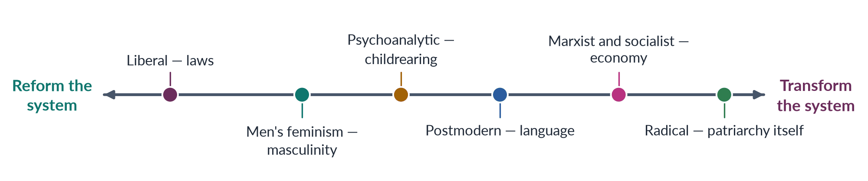
Figure 8 · The schools of feminism — from reform to transformation.
Draw it in: "any two schools" (2022) and "which feminism suits Pakistan?" (2018). It shows that you see the whole field.
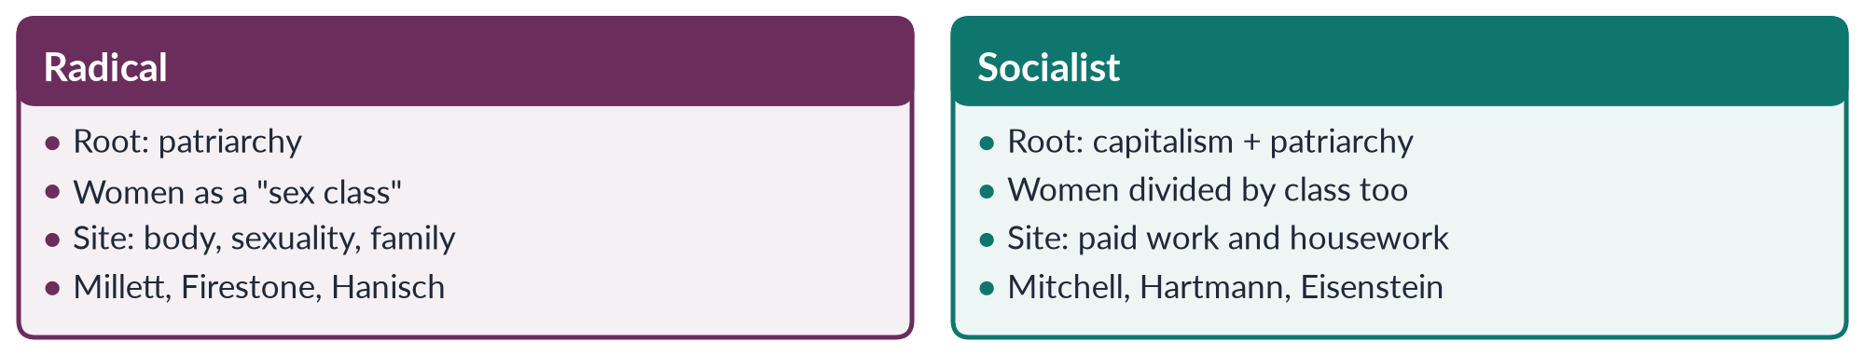
Figure 9 · Radical and socialist feminism.
Draw it in: radical versus socialist feminism (2016 — exactly this comparison), radical feminism (2024 note) and Marxist feminism (2021).
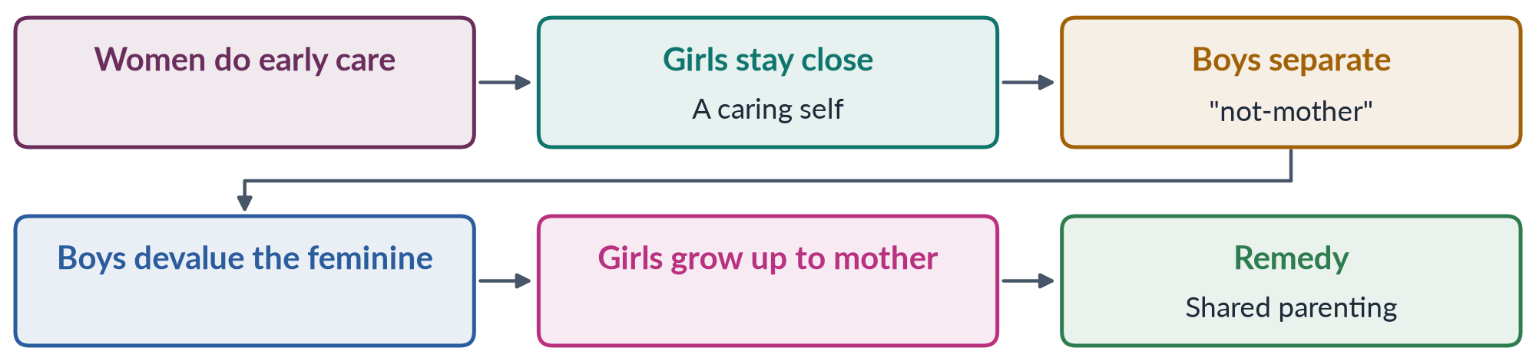
Figure 10 · Chodorow — how mothering reproduces inequality.
Draw it in: psychoanalytic feminism (2021).
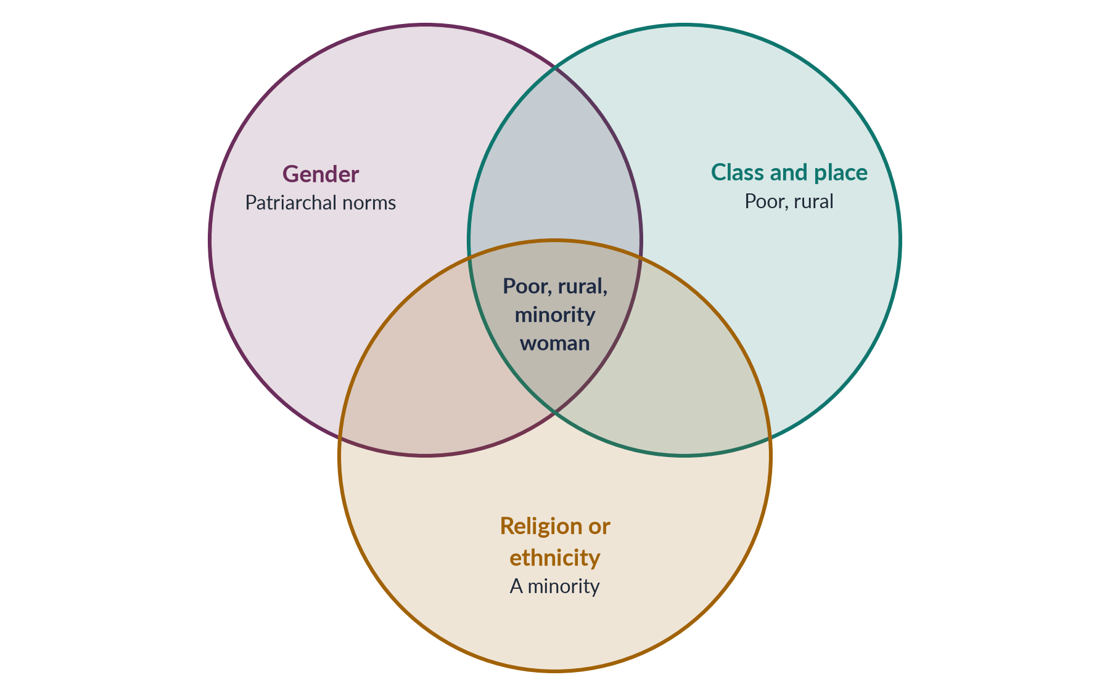
Figure 11 · Intersectionality — overlapping systems, one position.
Draw it in: intersectionality (2025), and Topic 5's 2026 question. Name Crenshaw (1989) and Collins (1990) beside it.

Every past question as an answer plan
Use these plans in the last fortnight: read the question, say the plan aloud from memory, then check. Each plan is the skeleton of the full model answer in T2QA.
2016 Q7 — What is feminism? How is radical feminism different from socialist feminism? Definition of your own; hooks (2000) and Bhasin and Khan (1986); theory + practice; word from France (Auclert 1882); South Asian roots (Shinde 1882, Rokeya 1905). Common ground (five claims); schools part on cause, site, cure. Radical: radix; patriarchy the root; Millett, Firestone, Hanisch (1970); family, body, violence. Socialist: capitalism + patriarchy; Mitchell 1971, Hartmann 1979 (dual systems), Eisenstein 1979. Differences as sub-headings: root cause; unit (sex vs sex and class); view of men; concepts; campaigns; weaknesses; one example read both ways (wife beaten over wages). Compare figure. Shared: deep change, family as site, personal is political, shared history. Pakistan: WAF vs Hudood, laws 2016/2021 (radical); LFPR 24.4%, LHWs, Sindh HBW Act 2018 (socialist). Partners more than rivals.
2018 Q4 — Which type(s) of feminism can elevate women's socio-cultural, economic and political status in Pakistan? "Type(s)" = more than one; match schools to the three dimensions. Context: GGGR 2026 143/145, 59.5%; table (11 women on general NA seats 2024, 60 reserved; literacy 68/53; LFPR 24.4%). Liberal → legal/political (Arts 25, 27, 34; laws 2010–2025; quotas; NCSW 2000; limit: enforcement). Islamic → socio-cultural (Wadud, Hassan, Barlas; inheritance, mahr, khula, consent; MFLO 1961; limit: Zia 2018). Socialist → economic (unpaid farm work, home-based workers, LHWs, BISP 2008; childcare, transport). Radical insight → safety (acid 2011, honour 2016, rape 2021; argue via Art. 14). Men's → gatekeepers (fathers, clerics, police; Rozan; HeForShe; hooks). Intersectionality → reach (rural, poor, minority, disabled, khawaja siras). Pyramid figure. Less suitable schools and what each still offers. Plural, home-grown feminism, as in Pakistan's own reforms.
2019 Q8(b) — Short note: postmodern feminism. (~560 words.) No single "woman"; identities contingent (could be otherwise) and discursive (made by discourse); meaning of "woman" changes across time and place. Roots: Lyotard 1979 ("incredulity toward metanarratives"), Derrida 1967, Foucault. Thinkers: Butler 1990, Cixous 1975, Flax 1987, Scott 1986/88. Ideas: anti-essentialism and difference; language and literature; suspicion of grand theories; deconstruction of binaries. Compare figure (modern vs postmodern). Strengths; criticisms (Benhabib 1995, Nussbaum 1999, relativism); Spivak's strategic essentialism. Pakistan: many womanhoods; ghairat as discourse; Kishwar Naheed. A lens, not a programme.
2021 Q4 — Development of Marxist/socialist feminism and its stance on gender and exploitation. Use the question's definition. Five Marxist terms. Stage 1: Engels 1884 (property → monogamy → "world historical defeat"), Bebel 1879, Zetkin 1910, Kollontai. Stage 2: domestic-labour debate — Benston 1969, Dalla Costa and James 1972, Wages for Housework, Federici 1975; social reproduction; cycle figure. Stage 3: Mitchell 1966/71 (four structures), Hartmann 1979 (sex-blind; dual systems; family wage), Eisenstein, Young 1980, Mies 1986, Walby 1990. Stance: materialism; family serves capital; double burden (Hochschild 1989); two exploitations linked; remedy of economic independence and socialised care. Exploitation table (unpaid, cheap, reserve army, global factories). Criticisms + reply (SDG 5.4). Pakistan: LFPR 24.4%, unpaid farm work, HBW Act 2018, LHWs (1994; SC 2012), Sindhiani Tehreek, Okara, BISP.
2021 Q5 — Gender oppression and women's subordination in psychoanalytic feminism. Define; from attacking Freud to re-reading him. Psychoanalysis in brief. Freud: Oedipus, castration, penis envy, weaker superego (1925), "anatomy is destiny" (1924). Attack: Horney 1926 (envy of power; womb envy), Beauvoir, Friedan, Millett. Re-reading: Mitchell 1974. Mothering: Dinnerstein 1976 (fear of female power), Chodorow 1978 (relational girls, separating boys; flow figure), Gilligan 1982. Language: Lacan (Law of the Father), Irigaray, Kristeva, Cixous. Analysis table: envy, fear, rejection, self-sacrifice, male-centred culture, internalisation. Correct "inherent": produced and changeable; remedy shared parenting. Criticisms. Pakistan: son preference, "men don't cry", patriarchal bargain (Kandiyoti 1988), involved fathers. Change the nursery as well as the law.
2022 Q3 — Describe any two Western schools of feminism in detail. Choose liberal and radical and say why. Each under the same sub-headings. Liberal: meaning (reason, rights, reform); roots (Enlightenment); Wollstonecraft 1792, Seneca Falls 1848, Mill 1869, Friedan 1963, NOW 1966, Okin 1989, Nussbaum 2000; achievements (vote, Equal Pay Act 1963, Title VII 1964, CEDAW 1979/1996); methods; criticisms (structures, private sphere, male norm, class bias, individualism). Radical: radix; New Left; NYRW 1967, Redstockings 1969; Millett, Firestone, Hanisch, Brownmiller, Rich; libertarian vs cultural; ideas; achievements (shelters 1971, MacKinnon 1979); criticisms. Compare figure; agree/differ. Pakistan: Arts 25/27/34 and laws (liberal); WAF, laws on violence, Aurat March (radical). The two need each other.
2024 Q8(b) — Short note: radical feminism. (~550 words.) Radix; patriarchy the deepest oppression; replacing patriarchy = radical. Origin in the late-1960s New Left; NYRW, Redstockings. Millett, Firestone, Hanisch, Brownmiller (dates). Cycle figure of patriarchy. Ideas: sexual politics; personal is political (consciousness-raising); bodily autonomy (Rich 1976); two branches. Achievements (shelters 1971; domestic violence a crime; MacKinnon 1979). Criticisms (race and class; essentialism; anti-men image; backlash; patriarchy not unchanging). Pakistan: WAF vs Hudood 1979; laws 2011/2016/2021; Mera Jism Meri Marzi. Analysis powerful; argue it in constitutional and Islamic language.
2025 Q6 — Intersectionality of gender with other social identities. Define; Crenshaw 1989; "which women?" Origins: Sojourner Truth 1851; Combahee 1977; DeGraffenreid v. GM (1976); traffic image. Ideas: interaction, not addition (bus example); Collins 1990 matrix of domination; privilege and disadvantage together (employer and domestic worker). Venn figure. One heading per identity with Pakistani evidence: class (work, justice); place (literacy ~53%, MMR 186, 2022 floods); religion (reported forced conversions; Ahmadis); ethnicity and caste (Hazara; scheduled castes); disability, age (child marriage, ICT 2025; widows), gender identity (khawaja siras, 2018 Act). Summary table. Why it matters (data, policy incl. BISP, movement). Criticisms and Crenshaw's "lens" reply. Begin with the women at the overlaps.

Topic 3 · Feminist Movements — the West, the United Nations and Pakistan
AT A GLANCE · TOPIC 3 AT A GLANCE
Head IV of the syllabus. A steady mid-weight topic: 9.5 visits (nine full questions and one short note, 2016–2026) and 22 of the 140 MCQs. Two families carry it: the waves (2019, 2022, 2023 — an exact repeat of 2019 — 2024, 2025) and the movement in Pakistan (2016, 2022, 2024, 2026, plus APWA/WAF in 2018 and NGO-isation in 2026). The examiner always wants the link to Pakistan or to women's lives, and every Pakistan question carries a twist. The UN conferences have never been a full question, though MCQs on Mexico 1975, Beijing 1995 and CEDAW 1996 recur — they are due.

1. The waves in general
- Women's movement — collective, organised action over time to improve women's rights and status.
- Wave — a period of intense feminist activity with shared demands. Metaphor made popular by Martha Weinman Lear, "The Second Feminist Wave" (New York Times Magazine, 1968); the earlier suffrage campaign then became the "first wave".
- The four waves — first (c. 1848–1920: vote, property, education, legal personhood); second (1960s–80s: work, family, body, sexuality; "the personal is political"); third (1990s–2000s: diversity, identity, intersectionality, culture); fourth (c. 2012–: digital activism against harassment and violence).
- Critics of the metaphor — it follows white, Western, middle-class history; hides activism between waves; makes generations seem to reject each other; ignores the different timing of the global South. Use it as a map, not a law.

2. The first wave (c. 1848–1920)
- What women lacked — the vote; coverture (a married woman's legal identity "covered" by her husband's: no property, contracts or own wages); universities and professions closed; fathers got custody of children.
- Roots — Enlightenment "rights of man"; Olympe de Gouges (1791), Wollstonecraft (1792); training in the anti-slavery movement.
- USA — Stanton and Mott refused seats at the World Anti-Slavery Convention, London (1840) → Seneca Falls Convention (19–20 July 1848, New York; about 300 attended, about 100 signed, including Frederick Douglass) → Declaration of Sentiments: "all men and women are created equal"; demand for the vote. Anthony and Stanton's NWSA (1869); merged with AWSA in 1890; Sojourner Truth (1851); Wyoming vote (1869); Alice Paul pickets (1917); 19th Amendment (1920).
- Britain — suffragists: NUWSS (1897), Millicent Fawcett, peaceful methods (petitions, lobbying). Suffragettes: WSPU (1903), Emmeline and Christabel Pankhurst, "Deeds, not words" — window-smashing, arson, hunger strikes; Cat and Mouse Act (1913: hunger strikers released when weak, re-arrested later); Emily Wilding Davison died at the Derby (1913). 1918 Act: women over 30 with property; 1928: equal votes at 21. War work in 1914–18 helped.
- Other campaigns — Caroline Norton → Custody of Infants Act (1839); Matrimonial Causes Act (1857, divorce); Married Women's Property Acts (1870, 1882); Elizabeth Blackwell first US woman medical graduate (1849); Girton College (1869); Josephine Butler against the Contagious Diseases Acts (repealed 1886); temperance.
- Around the world — New Zealand 1893 (Kate Sheppard, first self-governing country); Australia 1902; Finland 1906 (first in Europe; could also stand); Turkey 1934; France 1944; India and Pakistan 1947 (with independence). Muslim world: Huda Shaarawi, Egyptian Feminist Union (1923).
- Principles, goals, strategies — women are rational citizens (liberal); vote, property, education, custody; conventions, petitions, lobbying, newspapers, militancy.
- Limits — mostly white and middle-class (Black Southern women barred until the Voting Rights Act 1965); legal, not social, equality; Western timing.
- Pakistan — vote came with independence; first-wave goals (education, property, legal status) shaped APWA, the 1948 Punjab inheritance Act and the MFLO 1961.

3. The second wave (1960s–1980s)
- Why — vote won but inequality in pay, jobs, family, body; the "feminine mystique"; causes: wartime work, more women at university, the pill (US 1960), the civil-rights movement, Beauvoir (1949).
- Two streams — liberal/equal rights: Friedan, The Feminine Mystique (1963, "the problem that has no name"); NOW (1966); lobbying, lawsuits. Women's liberation/radical: New York Radical Women, Redstockings; Millett, Firestone, Hanisch (1970); consciousness-raising (small groups turning private problems into political awareness), direct action.
- Key events — Kennedy's Commission on the Status of Women (1961); US Equal Pay Act (1963); Title VII (1964); UK Abortion Act (1967); Miss America protest (1968, "freedom trash can"); Ford Dagenham strike (1968) → UK Equal Pay Act 1970; Ruskin College conference (1970; four demands: equal pay, equal education and opportunity, 24-hour nurseries, free contraception and abortion on demand); Chiswick shelter (1971); Ms. (Steinem, 1972); ERA passed Congress (1972, never ratified — Phyllis Schlafly); Title IX (1972); Roe v. Wade (22 January 1973; overturned by Dobbs 2022); UK Sex Discrimination Act (1975); Manifesto of the 343 (France 1971); Iceland women's day off (24 Oct 1975, ~90%); CEDAW (1979).
- "The personal is political" (Carol Hanisch, 1970) — private problems (housework, marriage, sex, abortion) are shaped by power; most associated with the second wave (MCQ 2026).
- Voices — Steinem, Germaine Greer (The Female Eunuch, 1970), Millett, Firestone, MacKinnon (harassment as discrimination, 1979), Angela Davis (1981).
- Achievements — equal pay and anti-discrimination laws; contraception and abortion rights; shelters, rape crisis centres; harassment law; Women's Studies.
- Blind spots — white and middle-class (bell hooks, 1981; Audre Lorde); heterosexual bias (Friedan's "lavender menace", 1969); Western focus (Mexico City 1975 tensions); backlash (Faludi, Backlash, 1991).
- Why it faded — success; divisions ("sex wars"); Reagan–Thatcher conservatism; ERA deadline missed (1982); institutionalisation.
- Pakistan — WAF (1981) against the Hudood Ordinances (1979): a second-wave struggle over body, sexuality and violence; later harassment (2010) and honour (2016) laws.

4. The third wave (1990s–2000s)
- Spark — Anita Hill hearings (Oct 1991): she testified that Clarence Thomas harassed her; harsh questioning by an all-male committee.
- Name — Rebecca Walker, "Becoming the Third Wave", Ms. (January 1992): "I am not a post-feminism feminist. I am the Third Wave" (MCQ 2025); Third Wave Direct Action Corporation (1992).
- Theory — intersectionality (Crenshaw 1989; hooks; Combahee 1977); postmodern/queer (Butler 1990, gender performative); postcolonial (Mohanty 1984).
- Features — diversity (many womanhoods); intersectionality; individual choice; sex-positivity and reclaiming words; culture — Riot Grrrl (1991, zines = homemade magazines; Bikini Kill); Naomi Wolf, The Beauty Myth (1990); Eve Ensler, The Vagina Monologues (1996) → V-Day (1998); Manifesta (2000); "girl power"; global voices.
- Laws and campaigns — US Violence Against Women Act (1994); Vienna (1993) "women's rights are human rights"; DEVAW (1993); Beijing (1995); 16 Days of Activism (from 1991); WLUML (1984), Sisters in Islam (1988), Wadud (1992).
- Postfeminism — claim that equality is won and feminism unnecessary; criticised by Angela McRobbie, Faludi; third wave defined itself against it.
- Criticisms — too individual ("choice feminism"); consumerism ("girl power" as marketing); fragmentation; caricature of the second wave.
- Effects — voice for women of colour, LGBT and Southern women; intersectionality in law and policy; harassment reporting; violence as a human-rights issue.
- Pakistan — Beijing (1995; Benazir Bhutto spoke), NGO boom, attention to rural and minority women, khawaja siras (SC 2009; Act 2018), Islamic feminism (Riffat Hassan, Asma Barlas).

5. The fourth wave (c. 2012–)
- Definition — feminist activism using social media to share experience, expose harassment and violence, organise quickly and hold the powerful accountable; intersectional. Kira Cochrane, All the Rebel Women (2013).
- Campaigns — SlutWalk (Toronto 2011); Everyday Sexism Project (Laura Bates 2012); Delhi gang-rape protests (Dec 2012) → India's Criminal Law (Amendment) Act 2013; #NiUnaMenos (Argentina 2015; abortion legal Dec 2020); Women's March (21 Jan 2017); #MeToo (Tarana Burke 2006; global October 2017 after the Weinstein reports; Alyssa Milano); Ireland's referendum (25 May 2018); Spain's consent law (2022); Iran's "Woman, Life, Freedom" (Sept 2022).
- Features — digital tools; harassment and violence; intersectionality; bodily autonomy and consent; accountability ("call-out culture"); global speed.
- Criticisms — online abuse and doxxing (publishing private details); "slacktivism"; due-process concerns; digital divide; manosphere backlash.
- Pakistan — Aurat March (from 8 March 2018); #MeToo (2018); Digital Rights Foundation (2012; helpline 2016); PECA 2016; outrage after Qandeel Baloch (2016), the motorway gang rape (2020), Noor Mukadam (2021) → Anti-Rape (Investigation and Trial) Act 2021; mobile-internet gender gap 38% → 25% (GSMA, 2024–25).

6. The waves compared (2025)
- Principles — first: equal natural rights; second: personal is political, patriarchy; third: diversity, intersectionality, choice; fourth: consent, accountability, intersectionality.
- Goals — first: vote, property, education; second: pay, jobs, reproduction, violence; third: inclusion, sexuality, identity, global rights; fourth: end harassment and violence, safe spaces.
- Strategies — first: petitions, conventions, militancy; second: lobbying, lawsuits, consciousness-raising; third: culture, zines, networks; fourth: hashtags, testimony, mass marches.
- Theory — first liberal; second liberal, radical, socialist; third Black, postmodern, queer, postcolonial; fourth intersectional.
- Effects on women's lives — political (vote; about a quarter of parliamentarians worldwide are women); legal (property, contracts, divorce; discrimination unlawful); education and work (women at university and in all professions; pay gaps remain); body (contraception, safe abortion in many countries); safety (violence criminalised; shelters); voice (diverse women; harassment costly).
- Continuity vs change — new leaders, issues and methods each time, but one core demand: equal dignity and freedom. Treat the waves as stages of one movement.
- Unfinished — global gap 69.2% closed (2026), 120 years to parity; one in three women faces violence (WHO 2021); Roe reversed (2022); Pakistan 143rd of 145.
- Pakistan's waves — first ≈ welfare and reform (1947–70); second ≈ legal resistance (1980s); third ≈ NGOs and diversity (1990s–2000s); fourth ≈ Aurat March and digital (2018–). Phases overlap.

7. The United Nations and women
- Foundations — UN Charter (1945, "equal rights of men and women"); CSW (21 June 1946, meets each March); UDHR (10 December 1948 = Human Rights Day, MCQ 2018); Convention on the Political Rights of Women (1952); DEDAW (1967).
- International Women's Year 1975; UN Decade for Women 1976–85 ("Equality, Development and Peace").
- Four conferences — Mexico City 1975 (first; World Plan of Action; UNIFEM/INSTRAW; North–South tensions; MCQ 2016); Copenhagen 1980 (mid-decade; CEDAW signing ceremony; employment, health, education); Nairobi 1985 (Forward-Looking Strategies to 2000; large NGO forum); Beijing 1995 (4–15 September; 189 governments; Beijing Declaration and Platform for Action; 12 critical areas; gender mainstreaming; NGO forum at Huairou ~30,000; "women's rights are human rights"; Benazir Bhutto spoke).
- 12 critical areas — poverty; education; health; violence; armed conflict; economy; power and decision-making; institutional mechanisms; human rights; media; environment (area K → MCQ 2023); the girl child.
- Reviews — Beijing +5 (2000), +10, +15, +20, +25 (2020), +30 (March 2025): progress in education and laws; slow change in power and pay; violence; backlash.
- CEDAW — adopted 18 Dec 1979; in force 3 Sept 1981; "an international bill of rights for women" (MCQ 2026); Committee of 23 experts; reports every four years; Optional Protocol 1999 (individual complaints; Pakistan not a party). Key articles: 1 (definition), 2 (change laws and customs), 4 (temporary special measures, e.g., quotas), 5 (stereotypes), 7 (political life), 10 (education), 11 (employment), 12 (health), 14 (rural women), 16 (marriage and family), 29 (disputes → ICJ).
- Pakistan and CEDAW — acceded 12 March 1996 (accession = joining without prior signature); general declaration (subject to the Constitution) and reservation to Article 29(1); periodic reports; NGO shadow reports; Committee urges repeal of discriminatory laws, enforcement against violence and child marriage.
- Wider agenda — Vienna 1993; DEVAW (Dec 1993); Cairo ICPD 1994; UNSCR 1325 (31 Oct 2000, Women, Peace and Security); MDGs (2000); UN Women (July 2010, operational 2011; Michelle Bachelet; merged four bodies incl. UNIFEM); SDG 5 (2015); HeForShe (2014); Generation Equality Forum (2021); DAWN (1984).
- Assessment — achievements: global standards, violence as a human-rights issue, national machineries, NGO platforms. Limits: no enforcement; reservations; implementation gaps; "Western values" charge.
- What it gave Pakistan — Women's Division (1979); National Plan of Action (1998); NCSW (2000); National Policy (2002); reserved seats (2002); an international platform for activists.

8. Roots in South Asia and the Pakistan Movement
- Social reform — Raja Ram Mohan Roy → Bengal Sati Regulation (1829; MCQ 2026); Vidyasagar → Widows' Remarriage Act (1856); Tarabai Shinde (1882); Age of Consent Act (1891, 10 → 12); Child Marriage Restraint Act (Sarda Act) 1929; Dissolution of Muslim Marriages Act 1939; Shariat Application Act (1937).
- Muslim reform — Nazir Ahmad, Mirat-ul-Uroos (1869); Mumtaz Ali, Huquq-un-Niswan (1898) and Tahzib-e-Niswan with Muhammadi Begum; Sheikh Abdullah and Wahid Jahan Begum's Aligarh girls' school (1906); Begum Rokeya (1905, 1911); All-India Muslim Ladies' Conference (from 1914). Pattern: reform within tradition; education first.
- Pakistan Movement — Muslim League Central Women's Sub-Committee (Patna 1938); Fatima Jinnah (Madar-e-Millat); Jahanara Shahnawaz (only Muslim woman at the Round Table Conferences; first Constituent Assembly with Shaista Ikramullah, 1947); Ra'ana Liaquat Ali Khan; Lady Abdullah Haroon (Sindh); Salma Tassaduq Hussain, Viqar-un-Nisa Noon (1947 Punjab agitation); Fatima Sughra (flag on Punjab Civil Secretariat, Feb 1947). Quaid, Aligarh, 10 March 1944: "No nation can rise to the height of glory unless your women are side by side with you."
- Partition — abductions and violence; women's relief work → Women's Voluntary Service, Women's National Guard → APWA 1949.
- Inheritance 1948 — women legislators and a demonstration outside the Punjab Assembly → West Punjab Muslim Personal Law (Shariat) Application Act 1948 (inheritance incl. agricultural land): rights won by appealing to Islam against custom.
- What roots explain — reform from within Islam; education first; elite leadership; ties to nationalism; vote came with independence.

9. The movement in Pakistan — six phases
- Phase 1 · Welfare and reform (1947–70) — APWA (1949, founder and first president Begum Ra'ana Liaquat Ali Khan; schools, colleges, clinics, crafts; non-political welfare); PM Bogra's second marriage (1955) → Rashid Commission (report 1956) → MFLO 1961 (Ayub: registration of marriage; arbitration council permission for second marriage; divorce notice; orphaned grandchildren inherit); 1956 Constitution reserved seats; Fatima Jinnah vs Ayub (1965).
- Phase 2 · Constitutional equality (1971–77) — 1973 Constitution: Art. 25 (no sex discrimination), 27 (public service), 32 (women in local government), 34 (full participation), 35 (family); Ra'ana Liaquat Governor of Sindh (1973); IWY committee (1975).
- Phase 3 · Resistance under Zia (1977–88) — Hudood Ordinances (Feb 1979; zina, theft, drink, false accusation; rape victims who could not prove rape risked zina charges); WAF (Karachi, Sept 1981, after the Fehmida–Allah Bux stoning sentence; non-hierarchical, non-party, secular); 12 February 1983 Lahore protest against the Law of Evidence (WAF and Punjab Women Lawyers' Association; baton charge; Habib Jalib; National Women's Day since 2012); Safia Bibi (1983, visually impaired rape victim convicted of zina; FSC acquitted her); Qanun-e-Shahadat 1984 (Art. 17: two women witnesses in financial matters); Qisas and Diyat (1990/1997, "forgiveness" loophole); Zari Sarfaraz Commission (1983–85, shelved); Sindhiani Tehreek (1982).
- APWA vs WAF — APWA: 1949; Ra'ana Liaquat; welfare, education, skills; service and cooperation with the state; non-political; elite charity. WAF: 1981; resist discriminatory laws; protest, lobbying, legal analysis; secular, non-party, confrontational; professional urban women.
- Phase 4 · Democracy, Beijing, NGOs (1988–99) — Benazir Bhutto (1988, first woman PM of a Muslim country); First Women Bank (1989); women's police stations and LHW Programme (1994); Beijing (1995); CEDAW (1996); NGO boom (Shirkat Gah 1975, Aurat Foundation 1986, Simorgh, ASR); HRCP (1987); Samia Sarwar (1999, honour killing).
- Phase 5 · Reforms and machinery (2000–17) — NCSW (2000); 33% local seats (2001); 60 NA / 17 Senate reserved seats (2002); National Policy (2002); Criminal Law (Amendment) Act 2004 (honour crimes); Protection of Women Act 2006 (rape to Penal Code); Women's Parliamentary Caucus, Fahmida Mirza Speaker, BISP (2008); harassment (2010); acid, anti-women practices (2011); honour and anti-rape amendments, Punjab PWVA (2016, after Qandeel Baloch); Elections Act 2017 (5% tickets; 10% women's turnout). = state feminism (rights through the state).
- Phase 6 · New activism (2018–) — Aurat March (8 March 2018: violence, harassment, workers, khawaja siras, bodily autonomy); Women Democratic Front, Hum Auratein (2018); digital activism; Anti-Rape Act 2021; Women's Property Rights Act 2020; ICT Child Marriage Restraint Act 2025 (18); ICT Domestic Violence Act 2025; backlash (petitions, "Haya March", online abuse).
- Other actors — rural and working women (Sindhiani Tehreek; Okara tenants from 2000; LHW union, SC 2012; Sindh Home-Based Workers Act 2018; fisherfolk women); religious women (Jamaat-e-Islami women's wing; Al-Huda, 1994, Farhat Hashmi); artists (Kishwar Naheed, Fahmida Riaz; Tehrik-e-Niswan 1979, Sheema Kermani; Ajoka 1984, Madeeha Gauhar; Sharmeen Obaid-Chinoy, Saving Face 2012, A Girl in the River 2016); lawyers (Asma Jahangir, Hina Jilani: first all-women law firm 1980, AGHS Legal Aid, HRCP 1987); legislators (caucus 2008).
- History to quote — Khawar Mumtaz and Farida Shaheed, Women of Pakistan: Two Steps Forward, One Step Back? (1987).

10. Western influence, past vs emerging, and the shift to the body
- Channels — education; the UN (conferences, CEDAW, SDGs); donors and NGOs; media; diaspora scholars.
- Wave by wave — first: education, property (vote came with independence; MFLO argued in Islamic terms); second: personal is political, violence (WAF vs Hudood; focus on law); third: diversity, NGOs, human rights (Beijing, CEDAW, Islamic feminism); fourth: digital, #MeToo, bodily autonomy (Aurat March).
- Not a copy — local roots; waves arrived out of order and together; adapted to Islam and culture; faced a state using religion to restrict women; postcolonial critique is itself Southern. Verdict: West supplied tools and platforms; Pakistani women chose and adapted them.
- Laws showing influence — Harassment Act 2010 (CEDAW Art. 11); reserved seats 2002 (CEDAW Art. 4, Beijing area G); NCSW 2000 (Beijing area H; Act 2012); honour law 2016 (global campaigns; framed in Islamic and constitutional terms); ICT child-marriage law 2025 (SDG 5.3; CEDAW Art. 16).
- Past vs emerging (2024) — past: elite and professional leaders; APWA, WAF, NGOs; welfare, family law, discriminatory laws; lobbying, courts, press; language of Constitution and Islam; cooperation or legal resistance. Emerging: young urban women, students, workers, trans activists; Aurat March collectives, WDF; body, violence, harassment, care, online safety; marches, art, social media; language of consent and intersectionality; independent, confrontational. Effects: visibility; inclusion; faster state response (2020 case → 2021 law); backlash and polarisation; class limits (digital divide).
- Legal rights → bodily autonomy (2026) — locus of resistance = where a movement concentrates its struggle. 1980s WAF: fight laws via courts and lawyers, language of citizenship and Islam. 2020s Aurat March: claim body, safety and choice via streets and social media, language of consent. Why: many legal battles won but violence continues; new generation; fourth-wave influence; the body as the site of control (honour, forced marriage, harassment). Continuity: the march still demands laws; WAF already defended bodies. Formula: from rights on paper to rights over one's own body.
- Why bodily autonomy provokes — body linked to family izzat (honour); critics hear rejection of family and religion; supporters cite Islam's ban on forced marriage and Article 14 (dignity); wide agreement on substance.

11. NGO-isation (2026)
- NGO-isation — movement energy moves into professional, registered, donor-funded NGOs; activists become staff; campaigns become projects; accountability upwards to donors. Scholars: Sonia Alvarez (1999), Islah Jad (2004).
- Depoliticisation — turning a struggle about power into a technical problem managed by experts ("technocratic project" vs "social revolution").
- WAD — 1970s Marxist/dependency critique of WID (integrate women into development): women were always part of development, but on unequal, exploitative terms; adding women to projects leaves structures intact. GAD — unequal gender power relations; empowerment. (Topic 4.)
- How it happened — military rule closed political space; post-Beijing donor funds; jobs and protection; state liked service delivery. Timeline: Shirkat Gah 1975; WAF 1981 (unfunded); ASR 1983; Simorgh, Aurat Foundation 1985–86; 1990s NGO boom; GRAPs 2000s; INGO regulation from 2015; Aurat March 2018 (self-funded).
- The case for depoliticisation — donor-driven agendas; projectisation; professionalisation; upward accountability; urban/class bias; "Western agenda" label; competition and fragmentation; WAD: micro-credit and crafts leave land, feudal power, wages and unpaid care untouched.
- The case against — NGOs won laws (2006–2016); kept space open under military rule; services save lives; not all NGOs alike (WAF stayed unfunded); movements revived (Aurat March); growing local funding.
- Gender mainstreaming — Beijing 1995; in Pakistan: NPA 1998, National Policy 2002, GRAPs, gender budgeting, NCSW Act 2012, provincial departments after the 18th Amendment (2010); critics: checklist exercise, fades with donor money.
- Verdict — partly depoliticised; but produced laws, data and services; movement re-politicised (WAF legacy, rural struggles, Aurat March). Way forward: division of labour — NGOs for expertise and services, movements for mobilisation; local funding; accountability to women.

12. Evaluation (2016) and debates
- Achievements — family law (MFLO 1961; khula — Khurshid Bibi case 1967); criminal law (2006; 2010; 2011; 2016; 2021; DV laws 2013–2025); political voice (60 seats; 33% local; Elections Act 2017; first woman PM 1988, Speaker 2008, CM 2024); institutions (Women's Division 1979; NCSW 2000; commissions; women's police stations; harassment ombudspersons); CEDAW 1996; girls' education accepted.
- Strengths — local and Islamic legitimacy; legal expertise (Asma Jahangir, Hina Jilani); resilience under martial law; cross-party caucus; adaptability; research base.
- Weaknesses — elite urban leadership; enforcement gap; dependence on state and donors; NGO-isation; "Western agenda" label; religious backlash; divisions (secular/Islamic, liberal/left, old/young).
- Scorecard — GGGR 2026 143/145 (2025: 148/148); LFPR 24.4%; female literacy ~53%; 11 women won general NA seats (2024). Laws changed more than lives.
- Way forward — broaden the base (rural, worker, minority, disabled women, khawaja siras as leaders); enforce laws; local funding; alliances (parties, unions, ulema, men); local idiom (Constitution, Islam); economic agenda; digital safety; bridge generations.
- Lessons — law necessary, not sufficient; gains follow political openings; legitimacy matters; coalitions win; renewal comes from below.
- Debates — Aurat March (substance vs slogans; Arts 16–17 right to assemble); "Western agenda"; law vs body; digital reach; NGO capture; Beijing+30 and global backlash (Roe 2022; Afghanistan since 2021); secular vs Islamic feminism (Afiya Zia, 2018); men as gatekeepers or allies.

The key diagrams
Four diagrams carry most of Topic 3. Learn to draw each one from memory in under two minutes. A diagram placed early in an answer shows the examiner the whole argument at a glance and earns credit in its own right.
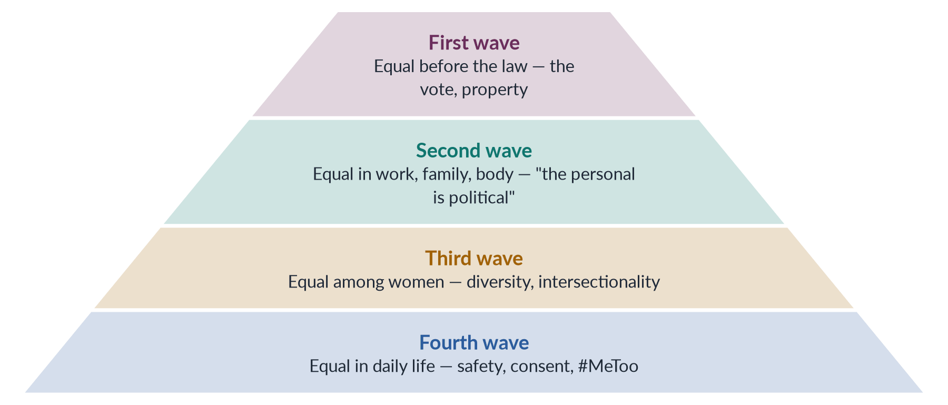
Figure 12 · Each wave deepened the meaning of equality.
Draw it in: every waves question (2019, 2022, 2023, 2024, 2025). Add one Pakistani echo for each wave.
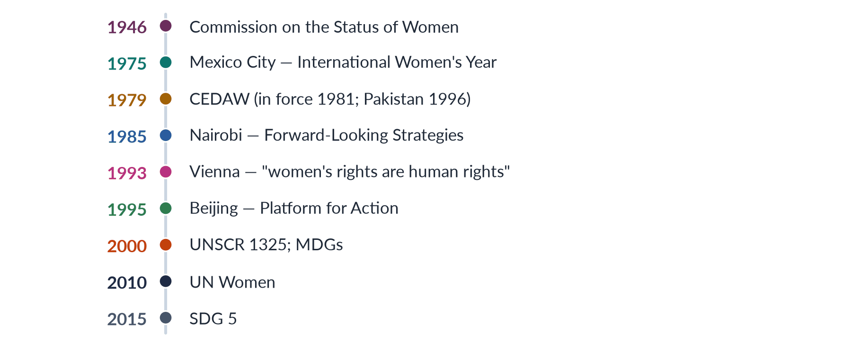
Figure 13 · The UN road for women's rights.
Draw it in: any UN question — never yet a full question, so it is due — and the background of every Pakistan question.
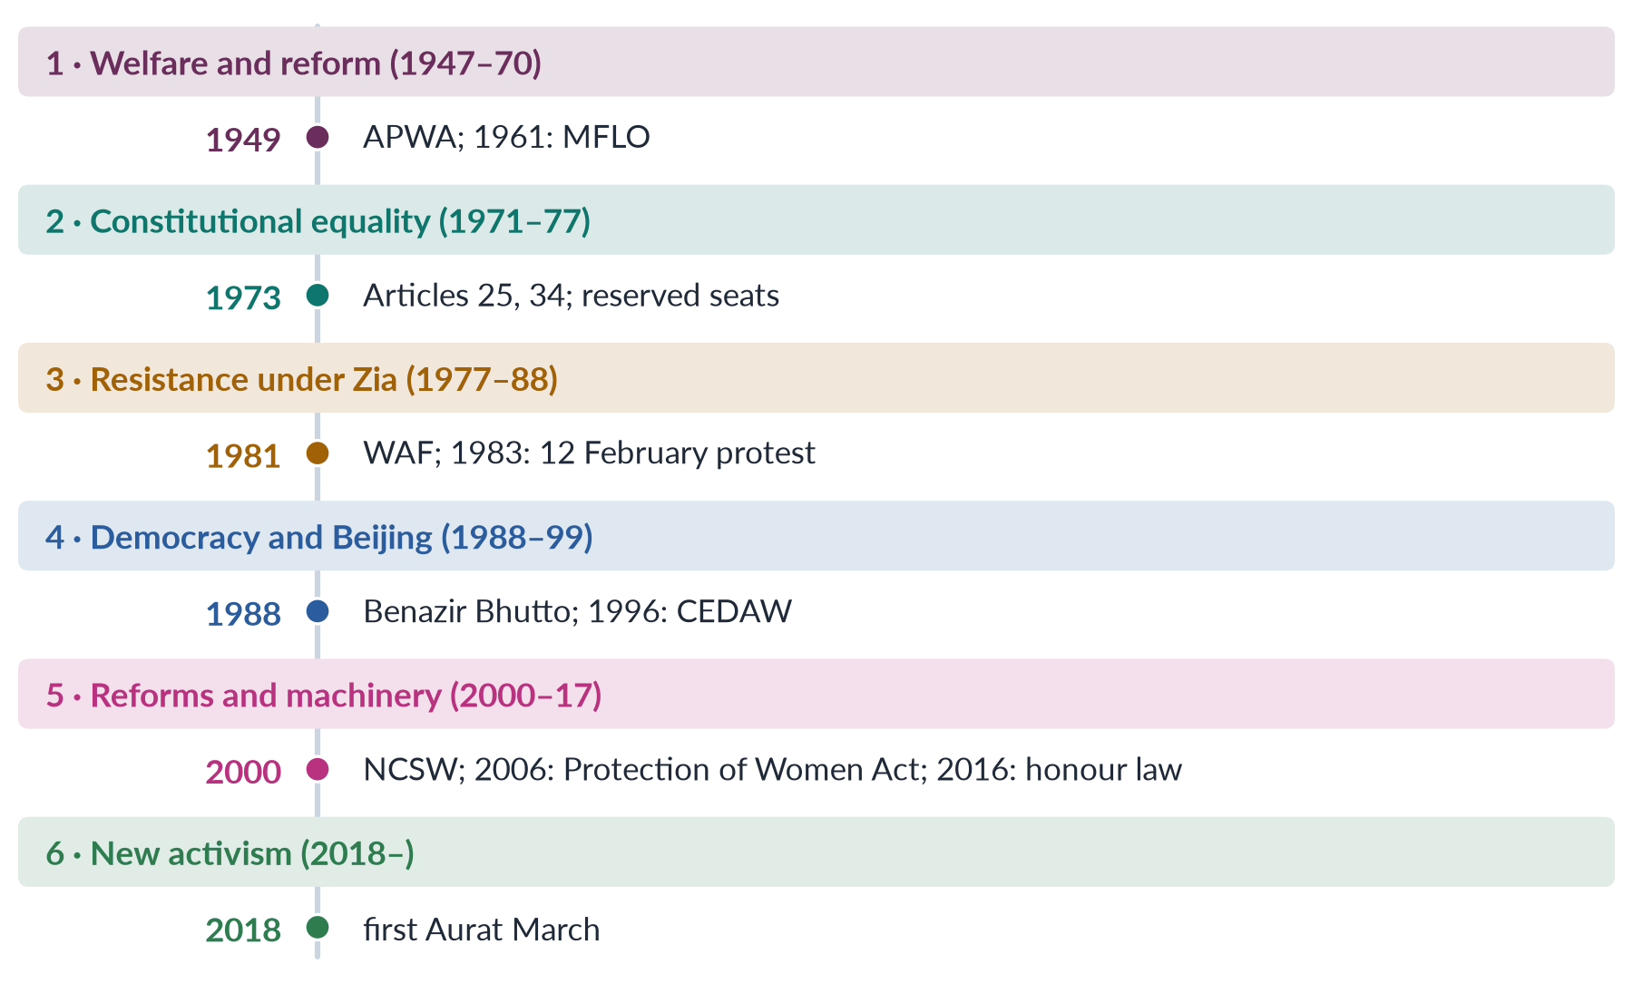
Figure 14 · Pakistan's women's movement in six phases.
Draw it in: the movement in Pakistan (2016, 2022, 2024, 2026) and APWA and WAF (2018).
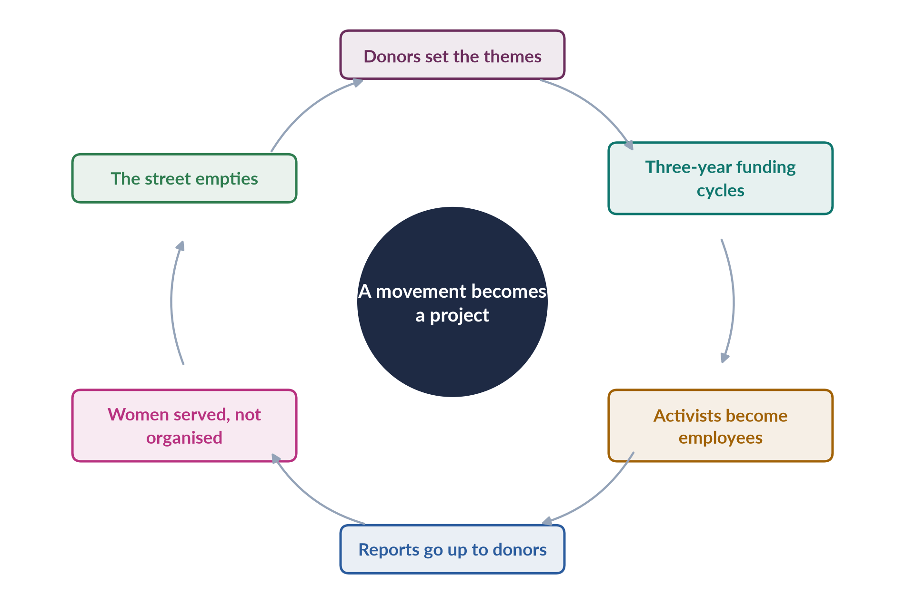
Figure 15 · The NGO-isation cycle, as critics describe it.
Draw it in: NGO-isation (2026). Then balance it: NGOs also drafted and defended the laws of 2010–2016.

Every past question as an answer plan
Use these plans in the last fortnight: read the question, say the plan aloud from memory, then check. Each plan is the skeleton of the full model answer in T3QA.
2016 Q5 — Women's movement in Pakistan; strengths and weaknesses. Define; Mumtaz and Shaheed (1987); the movement as a network (APWA, WAF, Sindhiani Tehreek, LHWs, religious women, lawyers, legislators, digital activists). Roots (Mumtaz Ali 1898; League women 1938; Quaid 1944). Phases: welfare (APWA 1949; Bogra 1955 → MFLO 1961); resistance (Hudood 1979; WAF 1981; 12 Feb 1983); reform (Benazir 1988; Beijing 1995; CEDAW 1996; NCSW 2000; 60 seats 2002; 2006, 2010, 2011, 2016 laws); new activism (Aurat March 2018; online outrage after Qandeel 2016 and motorway 2020; 2021 and 2025 laws). Timeline figure. Strengths (Islamic and constitutional legitimacy; Asma Jahangir and Hina Jilani, AGHS; resilience; caucus 2008; adaptability; research base). Weaknesses (elite base; enforcement; dependence and NGO-isation; backlash; divisions). Compare figure. Scorecard (143/145; 24.4%; 11 women). Way forward. Two steps forward.
2018 Q8(b) — Short note: APWA and WAF. (~540 words.) APWA: 1949; Begum Ra'ana Liaquat Ali Khan founder and first president; from Partition relief; welfare — schools, colleges, clinics, crafts; UN consultative status; protests over Bogra's marriage → Rashid Commission → MFLO 1961. WAF: Karachi 1981; Fehmida–Allah Bux; non-hierarchical, non-party, secular, unfunded; Hudood, Law of Evidence; 12 Feb 1983; Safia Bibi. Comparison table (era, aim, method, politics, achievement, criticism). Legacy: institutions vs rights movement; shared urban base; two stages of one movement; Aurat March inherits both.
2019 Q3 / 2023 Q5 — Three waves in the West; influence on Pakistan. Lear 1968. First wave: coverture; Stanton and Mott, London 1840 → Seneca Falls 1848; NUWSS 1897 / WSPU 1903; NZ 1893, UK 1918/28, US 1920; limits. In Pakistan: vote with independence; APWA; 1948 inheritance Act; MFLO 1961. Second wave: Friedan 1963, NOW 1966, personal is political, Equal Pay Act, Title VII, Roe 1973, shelters 1971; hooks' critique. In Pakistan: WAF vs Hudood (1979/1981); 12 Feb 1983; adaptation (Constitution, Islam; scholars invited); legacy 2006, 2010, 2016. Third wave: Anita Hill 1991; Walker 1992; intersectionality, Butler, Mohanty; Beijing. In Pakistan: Beijing (Benazir), CEDAW 1996, NGOs, diversity, khawaja siras, Islamic feminism. Mapping figure. Fourth wave: #MeToo; Aurat March. Influence vs roots (tools and platforms vs local roots; Women's Division 1979, NCSW 2000). Waves overlap. 2023 refresh: add 2021/2025 laws, fourth wave, newest data, sharper verdict.
2022 Q4 — First wave and third wave. Equal treatment under the same sub-headings. First: context (coverture; closed universities; custody); Seneca Falls and the Declaration; NWSA 1869; 19th Amendment; suffragists vs suffragettes; goals, methods, liberal theory (Mill 1869); achievements (NZ 1893, Finland 1906, UK, US; property Acts); limits (race, class; family untouched). Third: context (second-wave gains; Anita Hill; postfeminism); Walker 1992; Crenshaw, hooks, Butler, Mohanty; Riot Grrrl, Wolf, Ensler; goals and methods; VAWA 1994; limits (choice feminism, girl power). Compare figure; shared core. Pakistan: vote 1947, APWA, 1948; Beijing, CEDAW, Islamic feminism. Citizenship vs plurality.
2022 Q6 — Feminist movements in Pakistan in detail. Plural "movements". Roots. Welfare 1947–70 (APWA; 1948 inheritance; Bogra → MFLO 1961). 1973 Constitution (Arts 25, 27, 34; Ra'ana Governor 1973; promises from above). Zia (Hudood 1979; Qanun-e-Shahadat 1984; WAF 1981; 12 Feb 1983; Safia Bibi). 1988–99 (Benazir; First Women Bank; police stations; LHWs 1994; Beijing; CEDAW; NGOs; HRCP 1987; Samia Sarwar 1999; Hudood not repealed). 2000–17 (NCSW; 33% local; 60 seats; caucus 2008; 2006 Act; 2010, 2011, 2016; Qandeel; state feminism). Pyramid figure. 2018– (Aurat March; motorway 2020 → 2021 Act; ICT 2025). Other movements (Sindhiani Tehreek; LHWs SC 2012; Sindh HBW Act 2018; JI women, Al-Huda 1994; WDF 2018; Kishwar Naheed, Fahmida Riaz, Tehrik-e-Niswan 1979; Asma Jahangir, Hina Jilani). Evaluation; scorecard. Many movements, one struggle.
2024 Q4 — Impact of Western movements; past vs emerging trends and effects. Channels (education, UN, donors, media, diaspora). Wave-by-wave impact with adaptation: first (APWA, vote 1947, MFLO in Islamic terms, 1973 Constitution); second (WAF; personal is political; 2006 Act; methods — resource centres, legal aid, Safia Bibi); third (Beijing, CEDAW, NGOs, Islamic feminism, mainstreaming → NPA 1998, NCSW 2000, seats 2002); fourth (#MeToo, Aurat March, DRF, PECA 2016). Limits (local roots; waves together; hostile state; postcolonial critique; local issues). Past (elite; APWA, WAF, NGOs; welfare and law; courts; Constitution and Islam). Emerging (young; collectives, WDF; body, violence, care; marches and social media; consent; independent). Compare figure. Effects: visibility; inclusion; faster laws (2020 → 2021; Noor Mukadam); backlash; digital divide (25%). Past legitimacy + present energy.
2025 Q4 — Principles, goals and strategies of the waves; effects on women's lives. Four waves under three fixed sub-headings. First: rational citizens (Wollstonecraft, Mill); vote, property, education, custody; Seneca Falls, petitions, militancy, processions. Second: personal is political; pay, reproduction, violence, housework; NOW lobbying, consciousness-raising, shelters, Women's Studies, books and Ms. Third: diversity, intersectionality, construction, choice; inclusion, sexuality, harassment, human rights; culture, zines, Beijing networks, early internet. Fourth: consent, autonomy, accountability; end harassment; hashtags, testimony, Women's March 2017. Pyramid figure. Effects: political and legal (vote; a quarter of MPs; coverture ended; CEDAW); education, work, health (universities; pay laws; gaps; second shift; pill; Roe and Dobbs); safety and voice (violence criminalised; marital rape; #MeToo; diverse voices). Pakistan (1947; laws 1961–2025; Aurat March; waves overlap; 143/145; 24.4%). Unfinished (69.2%, 120 years; one in three; Afghanistan; Beijing+30 backlash). One long movement.
2026 Q3 — From WAF against Hudood to digital activism; legal rights to bodily autonomy. Define locus of resistance, legal rights, bodily autonomy. 1980s: Zina Ordinance; WAF 1981 (Fehmida–Allah Bux); 12 Feb 1983; methods (legal analysis, Safia Bibi, Asma Jahangir, Hina Jilani; Constitution and Islam; few public challenges under martial law). 1990s: Benazir; Beijing; CEDAW; NGOs; Samia Sarwar. 2000s–10s: state feminism; NCSW, seats, caucus; 2006 Act (WAF's central demand); 2010, 2011, 2016 — won on paper. 2020s: Aurat March; Mera Jism Meri Marzi; #MeToo 2018; Qandeel, motorway, Noor Mukadam → 2021 Act. Flow figure. What shifted (target, issues, language). Why (laws won, violence continued; new generation took gains for granted; fourth wave; body as site of control — izzat). What stayed (march demands laws — ICT 2025; WAF defended bodies). Costs (backlash; lost allies; digital divide 25%). From rights on paper to rights over one's own body.
2026 Q6 — NGO-isation; depoliticisation; the WAD critique. Define NGO-isation (Alvarez 1999; Jad 2004), depoliticisation (technocratic project vs social revolution), gender mainstreaming (Beijing 1995), WAD vs WID. How it happened (Shirkat Gah 1975; WAF 1981 unfunded; military rule; post-Beijing donors; service delivery; regulation from 2015). WAD applied (micro-credit and crafts leave land, feudal power, wages, unpaid care; the embroiderer example). Cycle figure. Evidence (donor agendas; projectisation; professionalisation and consultants; upward accountability; urban/class bias; "Western agenda"; competition; NGOs as employers). Mainstreaming as technocracy (NPA 1998; National Policy 2002; GRAPs; checklists fade with funding). Counter-case (NGOs drafted the 2006–2016 laws; kept space; trained councillors 2001; built data; services change power — personal is political; WAF unfunded; Aurat March self-funded; Sindhiani Tehreek). Compare figure. Verdict: partly true, but incomplete; division of labour; local funding; accountability to women.

Topic 4 · Gender and Development
AT A GLANCE · TOPIC 4 AT A GLANCE
Head V of the syllabus — the heaviest topic in the paper: 17.5 visits (sixteen full questions and three short notes, 2016–2026), asked every year, plus 17 of the 140 MCQs. Four families: WID/WAD/GAD (2016, 2017 note, 2018 note on needs, 2021, 2025); colonial and capitalist perspectives (2020, 2022, 2023, 2024); globalisation (2017, 2018, 2019, 2025); development theories (2019, 2019 note, 2021, 2024, 2025). The command word is almost always "critically". The newest questions join theory to the present: development as coloniality (2024), gendered globalisation (2025), climate and floods (2026). Never yet asked in full: world-system theory alone, gender mainstreaming, the SDGs, the care economy.

1. Development and why gender matters
- Development — improvement in people's lives: income, health, education, freedom, choice; not only GDP (value of goods and services produced; ignores unpaid work).
- History of the idea — Truman's "Point Four" (20 Jan 1949, "underdeveloped areas") → 1950s–60s growth and trickle-down → 1970s basic needs and the discovery of women (Boserup 1970) → 1980s structural adjustment → human development (Mahbub ul Haq, UNDP HDR 1990: "enlarging people's choices") → Sen, Development as Freedom (1999, capabilities = real freedoms) → MDGs 2000 → SDGs 2015 ("leave no one behind").
- Why gender matters — women are half the population; their unpaid work is uncounted (Waring, If Women Counted, 1988); policies are never gender-neutral; equality is a right (CEDAW, SDG 5) and also helps development (education, child health, household spending, growth); World Bank WDR 2012 "smart economics" (critics Chant and Sweetman 2012: women as instruments, not rights-holders).
- Measures — HDI (1990; not a gender index); GDI and GEM (UNDP 1995); GII (Gender Inequality Index, 2010); WEF Global Gender Gap Index (2006).
- Pakistan — GGGR 2026 143/145, 59.5%; economic 144th, education 130th, political 107th (2025: 148/148); LFPR 24.4% (LFS 2024–25); Ayub's "Decade of Development", Green Revolution; Haq's "22 families" (1968); first IMF SAP 1988; BISP 2008 (cash to women).
- Four questions of gender analysis — who works (paid/unpaid)? who owns and controls? who benefits? do gender relations become more equal?

2. Colonial perspectives of gender (2020, 2023, 2024)
- Meaning — how colonial rulers saw, judged and changed gender relations, and how the colonised responded: (1) the colonial gaze; (2) colonial policies; (3) the nationalist response.
- The gaze — James Mill, History of British India (1817): women's status = measure of civilisation, India judged low; Katherine Mayo, Mother India (1927): Indian men degenerate, women victims (Gandhi: "a drain inspector's report"); Spivak (1988): "White men are saving brown women from brown men"; Lata Mani: in the sati debate women were the "ground", not subjects; justified the "civilising mission".
- Laws — Bengal Sati Regulation 1829 (Roy); Hindu Widows' Remarriage Act 1856 (widows lost late husband's property); Indian Penal Code 1860 (adultery s. 497 punished only the man, wife as husband's property); Cantonment and Contagious Diseases Acts 1864–68 (forced examination of women); Female Infanticide Prevention Act 1870; Criminal Tribes Act 1871 (hijras); Punjab Laws Act 1872 (custom first → Muslim women lost Islamic inheritance); Age of Consent Act 1891 (10 → 12); Sarda Act 1929; Shariat Act 1937; Dissolution of Muslim Marriages Act 1939.
- Four channels — law (codified personal law with male scholars and landlords → rigid, patriarchal "tradition"; "Anglo-Muhammadan law"); land (settlements recorded land in male heads' names; women's use rights lost); economy (machine cloth destroyed women's spinning and weaving; cash crops, plantations, cantonments); education (some girls' schools; a small educated elite of women).
- Nationalist response — Partha Chatterjee (1989): outer material world (copy the West) vs inner spiritual world of home (keep "Indian"); women as guardians of the inner world; the "new woman" — educated but modest; Muslim reformers (Nazir Ahmad 1869; Mumtaz Ali 1898): education within Islamic family values → women as symbols of honour and identity.
- Assessment — gains (sati ban, remarriage, age of consent, girls' schools, 1939 divorce law) vs losses (patriarchal codification, lost inheritance and land, criminalised hijras, bodily control, women used to justify rule); reforms often from Indian reformers. Verdict: colonialism rearranged patriarchy.
- Legacy in Pakistan — PPC 1860; Sarda Act until Sindh 2013 / ICT 2025; low land ownership and customary denial of inheritance; stigma of khawaja siras; women as symbols of identity.

3. Capitalist perspectives and "development as coloniality" (2022, 2023, 2024)
- Capitalism — private ownership, markets, wage labour, profit. Two perspectives: liberal/market (jobs and income free women; remove barriers; smart economics) vs critical/socialist-feminist (capitalism depends on and deepens subordination).
- Critical ideas — Engels 1884 (private property → control of women's sexuality → "world historical defeat of the female sex"); industrial capitalism's public/private split, separate spheres, male breadwinner; unpaid labour/social reproduction (Benston 1969; Dalla Costa and James 1972); women as cheap, flexible labour / reserve army; Maria Mies (1986) — "housewifisation" (defining women as housewives to cheapen their work; lace makers of Narsapur); Federici, Caliban and the Witch (2004) — witch-hunts and early capitalism.
- Pakistan — home-based workers (Sindh HBW Act 2018); textiles and the Ali Enterprises fire (Karachi, 11 Sept 2012, ~260 dead); cotton pickers; unpaid care; LFPR 24.4%.
- Colonial + capitalist linked — colonialism was capitalist expansion (East India Company); both created the public/private split; both extracted value from women's cheap or unpaid work; both used "civilisation/progress" to justify power.
- Coloniality — Aníbal Quijano (2000): colonialism (formal rule, ended) vs coloniality (continuing patterns of power in race, economy, knowledge); María Lugones (2007): coloniality of gender — European binaries and male-headed households imposed.
- Post-development — Escobar, Encountering Development (1995); Sachs, The Development Dictionary (1992): development as a discourse that defines the South as "underdeveloped" and makes Western experts the authorities.
- Thesis applied to gender — the "Third World woman" as victim (Mohanty 1984); outside experts set agendas; debt and conditions (SAPs, IMF); extraction via supply chains; Western gender models imposed.
- Counter-argument — vaccines, schools, lower maternal and child deaths; Southern ownership (Haq; DAWN 1984); women themselves demand education and rights. Line: development must be decolonised, not abandoned — owned by local women, focused on power.

4. Modernisation theory (2019, 2021, 2024)
- Definition — poor countries are poor because "traditional"; they develop by following the West: industry, cities, education, democracy, modern values; obstacles are internal (culture, religion, family).
- Rostow, The Stages of Economic Growth: A Non-Communist Manifesto (1960) — traditional society → preconditions for take-off → take-off → drive to maturity → high mass consumption; aid and investment help "take-off"; a Cold War theory. Also Parsons (pattern variables), Lerner (Passing of Traditional Society, 1958), Inkeles and Smith (Becoming Modern, 1974).
- On women — tradition oppresses, modernity frees; benefits trickle down through the male breadwinner; women as mothers and homemakers (welfare, nutrition, family planning); Western nuclear family as model.
- 2021 statement — correct as description: modernisation located causes inside societies (culture, purdah, honour, parents' attitudes, traditional values); cure = education, media, urbanisation, Western values.
- Gender critique — Boserup (1970): modernisation gave land, technology, training and credit to men → women farmers marginalised; female (hoe) vs male (plough) farming systems; blames culture and ignores structures (colonial history, trade, land, state); West has its own patriarchy (new forms: housewife ideal, beauty industry, double burden); trickle-down failed within households; "tradition" often colonial or changing; ignores women's agency.
- Still relevant — education, cities, media and paid work do widen choices; some cultural practices are real obstacles (child marriage, honour killing, inheritance denial). Weakness: culture as the only cause, West as the only model.
- Pakistan — Ayub era (1958–69), Green Revolution (machines, credit to male landowners; poor women lost farm work), MFLO 1961 as a modernising reform; today girls' education and phones widen options but LFPR stays 24.4% → structures matter.

5. Dependency theory
- Definition — poverty is produced by colonialism and unequal exchange; the rich centre extracts from the periphery; underdevelopment is a result, not a stage.
- Thinkers — Prebisch (ECLA, 1950; Prebisch–Singer thesis: falling terms of trade for raw materials); Andre Gunder Frank ("development of underdevelopment", 1966); Walter Rodney (How Europe Underdeveloped Africa, 1972); Samir Amin (delinking); Cardoso and Faletto (1969, "dependent development").
- Policy — import-substituting industrialisation; protection; planning; South–South cooperation; New International Economic Order (UN, 1974).
- Offers gender analysis — structures not culture; colonial history; explains cheap (increasingly female) labour; links gender to class.
- Gender critique — gender-blind (nations and classes, not women and men); women's unpaid subsistence work subsidises cheap exports (Mies); ignores local patriarchy; male nationalist industrial models; "Asian tigers" grew by export-led growth relying on young women's labour.
- Feminist uses — "double dependency" (country on centre; women on men); Helen Safa on Latin American women workers.
- Pakistan — cotton and textiles; cotton pickers; IMF debt limits social spending; but feudal land, custom and mobility limits also matter.

6. World-system theory and "gendered globalisation" (2025)
- Wallerstein, The Modern World-System (1974; MCQ 2019) — one capitalist world-economy since the 1500s; core (rich, finance, technology), semi-periphery (both exploiter and exploited), periphery (raw materials, cheap labour); surplus flows via unequal exchange; differs from dependency by one system, the semi-periphery and long history.
- Gender extensions — Smith and Wallerstein (1992): households combine wages with unpaid work, so employers pay below a living wage — women's unpaid labour fills the gap; Mies (1986): exploitation of nature, colonies and women; global assembly line (Fuentes and Ehrenreich 1983); Kathryn Ward (1990).
- Gendered globalisation — globalisation relies on, reshapes and often deepens gender inequality, while creating some opportunities.
- New forms of patriarchal power — corporate/workplace patriarchy (low wages, surveillance, harassment); feminisation of labour (Standing 1989: flexible, informal, low-paid); global care chains (Hochschild 2000); debt and austerity; commodification of bodies (trafficking, surrogacy, beauty industry); cultural backlash.
- Evidence — harm: Rana Plaza (Bangladesh, 24 April 2013, 1,100+ dead, mostly women); Ali Enterprises (2012). Gains: first independent income for millions of women; later marriage; bargaining power (Kabeer, The Power to Choose, 2000).
- Evaluation — globalisation creates opportunities and new patriarchal controls; effect depends on labour rights, state policy, women's organising; theory risks portraying women as passive and underplays local patriarchy and agency.
- Pakistan — periphery/lower semi-periphery (textiles, cotton, rice; external finance); women at bottom of chains; male Gulf migration; remittances record 38+ billion dollars (2024–25); EU GSP+ (2014; 27 conventions incl. CEDAW).

7. Structural functionalism (2019 note)
- Definition — society as a system of interrelated parts (family, education, religion, economy, government), each with a function keeping the whole stable (equilibrium). MCQ 2019: related to stability.
- Thinkers — Durkheim (shared values, division of labour); Talcott Parsons; Robert Merton (manifest, latent functions; dysfunctions); George Murdock (1949: nuclear family universal; sexual, reproductive, economic, educational functions).
- Parsons and Bales (1955) — husband-father instrumental role (breadwinner, link to society, task-oriented); wife-mother expressive role (care, emotion, socialising children); family functions: primary socialisation and stabilising adult personalities; avoids competition between spouses.
- Link to development — pattern variables → modernisation; planners treated men as producers, women as homemakers (home-economics classes; extension services to men).
- Critique — justifies inequality ("functional for whom?"); ignores power and conflict (violence, control of money); based on 1950s white middle-class America; ignores women's economic work; cannot explain change; biological assumptions. Critics: Friedan (1963), Oakley (Sociology of Housework, 1974), Marxist feminists.
- Useful — roles tied to institutions; socialisation; dysfunction (rigid roles waste talent).
- Pakistan — man as provider (kafeel), woman as homemaker in textbooks, sermons, dramas; but rural women do heavy productive work; two incomes needed; migration leaves women heads of households.

8. The theories compared (2024)
- Critical gender analysis asks: cause of poverty; where women appear; assumptions (family, work); silences; policy effects.
- Table in words — modernisation: internal tradition; women freed by modernity; critique = blames culture, men captured benefits. Dependency: external exploitation; women absent; critique = gender-blind, ignores local patriarchy and unpaid work. World-system: one unequal world economy; later households and assembly line; critique = early gender blindness, women as victims. Functionalism: incomplete modernisation; women expressive; critique = justifies inequality, ignores power.
- Shared weaknesses — gender blindness; unpaid work invisible; household as harmonious unit (vs Sen's "cooperative conflict", 1990; Agarwal's bargaining, 1997); women passive; male-centred progress.
- Responses — WID (answer to modernisation); WAD (from dependency/Marxism); GAD (socialist feminism); later: capabilities (Nussbaum 2000), post-development and decolonial, feminist economics (Waring, Elson, Folbre), ecofeminism.
- Conclusion — each theory holds part of the truth (culture, institutions, global structures); gender analysis adds power relations, unpaid work and agency, joining local and global.

9. WID — Women in Development (1970s)
- Origins — before 1970, the welfare approach (women as mothers). Boserup 1970. Term coined by women development professionals in Washington, DC (MCQ 2018). Percy Amendment 1973 (US aid must integrate women); USAID WID Office 1974; IWY 1975 and the UN Decade; women's ministries (Pakistan's Women's Division 1979).
- Principles — women left out; problem = exclusion, not the model; solution = access (education, credit, training, technology, jobs); liberal feminism; separate women's projects (MCQ 2019: women have an important role in development = WID).
- Moser's approaches of the era — equity (original WID; seen as threatening), anti-poverty (income projects), efficiency (women make development efficient; relies on unpaid time).
- Practice — sewing, handicrafts, poultry, kitchen gardens; credit; literacy and skills; appropriate technology (stoves, mills, pumps); women's units — critics: a "women's ghetto".
- Achievements — women visible in data and planning; institutions (women's ministries, the UN Decade fund later UNIFEM, INSTRAW); resources; women as producers; paved the way for CEDAW (1979).
- Limitations — accepted the development model ("add women and stir"); took the sexual division of labour for granted (MCQ 2024) → added to women's workload; women alone, not gender relations or men's power; ignored class, race, global inequality; small marginal projects in "feminine" activities; Western bias; instrumentalism. Main criticism: failed to transform gender relations (MCQ 2026).
- Pakistan — Women's Division (1979), Ministry of Women Development, vocational centres, credit schemes, First Women Bank (1989): skills and some income, but small scale; little change in land, inheritance, wages or decisions.

10. WAD — Women and Development (late 1970s)
- Origins — Marxist and dependency critics of WID; IDS Sussex workshop "The Continuing Subordination of Women in the Development Process" (1978); Southern scholars.
- Principles — women always part of development, but on unequal, exploitative terms; the problem is the nature of development — unequal international and class system; women's paid and unpaid work undervalued; strategy: women's projects plus structural change.
- Examples — EPZ jobs = integration as exploitation; cash crops (who profits? world prices? food security?); aid projects that leave debt and trade untouched. "WID says let women in; WAD says women are already in — at the bottom."
- NIEO link (1974) — fairer world economy would help Southern women; shared North–South framing later criticised for hiding conflicts between Southern women and men.
- Contributions — "development for whom?"; links to class and global inequality; values women's knowledge; Southern voice; prepared GAD and DAWN.
- Limitations — class over gender; ignored patriarchy within classes; women as homogeneous; little on household and reproductive work; women-only projects again; weak policy influence.
- Today — the lens for judging micro-credit, handicraft projects, export jobs and donor NGO projects (2026 NGO-isation question).
- Pakistan — the Hyderabad embroiderer trained by a project still sells to a middleman at piece rates, owns no land, does all housework → position unchanged; Okara (2000–) and Sindhiani Tehreek (1982–) closer to WAD's idea of change.

11. GAD, needs, roles, empowerment, mainstreaming
- Origins — 1980s socialist feminists (IDS Subordination of Women group, Kate Young); DAWN (Bangalore 1984; Development, Crises and Alternative Visions by Gita Sen and Caren Grown, Nairobi 1985); Beijing (1995) adopted mainstreaming and empowerment.
- Principles — gender relations of power, not women alone; gender socially constructed; production and reproduction, inside the household; women as agents; transformation of structures; role of the state; intersection with class and race. MCQ 2025: GAD focuses on "all of these".
- Molyneux (1985, Nicaragua) — practical vs strategic gender interests; Moser (1989, 1993) — practical and strategic gender needs.
- PGNs — immediate material needs from current roles (water, health, food, housing, fuel, income, childcare); accept division of labour; short term; welfare/anti-poverty/efficiency. MCQ 2026: they address immediate necessities.
- SGIs/SGNs — long-term interests in changing women's position (land and inheritance, laws against violence, equal wages, political power, bodily control); challenge division of labour; equity/empowerment. Example: hand pump near home (PGN) vs women's land ownership under the 2020 property law (SGN). Meeting PGNs through women's organisations can open strategic change.
- Moser's triple role — productive, reproductive, community-managing (men: productive and community-politics, paid, status). Five approaches — welfare (1950s, mothers), equity (1970s WID), anti-poverty, efficiency (1980s), empowerment (bottom-up, from the South).
- Kabeer — Reversed Realities (1994; MCQ 2018); empowerment (1999) = "expansion in people's ability to make strategic life choices where this ability was previously denied"; resources, agency, achievements. MCQ 2023: beneficiaries → active participants = empowerment. Longwe: welfare, access, conscientisation, participation, control. Harvard Framework (1985): activities, access and control.
- Gender mainstreaming — ECOSOC (1997): assessing the implications for women and men of any planned action, in all areas and at all levels; first adopted globally in the Beijing Declaration (1995; MCQ 2024); benefits "all of these" (MCQ 2025); tools: sex-disaggregated data, gender analysis, gender budgeting, audits, focal points, quotas.
- Pakistan GAD tools — Gender Reform Action Plans (2000s); gender-responsive budgeting pilots; 10% quota in federal jobs; BISP cash to women; Women's Property Rights Act 2020; laws on violence and child marriage.
- GAD limitations — hard to implement (reduced to checklists and training); "gender" can hide women; "mainstreamed away"; depoliticisation (NGO-isation); resistance from men and elites; "Western concepts?" (reply: DAWN is Southern).
- Comparison — focus: women / women and class / gender relations. Problem: excluded / unequally integrated / unequal power. Theory: liberal & modernisation / Marxism & dependency / socialist feminism. Goal: integrate / change system / transform relations. Household: not examined / little / inside, bargaining. Needs: practical / practical / practical and strategic. Women: passive recipients / exploited workers / agents. Critique: status quo / ignores patriarchy / hard to implement. Names: Boserup, Percy / IDS 1978 / Molyneux, Moser, Kabeer, DAWN.

12. Structural adjustment (2022)
- Background — debt crisis (Mexico 1982); IMF/World Bank loans with conditions; "Washington Consensus" (Williamson 1989).
- Conditions — cut spending (health, education, subsidies, public jobs); remove subsidies (food, fuel, power); user fees; devaluation; privatisation; trade and financial liberalisation; labour deregulation.
- Gender-blind — ignored the household/care economy; costs shifted to women's unpaid work. Diane Elson, Male Bias in the Development Process (1991): SAPs treat women's labour as "infinitely elastic".
- Critique — more unpaid care (sick at home, stretching food); worse women's health (fees; maternal care); girls withdrawn from school; loss of public-sector jobs (teachers, nurses); push into informal work; export jobs low-paid and insecure; food price rises; stress and violence; men lose breadwinner role; no voice for women.
- Evidence and response — UNICEF, Adjustment with a Human Face (Cornia, Jolly, Stewart 1987); Commonwealth, Engendering Adjustment for the 1990s (1989); DAWN 1985; response: safety nets, PRSPs (1999), "gender-responsive" language — core conditions little changed.
- Pakistan — first IMF SAP 1988; SBA 2023; 7-billion-dollar EFF 2024; conditions: energy prices, sales tax, development cuts, subsidy removal → women's unpaid work and budgets squeezed; BISP expanded as safety net (partial answer). Line: stabilisation may be needed but must be gender-assessed — protect health, education, BISP; progressive taxes; count care.

13. Globalisation (2017, 2018, 2019)
- Definition — growing interdependence of societies worldwide (MCQ 2023); Giddens: "intensification of worldwide social relations which link distant localities". Dimensions: economic, political, technological, cultural, human (migration). Accelerated from the 1980s; end of Cold War 1991; WTO 1995; internet.
- Highlighting gender issues (2017) — global norms and conferences (Beijing, CEDAW, SDG 5); media and #MeToo; supply-chain disasters (Rana Plaza); migration makes care visible.
- Opportunities — export jobs, first independent income (Bangladesh garments; East Asian electronics; Indian call centres; Kabeer 2000); information and mobile banking; rights norms (CEDAW, SDGs, GSP+); microfinance (Grameen 1983) and remittances; wider images of women.
- Inequalities (2019) — feminisation of labour (Standing 1989); EPZs (no unions, long hours, harassment); informal home-based subcontracting; wage gaps; global care chains (Hochschild 2000; kafala abuse); trafficking; agricultural displacement; unsafe workplaces (Rana Plaza 2013; Ali Enterprises 2012); commodification (skin-lightening creams) and backlash; inequality between countries.
- Pakistan (2018) — textiles and garments (home-based stitchers on piece rates); Sialkot's Atlanta Agreement 1997 (stitching moved to centres; women homeworkers lost work); cotton pickers and world prices; male migration and remittances (38+ billion dollars, 2024–25; women run households); IMF programmes; GSP+ 2014 (27 conventions incl. CEDAW); digital freelancing but 25% mobile gap; media and backlash; LFPR 24.4%, economic rank 144th — fewer women drawn into export jobs than in Bangladesh (mobility, transport, safety, industry structure).
- Balance — both good and bad; outcome depends on labour rights, social protection, transport and childcare, women's organisation, fair trade.

14. Climate change (2026)
- Why gendered — dependence on water, fuel, fodder; less land, savings, insurance; restricted mobility and warnings; care burdens; pregnancy and heat risks; little voice.
- Ecofeminism — domination of women and nature linked; coined by d'Eaubonne (1974); Shiva, Staying Alive (1988, "maldevelopment"); Mies and Shiva, Ecofeminism (1993); Chipko (1973); Maathai, Green Belt (1977; Nobel 2004). Risk: essentialism.
- Feminist environmentalism — Bina Agarwal, "The Gender and Environment Debate" (1992): women's relation to nature is material — work, property, power; explains variation among women; points to land rights and resources.
- 2022 floods — ~33 million affected, 1,700+ dead, a third of the country under water; damage and losses ~30 billion dollars; ~650,000 pregnant women (UNFPA). Women's impacts: maternal care lost; camp privacy and safety (toilets, lighting, harassment); menstrual hygiene; lost livestock, gardens, home-based work; relief registered to male heads or needing CNICs; care for the sick; girls out of school; early marriage reports; mobility and warnings.
- Heat waves — Jacobabad among hottest cities; cooking over open fires, field work, pregnancy risks, longer water collection, dress and mobility limits, lost home-based income.
- Critical analysis — ecofeminism: common logic of domination, moral force; but essentialist and romanticising. Feminist environmentalism: explains which women suffer (no land, savings, CNIC, mobility, voice) and policy. Intersectionality: poor, rural, landless, minority, disabled women suffered most. Use both.
- Frameworks — Beijing area K; UNFCCC Lima Work Programme on Gender (2014), Gender Action Plan (2017); Sendai Framework (2015); Pakistan National Climate Change Policy (2012, updated 2021), Climate Change Gender Action Plan (2022), NDMA Gender and Child Cell, BISP flood cash; Pakistan emits < 1% of global emissions; loss and damage fund (COP27, 2022).
- Policy — sex-disaggregated data; women in disaster management; women-friendly relief (toilets, lighting, female staff, sanitary kits, maternal care); cash to women and CNIC help; land rights; early warnings reaching women (phones, LHWs); climate-resilient livelihoods; protect girls' schooling; prevent early marriage.

15. Global goals and debates
- MDGs (2000–15) — 8 goals; MDG 3 gender equality (target: education parity); MDG 5 maternal health. Gender critique: narrow; left out violence, unpaid care, property. MCQ 2025: "equal political participation of women" was not an MDG (seats were only an indicator). Pakistan missed most targets.
- SDGs (2015–30) — 17 goals, 169 targets, universal, "leave no one behind"; SDG 5: "Achieve gender equality and empower all women and girls" (MCQ 2026). Targets: 5.1 discrimination; 5.2 violence; 5.3 child/forced marriage, FGM; 5.4 unpaid care; 5.5 leadership; 5.6 reproductive health; 5.a economic resources, land; 5.b technology; 5.c laws and policies. Gender also in SDGs 1, 3, 4, 6, 8, 13, 16.
- Pakistan — NA adopted SDGs as national agenda (Feb 2016); Kathmandu 2017 South Asian meeting (MCQ 2018); slow SDG 5 progress (143/145; 24.4%; MMR 186, 2019; child marriage); positives: laws 2020–25, BISP, girls' enrolment, mobile use.
- Assessment — targets, data and attention vs voluntary, data gaps, financing, COVID-19 setbacks; goals help when domestic movements use them.
- Debates — smart economics (opens doors vs instrumentalism); care economy and the "3 Rs" (recognise, reduce, redistribute; SDG 5.4; day-care, leave, water, clean fuel); IMF austerity (gender-assess; protect BISP); microfinance (empowerment vs debt trap; context matters — Kabeer); platform work and AI (flexible income vs insecurity and automation); climate justice (will finance reach women?); development as coloniality (decolonise, don't abandon); raising women's LFPR (safe transport, childcare, harassment law, protected home-based and digital work).

The key diagrams
Four diagrams carry most of Topic 4. Learn to draw each one from memory in under two minutes. A diagram placed early in an answer shows the examiner the whole argument at a glance and earns credit in its own right.
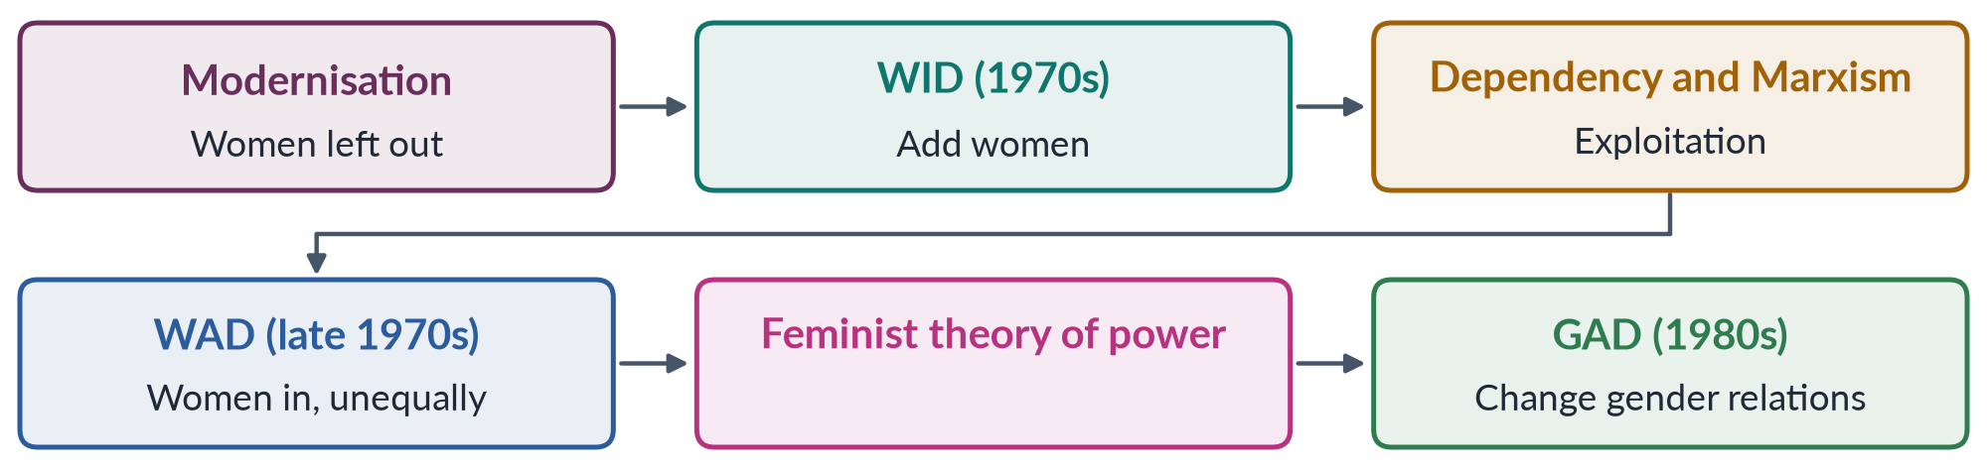
Figure 16 · From development theories to gender approaches.
Draw it in: WID, WAD and GAD (2016, 2021, 2025). It shows that each approach answered the failure of the one before.
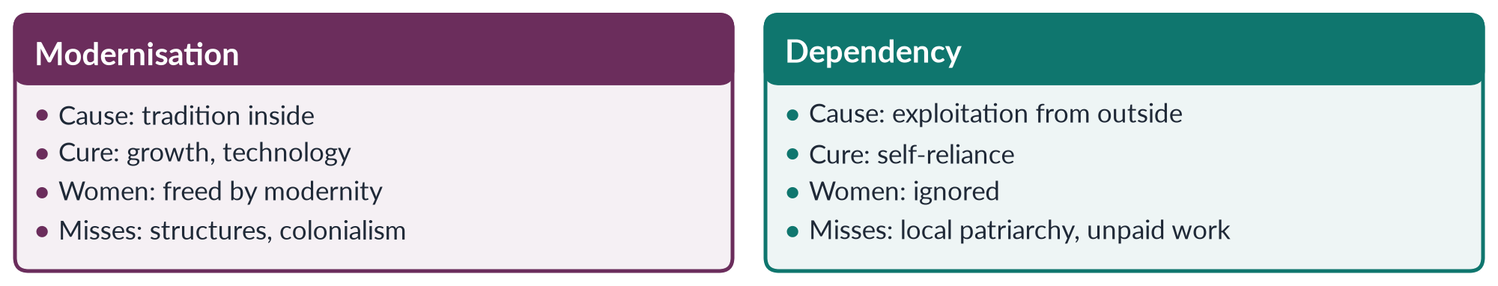
Figure 17 · Modernisation and dependency on women.
Draw it in: modernisation, dependency and subordination (2019), and the development-theory questions of 2021, 2024 and 2025.
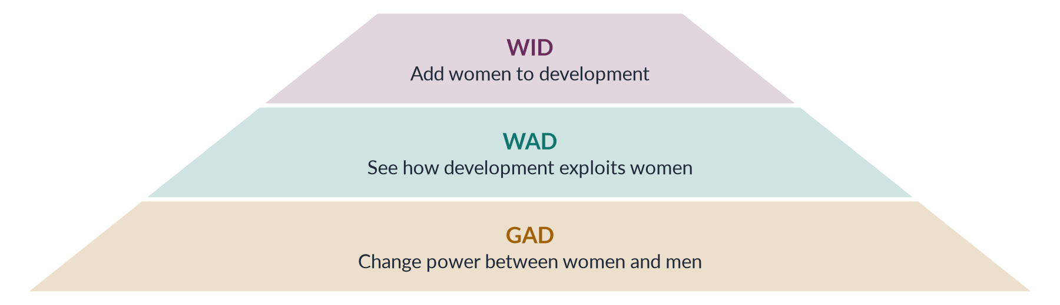
Figure 18 · From WID to GAD — how the approaches deepened.
Draw it in: every WID/WAD/GAD question, including the 2017 note. Read it bottom-up as "access → structure → power".
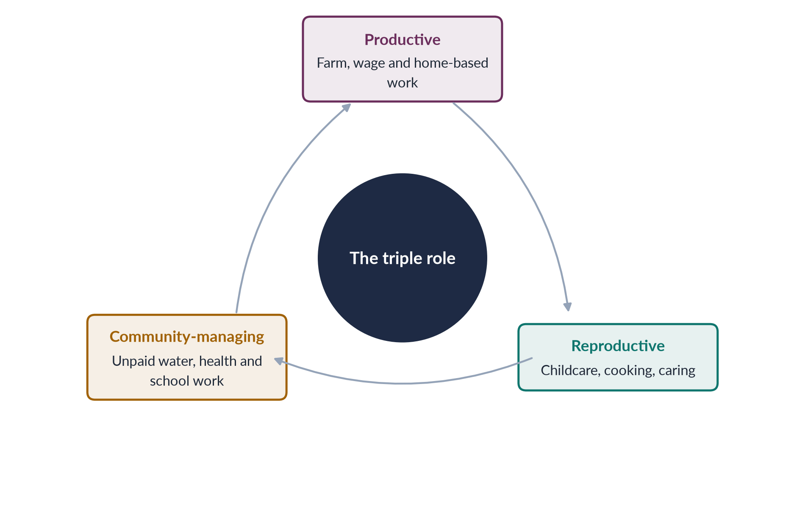
Figure 19 · Moser's triple role of women.
Draw it in: the note on practical and strategic needs (2018), and any GAD or globalisation answer that needs "women's work is undercounted".

Every past question as an answer plan
Use these plans in the last fortnight: read the question, say the plan aloud from memory, then check. Each plan is the skeleton of the full model answer in T4QA.
2016 Q8 — Critically review WID, WAD and GAD. Include → question → transform. Welfare before 1970; Boserup 1970. WID: Washington, Percy 1973, UN Decade; integration, access, liberal feminism; contributions (visibility, ministries, resources); limits (add women and stir; division of labour taken for granted; women alone; class blind; small projects; efficiency). WAD: Marxism, dependency, IDS 1978; always integrated, unequally; contributions ("for whom?", class, debt); limits (patriarchy within classes; household; women's projects). GAD: socialist feminism, DAWN 1984, Beijing 1995; gender relations, production and reproduction, agency, transformation; tools (PGN/SGN — Molyneux 1985, Moser 1993; triple role; Kabeer 1999); limits (checklists; hides women; mainstreamed away; resistance; "donor language"). Pyramid; table. Pakistan: Women's Division 1979, First Women Bank 1989 (WID); mainstreaming, BISP, 2020 property law (GAD); 143/145; 24.4%.
2017 Q6 — Globalisation has highlighted gender issues; examples from developing countries. Define (Giddens). Dimensions; WTO 1995. Visibility: norms (Beijing, CEDAW, SDGs), media (#MeToo), supply-chain scrutiny (Clean Clothes; Bangladesh Accord 2013), migration. Opportunities: Bangladesh garments (Kabeer 2000), Malaysia/Philippines electronics, Indian call centres, Kenyan mobile money. Harms: feminisation (Standing 1989), maquiladoras and EPZs, home-based subcontracting (India, Pakistan, Thailand), care chains (Philippines, Sri Lanka; kafala; Hochschild 2000), Rana Plaza 2013, Ali Enterprises 2012, trafficking (Nepal), factory harassment. Culture: GSP+, skin-lightening, backlash. Compare figure. Pakistan (textiles, HBW Act 2018, remittances 38bn+, GSP+ 2014, 24.4%, Sialkot and the Atlanta Agreement 1997). Policy decides.
2017 Q8(b) — Short note: gender and development. (~555 words.) Field vs GAD approach. Beyond WID and WAD (neither examined power or the household). Origins: Kate Young, IDS, DAWN 1984, Beijing 1995. Seven principles incl. active state. Tools flow figure (PGN/SGN, triple role, empowerment, mainstreaming). Strengths; limits (checklists, hides women, resistance). Pakistan (budgeting, 10% quota, BISP, 2020 law; 24.4%). Asks whether power changes.
2018 Q6 — Global political economy and Pakistani women. Define GPE (states, markets, IMF, WTO, UN, MNCs). Periphery/lower semi-periphery; 144th economic rank. Channels: textiles (garment jobs; home-based piece work; housewifisation; Sindh 2018); supply chains (Ali Enterprises; Atlanta 1997; GSP+ 2014); IMF (1988 onwards; 2024 EFF; prices, sales tax, cuts; Elson; BISP expanded); migration (38bn+; women heading households; women migrants and care chains); agriculture (cotton pickers; 2022 food prices and floods); digital (freelancing; 25% gap; platform insecurity); norms (Beijing, CEDAW, SDG 5 → NCSW, seats, laws; donor-driven); culture (beauty, backlash). Mapping figure. Policy. National policy decides.
2018 Q8(a) — Short note: strategic and practical gender needs. (~555 words.) Molyneux 1985 (Nicaragua; interests) → Moser 1989/1993 (needs; GAD). PGNs: immediate, material, from current roles; water, health, food, fuel, housing, childcare, income; short term; do not challenge; MCQ 2026. SGNs: from analysis of subordination; land, inheritance, laws against violence, equal wages, marriage choice, body, representation; long term; resisted. Table (nature, roles, examples, who defines, Moser's approaches, Pakistan). Simple box (well vs control of the well). Link: meeting PGNs via women's organisations opens SGNs; water project with women's committee. Pakistan: LHWs (1994; SC 2012), BISP, 2020 property law, ICT 2025.
2019 Q4 — Modernisation and dependency; subordination in modern societies. Two rival theories. Modernisation (Rostow 1960; five stages; tradition vs Western values; trickle-down); relevance (education, cities, media; real cultural obstacles); critique (Boserup; culture blamed; West not equal). Dependency (Prebisch, Frank 1966, Rodney; centre/periphery; produced underdevelopment); relevance (cheap female labour; debt and services; structures); critique (gender-blind; male industrial hero; local patriarchy; unpaid work — Mies). Compare figure. Modern societies: double burden, glass ceiling, pay gap, beauty industry (structures not only attitudes); global chains, Rana Plaza, austerity. What both miss: household bargaining (Sen 1990; Agarwal), unpaid care, agency. Pakistan: enrolment and fertility vs textiles and IMF; 24.4%; 143/145. Join cultural and structural.
2019 Q5 — Gendered inequalities created by globalisation. Accept premise; define; global village (WTO 1995, chains, phones). Inequalities: between nations (Wallerstein; brands shift orders; 69.2%, 120 years); feminised flexible informal labour (Standing; EPZs; housewifisation — Mies); wage and occupational gaps (part-time, home-based); care chains (Hochschild; kafala; grandmothers left caring); unsafe work (Rana Plaza, Ali Enterprises; harassment); austerity (Elson; girls withdrawn); trafficking, commodification (surrogacy, sex industry, skin-lightening); digital divide (25%) and backlash. Cycle figure. Counter-evidence (Kabeer 2000; Bangladesh Accord 2013). Pakistan (home-based, migration, IMF, 24.4%, Sindh 2018). Gendered terms; policy.
2019 Q8(c) — Short note: structural functionalism. (~550 words.) System of parts; stability (MCQ); living body; equilibrium. Durkheim; Parsons (pattern variables); Merton; Murdock 1949 (four functions). Parsons and Bales 1955 — instrumental/expressive (compare figure); functions: socialisation and stabilisation. Link to development (extension to men; cooking classes to women). Critique: justifies inequality; power and conflict; 1950s white middle-class (working-class and Black women always worked); hides women's work; cannot explain change (married women's paid work). Friedan 1963; Oakley 1974. Pakistan: provider–homemaker ideal vs rural work, two incomes, migration. Useful: institutions, socialisation, dysfunction.
2020 Q3 — How the colonial era influenced women's status in the subcontinent. Rearranged patriarchy. Gaze (Mill 1817; Mayo 1927; Gandhi; Spivak; Mani). Reform laws table (1829, 1856, 1870, 1891, 1929, 1939; from Indian reformers; weak enforcement). Codified personal law (Anglo-Muhammadan law; Punjab Laws Act 1872 → lost inheritance). Land settlements in men's names. Economy (machine cloth; cash crops; unpaid work invisible). Bodies (Contagious Diseases Acts; Criminal Tribes Act 1871; IPC 1860 s. 497). Education (Aligarh 1906; elite). Mapping figure. Nationalist response (Chatterjee 1989; Nazir Ahmad; Mumtaz Ali; symbols). Assessment (gains vs losses; officials reluctant to interfere). Legacy (PPC; Sarda Act until Sindh 2013/ICT 2025; land and inheritance; khawaja siras; symbols).
2021 Q6 — Modernisation blames internal cultural factors. Accurate but incomplete. Theory (Rostow 1960, Cold War; Parsons, Lerner 1958, Inkeles and Smith 1974). Tradition vs modernity. Elaborate: seclusion and honour; early marriage and fertility; son preference; religion (texts vs customs); rural "backwardness". Flow figure. Cure: education, media, cities, family planning, technology; women as mothers; trickle-down. Where it holds (child marriage, honour killing, inheritance; education works). Critiques: Boserup (male/female farming systems); structures ignored (dependency, world-system); West as false model (Friedan; reform looks foreign); "tradition" colonial and changing (Punjab 1872). Compare figure. Pakistan (Ayub, Green Revolution, MFLO 1961; today 24.4% and structural barriers). Culture one cause among many; change laws, property, markets too.
2021 Q7 — Approaches to women's development: WID, WAD, GAD. Near repeat — re-cut around "approaches". Welfare (Moser; mothers; invisible producers). WID (Boserup, Washington, Percy); three variants (equity, anti-poverty, efficiency); strengths; weaknesses (efficiency used unpaid time in adjustment). WAD (Marxism, dependency, IDS 1978; Southern voice); strengths; weaknesses (NIEO hard to adopt). GAD (Kate Young, DAWN 1984, Beijing); principles; tools; strengths (collective organisation); weaknesses. Spectrum figure (welfare → GAD empowerment). Practical–strategic test. Pakistan (welfare, WID institutions; GAD tools; 24.4%; 143/145). From welfare to empowerment; implementation and political will.
2022 Q7 — Capitalistic perspectives of gender. Define capitalism. Liberal market view (skills not sex; barriers; Kabeer 2000; smart economics WDR 2012 vs Chant and Sweetman 2012). Critical view: Engels 1884; separate spheres and breadwinner (Hartmann 1979 family wage); unpaid labour/social reproduction (Benston 1969; Dalla Costa and James 1972; Federici 1975; Waring 1988); reserve army (wartime) and feminisation (Standing 1989); housewifisation (Mies 1986, Narsapur); Federici 2004 witch-hunts. Compare figure. Global capitalism (EPZs, chains, care chains; Rana Plaza; Ali Enterprises). Pakistan (home-based; Sindh 2018; cotton; unpaid care; 24.4% — mobility, transport, harassment, childcare). Access to paid work plus the 3 Rs of care, with labour rights.
2022 Q8 — Gender critique of SAPs. Define SAPs; Mexico 1982; Williamson 1989 (goals set in Washington). Conditions table. Gender-blind: invisible care economy; Elson 1991 "infinitely elastic". Unpaid work rises (sick at home; stretching food; time-use surveys). Health (fees; maternal care; women delay own treatment) and girls' schooling. Jobs (public cuts; informal work invisible). Export jobs (cheap labour for foreign exchange; insecurity). Flow figure. Food prices, stress, violence; breadwinner loss. No voice (budgets judged by deficits). Evidence (UNICEF 1987; Commonwealth 1989; DAWN 1985); response (safety nets; PRSPs 1999; recipients not citizens). Pakistan (1988; SBA 2023; EFF 2024; prices, sales tax, cuts; BISP expanded). Gender-assessed stabilisation; human face.
2023 Q6 — Detailed note on colonial and capitalistic perspectives. Both reshaped by power and profit. Colonial: gaze (Mill, Mayo, Spivak, Mani), policies (reform laws; codified law, Punjab 1872; land and machine cloth; Contagious Diseases Acts, Criminal Tribes Act), nationalist response (Chatterjee; Nazir Ahmad, Mumtaz Ali; reform as protecting "our" women). Capitalist: market view (smart economics; critics) and critical view (Engels; separate spheres; social reproduction; reserve army and feminisation). Housewifisation (Mies — joins both). Venn figure. Four links (colonialism as capitalist expansion; public/private split; extraction of women's work; civilisation → development). Pakistan (PPC 1860; inheritance and land; home-based work, Sindh 2018; Ali Enterprises; 24.4% in agriculture and informal work).
2024 Q3 — Colonial and capitalistic perspectives; development as the new coloniality. Coloniality (Quijano 2000). Compact note on both perspectives; Mies's link. Lugones 2007 (coloniality of gender). Development as discourse (Truman 1949; Escobar 1995; Sachs 1992). Thesis applied: "Third World woman" (Mohanty 1984; Abu-Lughod 2002); experts, donors, beneficiaries, debt (Elson); supply-chain extraction (Rana Plaza, Ali Enterprises); imposed gender models and indicators. Mapping figure. Counter-argument (real gains; Haq 1990; DAWN 1984; women's own demands; anti-colonial language used against women's rights). Pakistan (IMF 2024, donor projects, textile chains vs MFLO 1961, 2006, 2016, 2025 won by Pakistani women). Decolonise, don't abandon.
2024 Q5 — Critical gender analysis of development theories. Method: cause, women, assumptions, silences, policies. Modernisation (Rostow; mothers; trickle-down; Boserup; West as model). Dependency (Prebisch, Frank, Rodney; structures, debt; gender-blind; local patriarchy; Mies). World-system (Wallerstein; Smith and Wallerstein 1992; assembly line 1983; women central to capitalism but portrayed as victims; Kabeer 2000). Functionalism (Parsons and Bales 1955; justifies inequality; extension services; socialisation useful). Table. Shared blind spots (gender blindness; Waring 1988; Sen 1990 and Agarwal; passive women; male-centred progress). Responses: WID, WAD, GAD (Kabeer 1999). Later: Sen and Nussbaum 2000; Escobar, Mohanty; feminist economics; ecofeminism (Agarwal 1992). Pakistan: the cotton picker through each lens (24.4%). Gender analysis completes the theories.
2025 Q3 — Gendered globalisation, world-system theory, new patriarchal power. Define (uses, reshapes, creates; Acker, Sassen). Wallerstein 1974 (core, semi-periphery, periphery; unequal exchange). Blind spot → extensions (Smith and Wallerstein 1992; Mies 1986; Fuentes and Ehrenreich 1983; Ward 1990). Pyramid. New patriarchal power: workplace (targets, surveillance, harassment; young women preferred as less likely to organise); feminised informal labour (Standing; home as workplace); care chains (Hochschild; kafala); debt and austerity (Elson); commodified bodies and backlash. Evidence of inequality (Rana Plaza; Ali Enterprises; 69.2%, 120 years). Counter-evidence (Kabeer 2000; CEDAW, SDG 5; Bangladesh Accord 2013; agency). Compare figure. Pakistan (periphery; home-based; Sindh 2018; remittances; GSP+ 2014; 24.4%). Largely true but incomplete.
2025 Q7 — WID and GAD: principles and limitations. Include vs transform. WID origins (Boserup; Washington; Percy 1973; Decade); principles (five); limitations (division of labour; practical not strategic; women alone; small projects in crowded "feminine" markets; class blind); strengths. GAD origins (Kate Young, IDS; DAWN 1984; Beijing 1995); principles (six); tools (Molyneux 1985, Moser 1993; triple role; Kabeer 1999; mainstreaming). Compare figure. GAD limitations (checklists; hides women; mainstreamed away; depoliticisation; resistance; urgent needs neglected; "donor language"). Compared (share vs power; many "GAD" programmes still WID in practice). Pakistan (WID institutions; GAD tools; 24.4%). Lessons (practical needs through women's organisations → strategic; LHWs). GAD analysis with WID delivery.
2026 Q5 — Climate change: floods and heat waves in Pakistan; ecofeminism and feminist environmentalism. Why gendered (dependence on water, fuel, fodder, livestock; little land and savings; mobility; care; voice). Ecofeminism (d'Eaubonne 1974; Shiva 1988; Chipko 1973). Feminist environmentalism (Agarwal 1992: material). Compare figure. Floods 2022 (33m; 1,700+ dead; a third under water; ~30bn dollars; 650,000 pregnant women). Impacts: maternal health; camp safety and privacy; menstrual hygiene; lost livestock and home-based work; relief to male heads and CNIC barriers; disease and care; girls out of school; early marriage reports. Heat (Jacobabad; kitchens; fields; pregnancy; water; dress and mobility; home-based income). Critical analysis (ecofeminism: extractive development and climate justice — Pakistan < 1% of emissions; essentialist; feminist environmentalism explains which women; intersectionality). Cycle figure. Frameworks (area K; Lima 2014; GAP 2017; NCCP 2021; ccGAP 2022; NDMA Gender and Child Cell; loss and damage COP27 2022). Policy list. Women at the centre of climate policy.

Topic 5 · Status of Women in Pakistan
AT A GLANCE · TOPIC 5 AT A GLANCE
Head VI of the syllabus: 8.5 visits (eight full questions and one short note, 2017–2026), plus 19 of the 140 MCQs — mostly laws and dates. Four families: health (2017, 2023, 2024 — Fathalla's road); the gender-gap ranking (2018 "second-worst", 2026 the 2025 report); employment and the double burden (2019); law and human rights (2020). The 2026 paper added intersectionality and the digital gender gap. Every answer lives on current, dated data. Never yet asked in full: women's education, family law and the MFLO 1961, women in politics, climate impacts.

1. What "status" means and the framework
- Status of women — women's position in society: rights, resources, respect and power compared with men's. Four syllabus dimensions: health, education, employment, law; plus politics, intersectionality, digital access, climate.
- Constitution 1973 — Art. 25 (equality; no discrimination on the basis of sex; special provision for women allowed); 25A (free, compulsory education 5–16, 18th Amendment 2010); 26–27 (no sex discrimination in public places or service); 32 (women in local government); 34 (full participation of women); 35 (protect marriage, family, mother, child); 37(e) (maternity benefits); 51, 59, 106 (reserved seats — 60 in the NA). Fundamental rights (Arts 8–28) are enforceable in court; Principles of Policy (29–40) are goals.
- Headline figures — MMR 186 (2019); female literacy ~53% (men ~68%; Census 2023); female LFPR 24.4% (2024–25); GGGR 2026 143/145.
- The four test questions — Is she healthy? Is she educated? Can she earn? Does the law protect her — in practice, not only on paper?
- Answer formula for every status question — (1) latest data; (2) causes; (3) laws and programmes; (4) way forward — a status answer without causes and solutions is half an answer.
- This topic feeds every other — figures, laws and institutions for Topic 4 (development), Topic 6 (governance) and Topic 7 (violence) come from here.

2. Measuring status — the Global Gender Gap (2018, 2026)
- Global Gender Gap Index — World Economic Forum, since 2006; how much of the gap between women and men is closed (0–100%) in four sub-indices: economic participation and opportunity (labour force, wages, income, senior roles), educational attainment (literacy, enrolment), health and survival (sex ratio at birth, healthy life expectancy), political empowerment (parliament, ministers, heads of state). Measures gaps, not well-being.
- Other measures — UNDP GII (2010), GDI (1995); World Bank Women, Business and the Law; SDG 5 indicators.
- Pakistan's record — 2006 112/115; 2017 143/144 ("second-worst" — 2018 question); 2021 153/156; 2023 142/146 (MCQ 2024); 2025 148/148, 56.7%, zero women ministers; 2026 143/145, 59.5% (strongest gain in a decade), sub-ranks economic 144th, education 130th, political 107th; lowest in South Asia and of 38 lower-middle-income economies. Global gap 69.2%, parity 120 years, Iceland first. Distinguish rank from score.
- Why so low (four sub-indices) — economic: LFPR 24.4% vs roughly 80% for men; one of the widest pay gaps (ILO); few women managers; informal/unpaid work. Education: literacy 53/68; 25m+ out of school, mostly girls; rural, Balochistan and KP gaps. Health: sex ratio, MMR 186, anaemia. Politics: 60 reserved seats but only 11 women won general seats (2024); no women ministers (2025).
- Why commitments (Constitution, CEDAW 1996, Beijing 1995, SDGs 2015) have not closed the gap — enforcement gap; patriarchal norms (purdah, honour, son preference, early marriage); poverty and low spending (health ~1%, education ~2% of GDP); unsafe transport and harassment; unpaid care, no childcare; weak political will and voice; crises (militancy, 2022 floods, economic crises); uneven provincial capacity after the 18th Amendment (2010).
- South Asia — Bangladesh (garment jobs, women leaders), Sri Lanka (literacy, maternal health), Nepal (2015 quotas) show policy, not religion or region, decides.
- Moving up — women's paid work (transport, childcare, harassment law, protected home/digital work); pay gap; senior posts; girls' secondary schooling; maternal health; appoint women ministers.
- Critique of the index — consistent and comparable vs measures gaps not well-being, misses violence, unpaid care and informal work, data dated, rank swings. Signal, not whole story.
- Rank vs score in one example — 2006 112/115 → 2025 148/148: the score rose slowly (girls' enrolment; 60 reserved seats from 2002), but others improved faster and more countries were added, so the rank fell.
- Report-card image — four subjects; Pakistan fails worst in economic participation; improving it lifts the overall grade most.
- Answer frame (2026 Q4) — index and sub-indices → 2025 result (148/148, 56.7%) and 2026 (143/145, 59.5%) → economic, education, health, political evaluation → socio-economic factors → political factors → critique → way forward.

3. Women's health (2017, 2023)
- Definition — WHO (1946): complete physical, mental and social well-being. Life cycle: before birth/infancy (son preference) → childhood (malnutrition) → adolescence (early marriage, anaemia) → reproductive years → older age (NCDs, cancers).
- Indicators — MMR 186 (PMMS 2019); anaemia ~42% of women 15–49 (NNS 2018); stunting ~40% of under-fives (NNS 2018); TFR ~3.6; contraceptive use ~34%; skilled birth attendance ~two-thirds (PDHS 2017–18); health spending ~1% of GDP.
- Problems — maternal death; malnutrition and anaemia (women eat last; intergenerational cycle); high fertility; early marriage; RTIs and fistula; breast cancer (MCQ 2019: ~13,000 deaths a year; late diagnosis; October awareness month) and cervical cancer (HPV vaccine introduced 2025); NCDs; mental health (depression and anxiety from violence, isolation, forced marriage; few psychiatrists; stigma); violence; disasters (650,000 pregnant women in 2022 flood areas).
- Causes — social/cultural (son preference, early marriage, restricted mobility, low decision power, preference for female doctors); economic (poverty, food insecurity, costs — mostly out-of-pocket); health system (low spending, few female staff, rural gaps, women graduates not practising); education (low literacy, taboos).
- Programmes — LHW Programme 1994 (Benazir; ~1,000 people per LHW; family planning, antenatal care, immunisation; SC regularisation 2012; jobs for rural women); community midwives; Sehat Sahulat health card (2015–16; hospital care, not primary care); BISP and Benazir Nashonuma; Arts 35 and 37(e); health provincial after 2010.
- Improve within available resources (2017) — primary care first; LHWs and midwives; family planning; iron, folic acid, fortification; skilled birth attendance and referral; female workforce and telemedicine; cancer screening awareness; engage men and mothers-in-law; enforce child-marriage laws; target with BISP data; mental health in primary care.
- Status "as a whole" (2023) — link health to education, work, law and political voice.
- LHW Programme in detail — launched 1994; women recruited from their own communities, each serving about 1,000 people; family planning, antenatal advice, immunisation, referral; evaluations linked it to higher contraceptive use and immunisation; problems: coverage gaps, delayed pay (regularised by the Supreme Court, 2012).
- Health and status (2023) — treating health without status is like treating fever without the infection: education, income, property and voice make women seek care earlier, space pregnancies and feed children better.
- Examples to cite — Punjab girls' stipend (2004); Sindh Home-Based Workers Act (2018); Maternity and Paternity Leave Act (2020); Property Rights Act (2020); BISP (2008); Women's Parliamentary Caucus (2008).

4. Maternal health and Fathalla (2024)
- Mahmoud Fathalla — Egyptian obstetrician (later FIGO president); Safe Motherhood Conference, Nairobi 1987 (launched the Safe Motherhood Initiative); "Why did Mrs X die?"; maternal death = end of a long road built by society; most deaths preventable; "women are not dying because of diseases we cannot treat… but because societies have yet to decide their lives are worth saving".
- The road — born female and poor → undernourished and anaemic → little schooling → married young → no family planning, many close pregnancies → no antenatal care → complication (haemorrhage, eclampsia, obstructed labour, infection, unsafe abortion) → delays → death.
- Three delays (Thaddeus and Maine 1994) — deciding (danger not recognised; permission; cost), reaching (distance, roads, transport, floods), receiving care (no staff, blood, drugs, theatre).
- Data — MMR 186 (worse in rural areas, Balochistan); skilled attendance ~two-thirds; anaemia ~42%; TFR 3.6; contraception 34%, unmet need ~1 in 6; SDG 3.1 MMR < 70 by 2030.
- Social context — son preference; literacy 53%; poverty; low decision power.
- Cultural context — early marriage (girls' federal age 16; 18 only in Sindh 2013, Islamabad 2025; Punjab bill 2026); purdah and escorts; female-doctor preference; home births with dais; taboos; pressure for sons.
- Demographic context — 241 million (Census 2023), growing 2.55%; young; rural majority; regional inequality; floods.
- Closing the road — delay marriage, keep girls in school; nutrition; family planning (LHWs, pharmacies, scholars); antenatal care (WHO: 8 contacts); skilled attendance; emergency obstetric care with blood banks, ambulances (Rescue 1122); female workforce; community awareness; maternal death reviews.
- Pakistani "Mrs X" — Balochistan girl: fed last, left school (distant school), married at 15, six births, anaemia, bleeding at home, waited for husband, four hours to blood — every stage a policy failure.
- Why Fathalla's framing matters for policy — every stage of the road is shaped by society, so policy can act at every stage: girls' schooling and nutrition, enforced marriage age of 18, family planning, antenatal care, skilled birth attendance, emergency transport and blood banks; a system that waits for the final emergency acts too late.
- Mapping to draw — son preference and poverty → anaemia; low literacy → little knowledge or voice; early marriage → adolescent pregnancy; pressure for sons and low contraception → many close pregnancies; purdah and permission → delay in deciding; distance, roads, floods → delay in reaching; few female staff, no blood banks → delay in receiving.

5. Women's education (never asked — blind spot)
- Why it matters — later marriage; fewer, healthier children; antenatal care and immunisation; higher earnings; voice; knowledge of rights; educated daughters (virtuous cycle).
- Article 25A (2010) — free, compulsory education 5–16; provincial laws; weak enforcement.
- Status — literacy 60.65% (men ~68%, women ~53%; Census 2023); 2019 paper 48% (MCQ); WEF female literacy ~48.5% (2025); 25m+ out of school, mostly girls; education rank 130th (2026); dropout after primary; women ~half of university students, majority in medicine; low learning; missing facilities.
- Provinces — Punjab and Islamabad lead; rural Sindh lags; KP (former tribal areas) improving after conflict; Balochistan lowest.
- Causes — supply (few girls' middle/secondary schools, distance, no female teachers, no toilets or walls); demand (poverty, costs, girls' housework, early marriage, "belongs to another household"); safety and conflict (harassment; Swat ban 2007–09; Malala shot 9 Oct 2012, BBC diary 2009, UN speech 12 July 2013, Nobel 2014); floods 2022.
- Other issues — "doctor brides" (graduates not practising; telemedicine as a fix); madrassas (free, near, accepted; limited modern subjects; mainstreaming); adult literacy and non-formal education.
- Programmes — Punjab girls' stipend (2004); BISP Waseela-e-Taleem; community/home schools; female teachers; missing-facilities programmes; non-formal education; scholarships.
- Way forward — enforce 25A; nearby secondary schools or safe transport; local female teachers; stipends; 18-year marriage age; protect and rebuild schools; change norms; link education to jobs and digital skills; raise spending above ~2% of GDP.
- Likely question (never asked) — "Discuss the status of women's education in Pakistan; what causes the gender gap and how can it be closed?" — structure: why it matters → data (literacy, out-of-school, dropout) → provinces → supply, demand, safety causes → programmes → way forward.
- Supply vs demand — supply: too few girls' middle and secondary schools within reach, no female teachers, no toilets or boundary walls; demand: poverty, girls' housework, early marriage, "she belongs to another household"; both must be tackled.
- Conflict and education — Swat school ban (2007–09), Malala (2012), destruction of girls' schools in the former tribal areas; the 2022 floods damaged thousands of schools.

6. Women and employment (2019)
- Data — female LFPR 24.4% (LFS 2024–25; 21.4% in 2020–21); Punjab 33.8%, KP 21.1%, Sindh 20.5%, Balochistan 14.5%; mostly agriculture and informal; economic rank 144th.
- Where — agriculture (unpaid family work; cotton picking; livestock); home-based piece work via middlemen; domestic work; teaching, nursing, LHWs; manufacturing; professions and IT (small, growing).
- Reproductive roles and double burden — bearing and raising children, household maintenance; Moser's triple role (productive, reproductive, community); second shift (Hochschild 1989); women do ~3× men's unpaid care (ILO 2018).
- Worldwide challenges — double burden; pay gap; comparable worth (equal pay for work of equal value; MCQ 2023); occupational segregation; glass ceiling (invisible barriers to the top; MCQ 2024); sticky floor (low-wage, low-mobility jobs; MCQ 2026); motherhood penalty; harassment; lack of childcare and maternity protection; informality; social disapproval.
- Pakistan's challenges — mobility and safety (transport, street harassment; women-only buses); norms (breadwinner, honour; teaching/medicine accepted); joint-family double burden; informality and wide pay gap; Harassment Act 2010 (amended 2022; committees, ombudsperson; weak in private/informal sectors); childcare scarce; Maternity and Paternity Leave Act 2020 (federal), Sindh Maternity Benefits Act 2018; missing educated women; 10% federal quota (MCQ key: PML-Q, 2002), unfilled posts.
- Agriculture detail — unpaid; wages to husbands; no land, credit, extension; heat and pesticides.
- Home-based detail — piece rates, middlemen, no protection; Sindh HBW Act 2018 (minimum wage, social security); Home-Based Women Workers Federation; Punjab Domestic Workers Act 2019.
- Formal sector — banks, civil service, army, police, courts; Justice Ayesha Malik, first woman SC judge (2022); few senior women.
- Benefits of work — income, independence, networks, voice (Kabeer 2000 on Bangladesh).
- Way forward — safe transport and harassment enforcement; childcare; paternity leave and shared care; equal pay; protect informal workers; skills and digital work; women in management; count unpaid care (SDG 5.4).
- Double burden example — a village teacher earns a salary but still cooks, cleans and cares for children and in-laws before and after school; without childcare, transport or help at home, many such women stop work after marriage or a first child.
- Answer frame (2019) — double burden defined → trend (21.4% → 24.4%) → five worldwide challenges → Pakistan's challenges → benefits of paid work (Kabeer 2000) → laws and policies → share care and make work decent.
- What would raise participation fastest — safe transport, childcare, enforcement of the harassment law, protected home-based and digital work, equal pay for work of equal value.

7. Constitution and family law
- Rights table — Art. 8 (void inconsistent laws); 9, 14 (security; dignity); 11 (no slavery, trafficking); 25, 25A, 26, 27, 32, 34, 35, 37(e), 51/59/106.
- Family-law sources — Shariat Act 1937 (and West Punjab 1948 — agricultural land); Dissolution of Muslim Marriages Act 1939; MFLO 1961; Family Courts Act 1964; Child Marriage Restraint Act 1929; Guardians and Wards Act 1890; Dowry and Bridal Gifts (Restriction) Act 1976; Sindh Hindu Marriage Act 2016, Hindu Marriage Act 2017.
- MFLO 1961 (Ayub; after Bogra's 1955 marriage and the Rashid Commission) — marriage registration; polygamy needs Arbitration Council permission; talaq notice, effective after 90 days; maintenance; orphaned grandchildren inherit; girls' marriage age raised to 16.
- Divorce and dower — judicial divorce (1939 grounds); khula (Khurshid Bibi 1967); family-court amendments 2002, 2015; haq mehr; maintenance; talaq-e-tafweez in the nikah-nama.
- Child marriage — federal 16; Sindh 2013 = 18; ICT 2025 = 18 (assent 30 May 2025; CII opposed); Punjab bill April 2026; FSC 2021: minimum age not against Islam.
- Inheritance — Islamic shares (daughter half a son's); denied by custom (haq bakhshwana); Anti-Women Practices Act 2011; Enforcement of Women's Property Rights Act 2020 (ombudsperson); very low female land ownership.
- Custody — Guardians and Wards Act 1890; child's welfare; mothers' hizanat of young children.
- Cases — Khurshid Bibi 1967 (khula); Saima Waheed (LHC 1997, SC 2004: adult woman may marry without wali); FSC 2021; inheritance cannot be taken by custom.
- Dowry — burden; 1976 Act unenforced; violence over dowry; mehr is the husband's duty.
- Assessment — gains (registration, notice, polygamy limits, khula, maintenance, family courts, marriage ages) vs gaps (rural registration, unpermitted polygamy, age 16 remains, inheritance denied, slow courts, costs, low awareness).
- Family courts in practice — cases often take years; costs and travel deter poor women; khula is the most common route to divorce for women; maintenance orders are hard to enforce.
- Likely question (never asked) — "Evaluate women's rights under the Constitution and the MFLO 1961" — rights table → MFLO provisions → divorce and dower → child marriage → inheritance → custody → cases → gains vs gaps.

8. Protective laws, human rights, enforcement (2020)
- Hudood (1979) → 2006 — Zina Ordinance endangered rape complainants; Protection of Women (Criminal Laws Amendment) Act 2006 (Musharraf; MCQ 2016) moved rape to the PPC.
- Protective laws — Criminal Law (Amendment) Act 2004 (honour); 2006; Harassment Act 2010 (amended 2022); s. 509 PPC 2010 (public harassment); Acid Act 2011; Anti-Women Practices Act 2011 (forced marriage, vani/swara, marriage to the Qur'an, inheritance); DV laws: Sindh 2013, Balochistan 2014, Punjab 2016, KP 2021, Islamabad 2025; honour law Oct 2016 (mandatory life; after Qandeel Baloch, July 2016); anti-rape amendment 2016 (DNA); PECA 2016; Transgender Act 2018 (FSC 2023; appeal pending); Property Rights Act 2020; Anti-Rape (Investigation and Trial) Act 2021 (special courts, investigation units, crisis cells); ICT child-marriage law 2025.
- Institutions — NCSW 2000 (Musharraf; MCQ 2016; NCSW Act 2012); National Policy for Development and Empowerment of Women 2002 (MCQ 2018); provincial commissions; NCHR (Act 2012); Ministry of Human Rights (2015); harassment ombudspersons; Punjab Women Protection Authority, VAW centre Multan 2017; women's police stations (1994); family courts (1964); shelters (Dar-ul-Aman); helpline 1043; Rescue 1122.
- International — CEDAW 1996; CRC 1990; ICESCR 2008; ICCPR 2010; CAT 2010; UPR; GSP+ 2014 (27 conventions).
- 2020 statement — three requirements: guarantee rights (laws, institutions — largely present); environment for enjoyment (awareness, access, acceptance — weak); operative safeguards and speedy remedy (police, courts, commissions — weakest). Wording echoes the NCHR Act 2012 preamble. Pyramid: guarantee → enjoyment → remedy.
- Honour killing case — Qisas and Diyat (1990/1997) "forgiveness" loophole; Qandeel Baloch; Oct 2016 law; still hundreds a year; disguised or settled.
- Enforcement gap causes — low awareness; police attitudes, few women police; slow, costly courts, weak forensics, low convictions; family pressure, jirgas; weak, under-funded commissions and shelters; uneven laws after 2010; CII opposition; norms over law.
- Closing the gap — legal literacy; gender-sensitive policing; special courts, legal aid, forensics; one-stop centres; strong commissions; harmonised laws (18 everywhere); engage scholars; publish data.
- The honour-killing loophole as a case of guarantee without remedy — the right to life guaranteed while Qisas and Diyat let families forgive killers; the 2016 Act requires life imprisonment after forgiveness; yet Qandeel Baloch's brother was acquitted in 2022 after a parental pardon.
- Answer frame (2020) — three requirements (guarantee, enjoyment, remedy) → guarantees present → enjoyment weak (awareness, access, custom) → remedies weakest (police, courts, jirgas, commissions) → critical evaluation → way forward.

9. Intersectional disadvantage (2026)
- Intersectionality — Crenshaw 1989: overlapping identities multiply disadvantage; "which women?"; Collins 1990: matrix of domination (laws, institutions, practices, ideas).
- Rural women — clinics far, few female doctors, home births; low literacy, few secondary schools; unpaid farm work, no land; feudal/tribal power, jirgas, vani/swara, honour violence.
- Religious minorities — reported forced conversion and marriage of Hindu and Christian girls (Sindh, Punjab); scheduled-caste Hindu women in bonded labour (Thar, Sindh); Christian women in sanitation and domestic work; biased textbooks; Hindu marriages unregistrable until 2016/2017; Ahmadi women.
- Ethnic minorities — Hazara widows (Quetta); Baloch women with worst indicators and conflict; former tribal areas (merged with KP 2018) — militancy, schools destroyed; Afghan refugee women.
- Disabled women — stigma, school exclusion, inaccessible transport and clinics, reproductive neglect, poor marriage prospects, higher abuse; 1981 job quota ordinance; ICT disability law 2020; CRPD ratified 2011; weak data.
- Others — home-based and domestic workers; widows and women-headed households; older women (no pensions, IDs); khawaja siras.
- Two lives — Lahore banker vs Tharparkar Hindu labourer.
- Policy — averages hide the worst-off; single-axis policies miss people; design for overlaps (mobile clinics, accessible girls' schools, protection from forced conversion, social security, CNIC drives); disaggregated data; voice in commissions.
- One village, three women — in Tharparkar a landlord's daughter may attend college, a tenant's daughter finish primary school, and a disabled scheduled-caste Hindu girl never enter a classroom — all "rural women", entirely different access.
- Answer frame (2026 Q7) — define intersectionality (Crenshaw, Collins) → overlapping systems → rural women → religious minorities → ethnic minorities → disabled women → table of access → why single-axis policy fails → policy for the overlaps.

10. The digital gender gap (2026 note)
- Definition — gap in access (phone, internet), skills/use, benefits. Measured by GSMA (Mobile Gender Gap Report); South Asia has the widest gaps.
- Progress — mobile-internet gap 38% → 25%; ~8 million more women online (2024–25). Drivers: cheaper phones and data; digital BISP payments; skills programmes; social media and freelancing; more women's CNICs.
- Barriers — cost; CNIC needed for a SIM; literacy (~53%); norms (disapproval; shared or male-controlled phones); online harassment, blackmail, image abuse; lack of relevant local-language services. Gap widest for rural, older, poorer, less-educated women.
- Implications — opportunities: home-based income (freelancing, e-commerce), mobile banking, telemedicine, online learning, voice and activism. Risks: harassment, family surveillance, insecure platform work, scams, a new divide.
- Law and help — PECA 2016 (amended 2025); FIA cybercrime wing (moving to a new agency); Digital Rights Foundation helpline (2016); most women don't report.
- Way forward — affordable access and CNIC drives; digital skills via schools, LHWs, BISP; safety by design and women-friendly reporting; women-centred services in local languages; protect freelancers; data; SDG 5.b.
- Why the gap matters — cash transfers, banking, health information, education and work are moving online; offline women are cut off from services, so the digital gap can widen every other gender gap.
- Network effect — once some women in a family or neighbourhood go online, others follow — part of why the gap narrowed so fast.
- A 38% gap means — for every 100 men using mobile internet, about 62 women did; at 25%, about 75 women.

11. Politics and climate
- Politics — NA 336 (266 general, 60 women, 10 non-Muslim); Senate 17 women's seats (2002); 2024: 306 women contested general seats, 11 won; zero women ministers (2025); Maryam Nawaz first woman CM (Feb 2024); Benazir Bhutto PM (1988); Fahmida Mirza Speaker (2008); Elections Act 2017 (5% tickets; void if women's turnout < 10%); millions fewer women voters (CNIC gap); 33% local seats under devolution (2000–01), later reduced; barriers: family and tribal opposition, cost, patronage, harassment, vote bans; Women's Parliamentary Caucus 2008 drove 2010–2016 laws; women in bureaucracy (10% quota) and judiciary.
- Climate — Pakistan < 1% of emissions; 2022 floods (650,000 pregnant women; schools damaged; livestock lost; relief to male heads, CNIC barriers; early-marriage reports); heat waves (Jacobabad; kitchens, fields, pregnancy, water, power cuts, home-based income).
- Linking the dimensions (2023) — education → health and earnings; health → work; work → voice; law → protection; politics → policy. Key programmes: LHWs 1994; Art. 25A; Harassment Act 2010; MFLO 1961; 2006 Act; 60 seats; PECA 2016; BISP 2008.
- Politics detail for status answers — women won 11 of 266 general NA seats in 2024; women were about 46% of registered voters, with turnout about 43% vs 52% for men; the Elections Act 2017 requires 5% of tickets for women and voids polls where women's turnout is below 10%.
- Climate detail — heat waves cut home-based workers' earnings and endanger pregnant women; relief distributed through male household heads and CNIC requirements excluded many women after the 2022 floods.

12. Debates in one line each
- 2026 rise — real but economic gap unchanged (144th; 24.4%).
- Low female LFPR — norms, safety, care, jobs, measurement; fastest levers: transport, childcare, harassment enforcement, protected home/digital work.
- Child marriage 16 vs 18 — health, education, SDG 5.3, FSC 2021 vs CII view; enforce and register.
- Laws vs enforcement — enforcement first.
- Inheritance — remedies (2011, 2020) plus automatic mutation, scholars, support.
- Digital — access plus skills and safety.
- Health workforce — LHWs, midwives, telemedicine, rural incentives.
- Leave no woman behind — disaggregated data; design for overlaps.

The key diagrams
Four diagrams carry most of Topic 5. Learn to draw each one from memory in under two minutes. A diagram placed early in an answer shows the examiner the whole argument at a glance and earns credit in its own right.
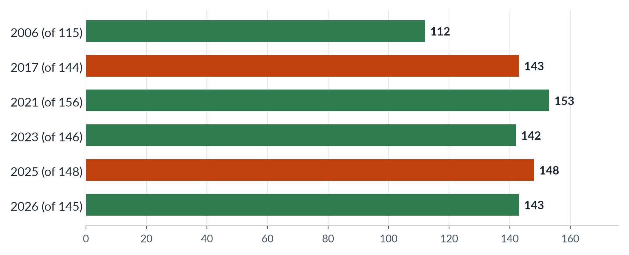
Figure 20 · Pakistan in the Global Gender Gap Report (rank; lower is better).
Draw it in: "second-worst" (2018) and the 2025 report (2026). Add the 2026 sub-index ranks: economy 144th, education 130th, politics 107th.
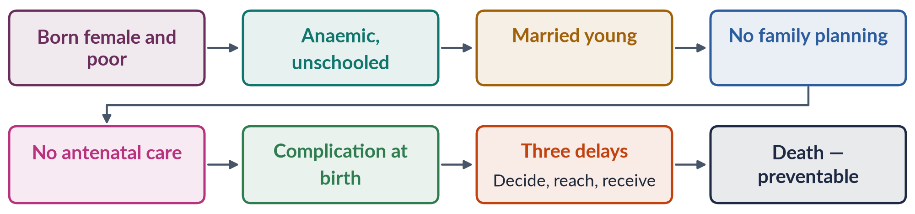
Figure 21 · Fathalla's road to maternal death (1987), shortened.
Draw it in: the health questions (2017, 2023) and the road to maternal death (2024). Pakistan's ratio is 186 per 100,000 live births (PMMS 2019).
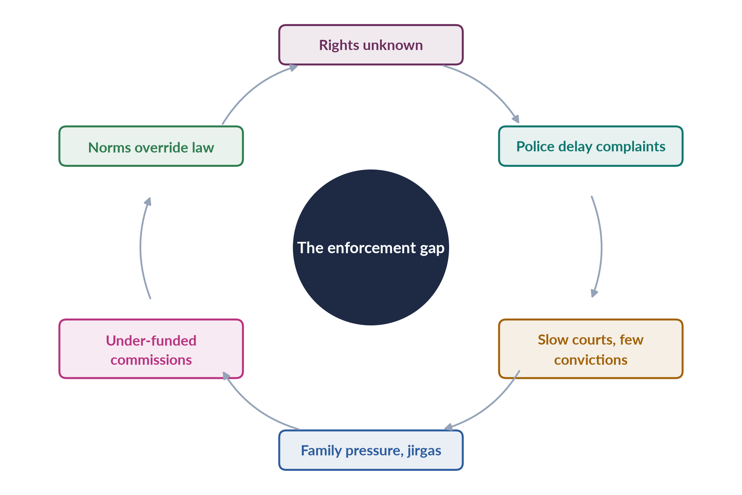
Figure 22 · Why laws fail women — the enforcement gap.
Draw it in: law and human rights (2020). Every list of laws must end with this gap.
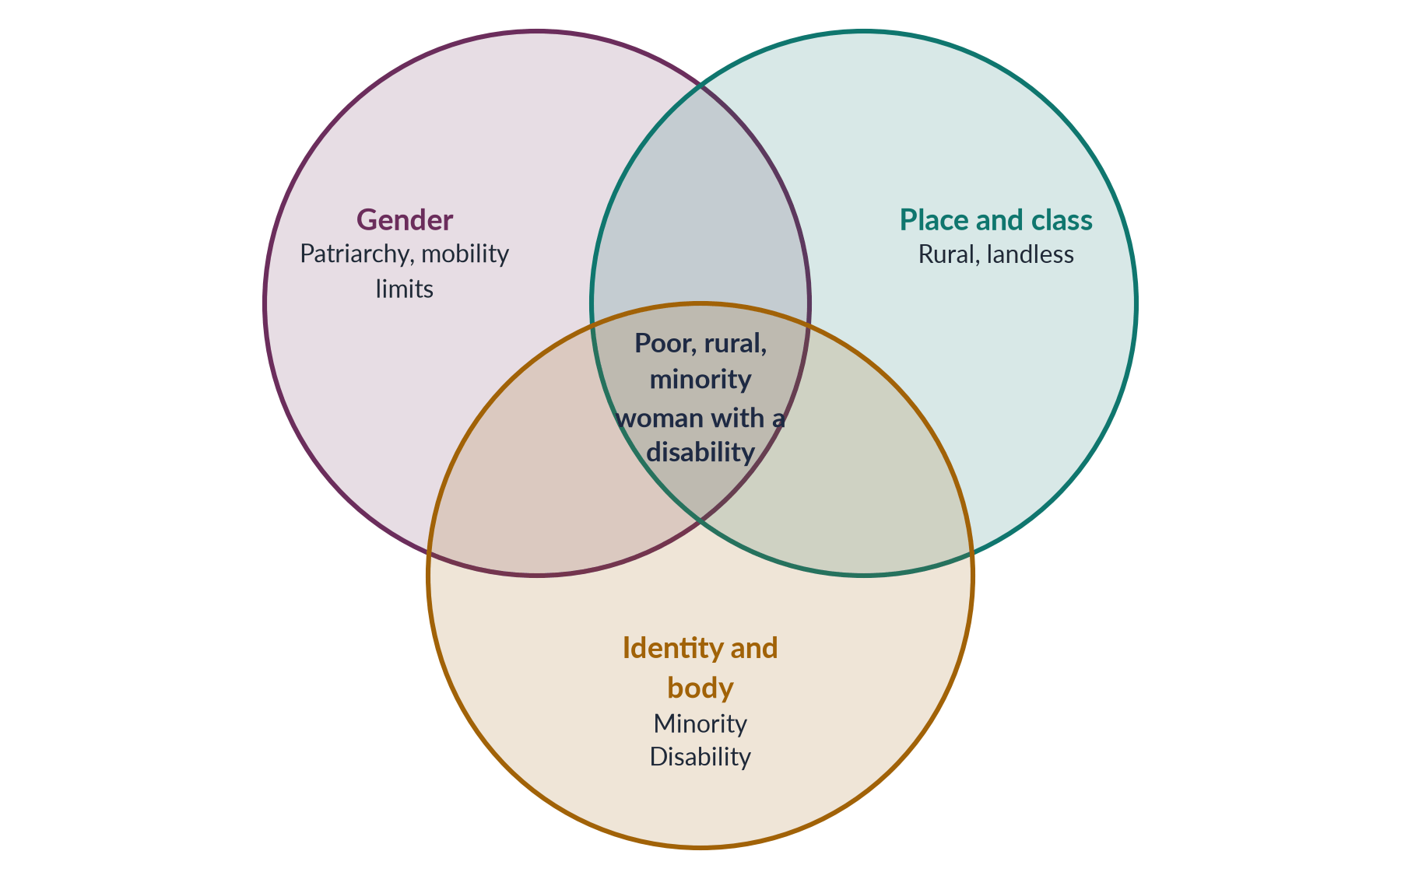
Figure 23 · Overlapping disadvantage in Pakistan.
Draw it in: intersectionality (2026), and any status question where "women" are not one group.

Every past question as an answer plan
Use these plans in the last fortnight: read the question, say the plan aloud from memory, then check. Each plan is the skeleton of the full model answer in T5QA.
2017 Q5 — Status of women's health; improvement within available resources. Define health (WHO 1946); health mirrors status. Maternal (MMR 186, PMMS 2019; skilled attendance about two-thirds; rural, Balochistan). Nutrition (anaemia 42%; stunting 40%; NNS 2018). Reproductive (TFR 3.6; contraception 34%; early marriage, age 16). Other burdens (breast cancer, cervical cancer and HPV 2025; mental health; violence). Causes tree (son preference, mobility, decision power, poverty, spending about 1% of GDP, few female staff). Programmes (LHWs 1994, midwives, Sehat Sahulat, BISP, Nashonuma). Principle: prevention and primary care before hospitals. Low-cost measures (LHWs, family planning, iron and folic acid, fortification, skilled attendance, referral, telemedicine) — mapping figure. Social measures (marriage age, men and mothers-in-law, health literacy). Better use of money (BISP targeting, partnerships, accountability). Most deaths preventable at low cost.
2018 Q5 — Why second-worst despite conventions and the Constitution. 143rd of 144 (2017): promises vs practice. Index and four sub-indices. Commitments: Arts 25, 34, 35, 37(e), 51; CEDAW 1996, Beijing 1995, SDGs 2015. Gaps: economic (LFPR, pay, informality), education (literacy 53/68, girls out of school), health (MMR, anaemia, son preference), political (reserved seats, few ministers). Reasons: enforcement gap; patriarchal norms (purdah, honour, early marriage); poverty and low spending; mobility, safety and unpaid care; weak political will, CEDAW declaration, federal–provincial gaps after 2010, crises. Cycle figure. South Asian comparisons (Bangladesh, Sri Lanka, Nepal). Way forward (women's work, enforcement, girls' secondary schools, women in cabinet); 2026: 143/145 shows movement is possible.
2019 Q6 — Paid employment and reproductive roles: challenges worldwide and in Pakistan. Double burden. Terms: reproductive role, Moser's triple role, second shift (Hochschild 1989). Trend: rising worldwide; Pakistan 21.4% → 24.4%. Worldwide: time poverty (women do about 3× the unpaid care — ILO 2018); pay gap and comparable worth; segregation, glass ceiling, sticky floor; motherhood penalty, childcare, maternity protection; harassment and informal work. Cycle figure. Pakistan: mobility and transport; norms (breadwinner, honour); joint families; informality (agriculture, home-based); harassment; scarce childcare; provincial gaps (Punjab 33.8%, Balochistan 14.5%). Benefits (income, voice — Kabeer 2000). Laws (Harassment Act 2010/2022; Maternity and Paternity Leave Act 2020; Sindh HBW Act 2018; 10% quota). Share care; make work decent.
2020 Q6 — A system that guarantees rights, enables enjoyment and gives speedy remedy. Human rights as the base of a democratic welfare state; statement echoes the NCHR Act 2012. Pyramid: guarantee → enjoyment → remedy. Guarantee: Arts 8–28 (enforceable), 25, 25A, 34, 35; CEDAW 1996, ICCPR 2010, ICESCR 2008; laws (2006, 2010, 2011, 2016, 2021); institutions (NCHR, NCSW 2000/2012, ombudspersons, provincial commissions). Enjoyment: low literacy and awareness, poverty, custom (honour, inheritance denial, early marriage). Remedy: police refusal and delay, slow courts, low convictions, jirgas, under-funded commissions and shelters. Cycle figure. Critical evaluation: strong on paper, weak in practice; progress (2016 honour law after Qandeel Baloch; 2021 special courts; 2025 ICT marriage age). Way forward: legal literacy, policing, courts, one-stop centres, strong commissions.
2023 Q7 — Current health status; measures for women's status as a whole. Define health and status. Health picture: maternal (186; two-thirds skilled attendance), nutrition (42%; 40%), reproductive (3.6; 34%; 241 million growing 2.55%), cancers (HPV 2025), mental health, violence, floods (650,000 pregnant women). Causes (norms, poverty, health system, literacy). Measures with examples: health (LHWs, midwives, telemedicine); education (Punjab stipend 2004; Art. 25A); economic (Sindh HBW Act 2018; Leave Act 2020; transport, childcare); legal (2021 special courts; Sindh 2013 and ICT 2025 marriage age; 2020 property law); political and social (women ministers — none in 2025; Women's Parliamentary Caucus 2008; BISP 2008; engaging men). Cycle figure. Dimensions rise together.
2024 Q2 — Fathalla's "maternity death road"; health in social, cultural and demographic context. Fathalla, Nairobi 1987, Safe Motherhood Initiative, "Why did Mrs X die?"; societies have yet to decide women's lives are worth saving. Road (born female and poor → anaemia → no school → early marriage → many pregnancies → no antenatal care → complication → delays → death) — flow figure. Three delays (Thaddeus and Maine 1994). Social (son preference, anaemia 42%, poverty, literacy 53%, decision power). Cultural (marriage age 16; 18 in Sindh 2013, ICT 2025; purdah; female-doctor preference; home births and dais; taboos). Demographic (241 million; 2.55%; TFR 3.6; 34%; young; rural; Balochistan; 2022 floods). Mapping figure. A Pakistani Mrs X. Wider issues; programmes; closing the road at every stage.
2026 Q4 — Pakistan in the Global Gender Gap Report 2025; factors behind the ranking. 148/148, 56.7% (2025); 143/145, 59.5% (2026). Index since 2006; gaps not well-being; global average about 69%. Evaluation by sub-index: economic (weakest; 144th in 2026); education (53/68; WEF 48.5%; 25m+ out of school; 130th in 2026); health (MMR 186; anaemia; sex ratio); political (zero women ministers; 11 women won general seats in 2024; Maryam Nawaz). Grid figure. Socio-economic factors: LFPR 24.4% (Punjab 33.8%, Balochistan 14.5%; informal; pay gap); norms, mobility, unpaid care, poverty; spending (health about 1%, education about 2% of GDP). Political factors: weak will and representation; enforcement gap (2010, 2016, 2021 laws); 18th Amendment; crises (2022 floods, IMF austerity). Cycle figure. 2026 rise (education and politics up 11 places; economics unchanged). Way forward; paid, decent work is the test.
2026 Q7 — Intersectionality and marginalised women: health, education, employment. Averages hide the worst-off (Lahore banker vs Tharparkar labourer). Crenshaw 1989; Collins 1990 matrix of domination. Systems: patriarchy, class, place, religion and caste, ethnicity, ableism — Venn figure. Rural women (distance, unpaid farm work, no land, jirgas, vani/swara). Religious minorities (forced conversion and marriage of Hindu and Christian girls; scheduled-caste bonded labour; Christian sanitation workers; Hindu Marriage Acts 2016/2017). Ethnic minorities (Hazara widows; Balochistan; former tribal areas merged 2018). Disabled women (stigma; inaccessible clinics and schools; 1981 quota; CRPD 2011; ICT Act 2020). Table: group × health, education, employment. Single-axis policy fails. Policy for the overlaps (mobile clinics, accessible schools, protection against forced conversion, social security, CNIC and marriage-registration drives, disability quotas, disaggregated data, voice).
2026 Q8(a) — Short note: digital transformation and the mobile gender gap. (~555 words.) Gap in access, skills, benefits; GSMA; South Asia widest; 38% = 62 women per 100 men. Progress 38% → 25%; eight million more women online (2024–25); widest for rural, poor, older, less-educated; shared handsets. Drivers: cheaper phones and data; digital BISP payments; CNICs; skills programmes; social media and freelancing; network effect. Barriers: cost; CNIC for a SIM; literacy 53%; norms and male control; online harassment. Compare figure: opportunities (home-based income, mobile wallets, telemedicine, learning, voice) vs risks (harassment, surveillance, insecure platform work, new divide). PECA 2016; Digital Rights Foundation helpline 2016. Way forward; SDG 5.b; access plus skills and safety.

Topic 6 · Gender and Governance
AT A GLANCE · TOPIC 6 AT A GLANCE
Head VII of the syllabus: 8.5 visits (eight full questions and one short note, 2016–2025), plus 14 of the 140 MCQs — mostly firsts and numbers. Three families: quotas (2016 pros and cons, 2021 results, 2024 impact, 2025 history); participation (2017 democracy and development, 2018 "half the sky", 2024 a human right); and representatives and leaders (2020 "pull each other up", 2022 issues of women representatives). The suffragist movement was a short note in 2019. Every answer is a judgement built on Pitkin, Dahlerup, the quota history and the 2024 election data. Never yet asked in full: defining governance, women as voters, and the South Asian case studies.

1. Governance and why gender matters
- Governance — the manner in which power is used to manage a country's resources (World Bank 1992); wider than government: state, markets, parties, civil society, jirgas. Popularised after the World Bank's 1989 "crisis of governance".
- Good governance (UNESCAP, eight features) — participation, rule of law, transparency, responsiveness, consensus orientation, equity and inclusiveness, effectiveness and efficiency, accountability. Participation of women and men is part of the definition.
- Gender and governance — two questions: are women present where decisions are made, and do outcomes serve women? Parts: participation; institutions (NCSW 2000, caucuses); gender-responsive budgeting; accountability (sex-disaggregated data).
- Four arguments — justice (half the citizens), interests (distinct needs), resource (talent), symbolic (role models).
- Rights basis — UDHR Art. 21 (1948); ICCPR Art. 25 (1966); CEDAW Art. 7 (political life) and Art. 4(1) (temporary special measures); Constitution Arts 17, 25, 32, 34, 51, 59, 106; SDG 5.5.
- Government vs governance — government = institutions holding state power (parliament, cabinet, courts, civil service); governance = the whole process of managing public affairs, incl. markets, parties, civil society, media, jirgas. UNDP 1997: authority exercised so citizens articulate interests, exercise rights, meet obligations, mediate differences.
- Village pump example — an all-male council sites the pump near the mosque or market; women who fetch water want it near homes: who sits at the table changes what is decided.
- Pakistan's gender machinery — Women's Division 1979 → Ministry of Women Development → devolved to provinces after the 18th Amendment (2010) (Women Development Departments); federal Ministry of Human Rights (2015); NCSW 2000 (Act 2012); provincial commissions (e.g. Punjab 2014); National Policy for Development and Empowerment of Women (2002); Gender Reform Action Plan (GRAP) (early 2000s — women's share of public jobs; gender-sensitive departments); Finance Ministry Gender Responsive Budgeting Initiative; harassment ombudspersons (2010) and property ombudsperson (2020). Verdict: the machinery exists; resources and political will are weak.
- Governance spaces beyond parliament — executive (zero women federal ministers, 2025); bureaucracy (10% quota; few in top grades); judiciary (Ayesha Malik, first woman SC judge, 2022); local government (33%, 2000–01); party executives (decide tickets and lists); informal jirgas and panchayats (all-male; vani, swara, honour punishments).
- Jinnah (Aligarh, 10 March 1944) — "No nation can rise to the height of glory unless your women are side by side with you" — opener for any participation answer.

2. Representation theory
- Pitkin 1967 — formal (rules), descriptive (resemble), substantive (act for), symbolic (stand for).
- Phillips 1995 — "politics of presence": who represents matters, not only ideas.
- Kanter 1977 — tokens under ~15%: visible, isolated, pressured.
- Dahlerup 1988 — critical mass (~30%); also critical acts; "fast track" (quotas) vs "incremental track" (Nordic).
- Childs and Krook 2009 — critical actors matter more than numbers.
- Targets: ECOSOC 30% (1990); Beijing Critical Area G (1995).
- Use: "Quotas delivered descriptive representation; the question is substantive representation."
- Pitkin applied to Pakistan — formal: reserved seats from party lists, general seats by FPTP; descriptive: about one-fifth women vs half the population; substantive: laws of 2010–2016; symbolic: Benazir Bhutto (1988), Maryam Nawaz (2024).
- Critical mass — balanced view — for: more women reduce tokenism, permit alliances, normalise women's issues (Nordic parliaments, Rwanda); against: women divided by party, class, ideology; a few determined women can achieve much; party discipline limits all members. Line: numbers create the opportunity; critical actors, cross-party caucuses and party support turn it into change (Pakistan's Women's Parliamentary Caucus, 2008).
- Mansbridge (1999) — descriptive representation matters most where groups have been distrusted or where interests are "uncrystallised" (not yet on the agenda) — e.g. domestic violence before women entered parliament.
- Using theory in answers — open with a definition of governance or representation, then frame the judgement: "Quotas have delivered descriptive representation; the question is substantive representation."

3. The suffrage movement (2019 note)
- Suffrage = right to vote. Suffragists (peaceful; NUWSS 1897, Millicent Fawcett) vs suffragettes (militant; WSPU 1903, Emmeline Pankhurst, "Deeds, not words"; word coined by the Daily Mail 1906).
- Against women's votes — separate spheres, coverture, "nature", social order. For — natural rights, democracy (no taxation without representation), social improvement.
- USA — London 1840 (Stanton and Mott excluded) → Seneca Falls 1848 (Declaration of Sentiments; Douglass) → 15th Amendment 1870 split → NWSA (Stanton, Anthony) and AWSA (Stone) 1869 → Wyoming 1869 → NAWSA 1890 → Alice Paul, pickets 1917 → 19th Amendment 1920 → Voting Rights Act 1965 for Black women in the South.
- Britain — Wollstonecraft 1792 → Mill's petition 1866, Subjection 1869 → NUWSS 1897 → WSPU 1903 → hunger strikes, Cat and Mouse Act 1913, Emily Davison 1913 → war work → 1918 (over 30, property) → 1928 (21, equal).
- World — New Zealand 1893 (Kate Sheppard; MCQ 2024); Australia 1902; Finland 1906 (first to stand); Norway 1913; Russia 1917; Germany 1918; USA 1920; Ceylon 1931; France 1944; India and Pakistan 1947; Switzerland 1971; Saudi Arabia 2015 (municipal).
- South Asia — 1917 Women's Indian Association deputation to Montagu (Sarojini Naidu); Madras 1921; 1935 Act (6 million women; reserved seats); Muslim League women's sub-committee 1938; Pakistan 1947 adult franchise; first CA two women.
- Assessment — necessary not sufficient; class and race limits; led to the second wave; Pakistan still has a 9.94m registration gap.
- Suffrage in the Muslim world — Azerbaijan 1918 (often cited first); Turkey local 1930, national 1934 (18 women MPs in 1935); Indonesia 1945; Pakistan 1947; Bangladesh 1971; Iran 1963; Kuwait 2005; Saudi Arabia 2015 (municipal). Many Muslim-majority states enfranchised women before Switzerland (1971); Pakistan, Bangladesh, Turkey and Indonesia have had women heads of government.
- Short-note frame (2019) — meaning (suffragist vs suffragette) → origins (Wollstonecraft, Seneca Falls) → USA (NWSA/AWSA 1869, NAWSA 1890, 19th Amendment 1920) → Britain (Mill 1866, NUWSS 1897, WSPU 1903, 1918, 1928) → world (NZ 1893, Finland 1906) → South Asia (1917, Madras 1921, 1935 Act, Pakistan 1947) → assessment (necessary, not sufficient).
- Why the vote mattered — once women voted, legislators in Britain and the US began passing laws on married women's property, custody, maternity and working conditions.
- Limits — white, middle-class leadership; racism (Black women in the US South until 1965); class (Britain's 1918 property rule); formal rights without social equality → second wave.

4. Women as voters
- Law — vote at 18 (from 21 in 2002; MCQ 2016); CNIC (NADRA) needed; ECP prepares the roll.
- 2024 data — 128.58m voters; 69.26m men, 59.32m women; gap 9.94m (7.7%), down from 12.8% (2013). Turnout 43% women vs 52% men (gap 9 points, 10 in 2018); women cast 24.4m of 58.9m votes (+2.7m); widest gap KP (15.7), Sindh 7.4.
- Registration barriers — no CNIC, documents, distance, cost, family control, awareness.
- Turnout barriers — family decides; local agreements barring women; distance and security; few female polling stations and staff; care work; information.
- Remedies — Elections Act 2017 s. 9: poll void if women's turnout < 10%; special measures where the registration gap > 10%; Lower Dir by-election annulled 2015; NADRA mobile vans, women's counters; Aurat Foundation, FAFEN.
- Autonomy — family and biradari block voting; three steps: on the list, at the booth, own choice. BISP (2008) as courting women voters.
- Why the CNIC matters beyond voting — no CNIC = no vote, bank account, BISP payment, SIM card, inheritance claim or passport; BISP (2008, paid only to women with CNICs) was a major driver of women's registration — social policy and participation reinforce each other.
- Violence and intimidation — threats and rumours keep women home; women's polling stations may be targeted; militants have warned women not to vote; women polling staff are harassed. Remedies: safe nearby women's stations, women police, security.
- Women voting differently? — in the West a "gender gap" in party preference emerged from the 1980s (US women more Democratic; young women to the left of young men); in Pakistan family voting blurs it, but parties increasingly court women (BISP, provincial schemes).
- Balance — progress: gap 12.8% (2013) → 7.7% (2024); +2.7m women's votes; s. 9 deters open bans. Problems: 9.94m unregistered; 43% vs 52% turnout; family voting. Line: right secure, access improving, autonomy the deepest challenge.

5. Women as candidates (2024)
- Pipeline — eligible → aspirants → party tickets → winners.
- Data — 306 women contested NA general seats in 2024; 11 won (5 independents, 4 PML-N, 2 PPP); 8 in 2018; 5 (10 with by-elections) in 2013. 11 of 266 ≈ 4%.
- Law — age 25; BA condition 2002–08; Elections Act s. 206: 5% of general-seat tickets to women (no rule on winnable seats).
- Barriers — party gatekeeping and "electables"; money (costly campaigns, little female property); social norms (purdah, honour, consent, care); violence and harassment (online abuse; Benazir assassinated 27 Dec 2007); FPTP system and biradari; dynasty as the main route (Benazir, Maryam Nawaz).
- Fewer aspire — socialisation ("politics is dirty"), less encouragement.
- Reforms — raise and enforce the ticket quota in winnable seats; sanctions; campaign finance; women in party bodies; safety; local government as a pathway.
- Local government as pipeline — LGO 2001: 33% of union, tehsil and district seats; ~36,000 women elected (2000–01); some seats unfilled in conservative districts; proxies; but confidence, experience and respect gained; some moved to provincial seats; provincial LG laws of the 2010s kept women's seats at lower shares.
- Online harassment — trolling, doctored images, sexual slurs and threats against women candidates; PECA 2016; Digital Rights Foundation helpline (2016); weak enforcement; abuse drives some women out of politics.
- Fewer aspire — women less often encouraged to run, more likely to doubt qualifications, more worried about family effects; "politics is dirty"; mentoring and encouragement raise ambition.
- Cases — Benazir Bhutto (PPP chair; PM 1988–90, 1993–96; assassinated 27 Dec 2007, Rawalpindi) — possibility and danger; 11 women on general seats in 2024 = about 4% of 266.
- Dynasty balance — critics: proxies; defenders: many became leaders in their own right; male dynasties common too. Line: a route, not a disqualification — the problem is that it is almost the only route.

6. Women as representatives (2022)
- Seats — NA 336 (266 general, 60 women, 10 non-Muslim); Senate 96 (17 women; 18 in 2024); Punjab 66, Sindh 29, KP 26, Balochistan 11. Women ≈ one-fifth of the NA.
- How reserved seats are filled — PR from party priority lists, in proportion to general seats won; independents who join a party count. 2024–25 Supreme Court dispute over PTI-backed independents' share.
- Two classes — general-seat women (constituency, funds) vs reserved-seat women (no constituency, party-dependent, "second-class").
- Issues — legitimacy ("nominated"); no constituency; party control and relatives on lists; unequal development funds and offices; soft portfolios, few committee chairs; zero women ministers (2025); sexist remarks and online abuse; family duties and late sessions; capacity; few move to general seats.
- Response — Women's Parliamentary Caucus 2008 (Fahmida Mirza) → laws of 2010–2016; FAFEN/PILDAT find women among the most active members.
- Firsts — 1947 Shahnawaz and Ikramullah; 1965 Fatima Jinnah; 1973 Ra'ana Liaquat (governor); 1988 Benazir (PM); 2008 Fahmida Mirza (Speaker); 2011 Hina Rabbani Khar (FM); 2017 Tehmina Janjua (foreign secretary); 2022 Ayesha Malik (SC); 2024 Maryam Nawaz (CM).
- Reforms — constituencies or direct election; transparent lists; equal resources; key committees and ministries; codes of conduct; day-care; training.
- Senate and provinces — Senate's 17 women's seats filled by assemblies by single transferable vote (party strength again); Senator Sughra Imam moved the anti-honour-killing bill (2014); provincial caucuses pushed DV laws — Sindh 2013, Balochistan 2014, Punjab 2016, KP 2021; after the 18th Amendment provincial women legislators matter more for social policy.
- Everyday dependence — reserved-seat members often must approach a male general-seat colleague to get a tube well, school repair or road for the women who contact them.
- Effective or not? — yes: caucus laws, active in debates and questions, violence and harassment became parliamentary business; limited: dependent on leaders, few in real power, few move to general seats, economic policy still male. Line: real difference on women's issues despite structural constraints.
- Interim reform — assign reserved-seat members districts with equal development funds until direct election is introduced.

7. Quotas — types, pros and cons (2016, 2020, 2021, 2024)
- Definition — minimum number or share of women; temporary special measures (CEDAW 4(1)); Constitution Art. 25(3).
- Types — reserved seats (result: Pakistan 60, Bangladesh 50, Rwanda); legislated candidate quotas (opportunity: Pakistan 5%, Nepal, France parity 2000; zipper lists); voluntary party quotas (Sweden, Norway). Also local (India 1992 one-third; Pakistan 33% 2001), boards (Norway 40% 2003), jobs (Pakistan 10%).
- World — 130+ countries; women ≈ 27% of parliaments; Rwanda 60%+.
- Pros — fast track (Dahlerup); compensates barriers, not merit; justice and descriptive representation; better policy (Chattopadhyay and Duflo); role models; critical mass; training ground.
- Cons — merit; tokens and proxies (biwi-beti-behen); stigma; ceiling not floor; elite capture; weak voter link; essentialism; symptoms not causes.
- Answering merit — merit already distorted by money and biradari; many quota women highly educated; diversity improves decisions; Sweden's quotas pushed out "mediocre men" (Besley et al. 2017).
- Design — legal; placement in winnable seats; sanctions; transparent selection; direct election; review.
- Verdict — necessary but not sufficient; design decides.
- "Quotas are a Western idea" — answered — reserved seats date from the 1935 Act and Pakistan's own constitutions (1956, 1962, 1973); Muslim-majority users: Bangladesh (50 seats), Indonesia (30% candidate quota), Tunisia (parity lists, 2011), Afghanistan (about a quarter of lower-house seats under the 2004 constitution, lost after 2021); the UK and US have no national legislated quotas. The debate is about design, not culture.
- Simple words — a quota does not lower the bar; it removes a hidden bar that was already there.
- "Pull each other up" link (2020) — mentoring, sponsoring and networking within fair procedures = removing barriers men's networks never faced, not preferential treatment.
- Answering 2016/2021 — define + types → pros → cons → Pakistan's experience (history; 60; 5%; caucus laws; but 11 general-seat women) → reforms → balanced conclusion; cite Dahlerup (fast track) and Pitkin.

8. History of Pakistan's quota (2025)
- 1935 Act — reserved seats; Jahanara Shahnawaz (Round Table Conferences; Punjab Assembly 1937).
- 1947 — first CA 2 of 69 women.
- 1956 — 10 seats (5 East, 5 West). 1962 — 6 seats (3 + 3), indirect.
- 1973 — 10 NA seats for 10 years or three elections, indirect.
- 1985 — raised to 20 (Zia; alongside Hudood 1979, Evidence 1984).
- 1988–2002 — lapse: 1990, 1993, 1997 with no reserved seats; 2–6 women; over 97% male — the strongest case for quotas.
- 2000–01 — Devolution Plan / LGO 2001: 33% local (MCQ 2016); ~36,000 women councillors.
- 2002 — LFO: NA enlarged to 342, 60 women's seats (≈ 17%; 2021 question; MCQ 2016), Senate 17, provinces 128; validated by 17th Amendment 2003; NCSW 2000; National Policy 2002; women's share from <3% to >20%.
- 2008 — Women's Parliamentary Caucus. 2010 — 18th Amendment keeps seats. 2013+ — provincial LG laws reduce local share. 2017 — Elections Act: 5% tickets (s. 206), 10% turnout (s. 9). 2018 — 25th Amendment: NA 336, 60 kept; KP provincial seats rise.
- Assessment — symbolic (1956–88) → substantial (2002) → not yet empowering; next step direct election and stronger candidate quotas.
- Allocation worked example — NA women's seats by province after the 2023 delimitation: Punjab 32, Sindh 14, KP 10, Balochistan 4; within a province, seats in proportion to general seats won (Art. 51(6)(d)); independents joining a party within three days count. A party winning half of Punjab's general seats gets ≈16 of its 32 women's seats; a party with no general seats gets none.
- Consequences — reserved-seat women loyal to leaders who set list order; seats become a prize in membership disputes (2024–25).
- The 1990s lesson — with 2–6 women in a house of 200+, the NA was over 97% male; the lapse is the strongest historical case for quotas.
- Assessment frame — 1956–88 symbolic (few, indirect seats); 2002 onwards substantial (60, 17, 132; 5% tickets); not yet empowering (indirect, party-controlled).
- Timeline to draw — 1935 → 1947 → 1956 → 1962 → 1973 → 1985 → lapse 1988–2002 → 2000–01 → 2002 → 2008 → 2010 → 2017 → 2018.

9. Impact of women representatives (2017, 2018, 2021)
- Four impacts — policy, process, symbolic, democratic.
- World evidence — Chattopadhyay and Duflo 2004 (India; women heads invested in drinking water, roads in West Bengal); Beaman et al. 2009/2012 (less voter bias; higher girls' aspirations).
- Pakistan evidence — laws: 2006 Women's Protection Act; 2010 harassment and s. 509; 2011 acid and anti-women practices (private members' bills); 2012 NCSW Act; 2016 honour and rape; provincial DV laws 2013–2021; women among the most active members; agenda change; BISP 2008; 2001 councillors mixed.
- Democracy and development (2017) — legitimacy, consensus (cross-party caucus), peace (UNSCR 1325, 2000); spending on health, education, water; women's economic rights (property 2020, HBW Sindh 2018); LFPR 24.4%. Realities limiting it: poverty, literacy, patriarchy, feudal and tribal power, dynasties, military interventions, party dependence.
- Equal numbers (2018) — "women hold up half the sky" (Mao); for: justice, interests, France parity 2000, Rwanda; against: merit, women not one group, proxies; middle: parity of opportunity, quotas as a means; SDG 5.5.
- Limits — party discipline, dependence, elite composition, marginal posts, implementation gap, backlash (CII vs Punjab 2016 law).
- Honour-killing law as a case of critical actors — Sughra Imam's bill (2014) passed the Senate (2015), stalled in the NA; after Qandeel Baloch's murder (July 2016) women legislators, the caucus, civil society and media pressed again; a joint sitting passed the Act in October 2016 (life sentence even if the family forgives).
- Local councillors (2001–05) — mixed: many proxies and excluded from funds; others raised water, girls' schools and health, gained respect, moved up.
- UNSCR 1325 (2000) — women's participation in peace and security; agreements more durable when women take part.
- Parity examples — France's parity law (2000); Rwanda's majority-women parliament; Nepal 35% (2026).
- Answering 2017 — use the cycle (legitimate democracy → laws and budgets for health, education, water → women's work and property → growth → educated next generation → more demand for women's voice), then the socio-economic realities that limit it.

10. Women in leadership (2020)
- Pakistan — Benazir (1988–90, 1993–96); Maryam Nawaz (2024); Ayesha Malik (2022); Fahmida Mirza (2008); Hina Rabbani Khar (2011); Tehmina Janjua (2017); Lt Gen Nigar Johar (2020); zero women ministers (2025); 10% job quota; women's police stations (1994); SECP: one woman director.
- Metaphors — glass ceiling (1980s); sticky floor; leaky pipeline; labyrinth (Eagly and Carli 2007); glass cliff (Ryan and Haslam 2005; MCQ 2026); queen bee (Staines, Tavris, Jayaratne 1974).
- Barriers — stereotypes and the double bind; old boys' networks; care; subjective promotion; harassment; few role models.
- "Pull each other up" — useful — role models, mentoring, sponsorship, networks, family-friendly policies; mirrors men's networks; ends tokenism; India's role-model evidence; the caucus.
- Against — merit, resentment and stigma, extra burden on women, assumes solidarity, queen bee reality.
- Line — corrective, not preferential, when done within fair, transparent procedures and backed by institutional reform.
- Double bind in Pakistan — tough women called arrogant, gentle women weak; dress, family life and marital status scrutinised; Benazir faced claims that a woman could not head a Muslim state; Maryam Nawaz similar comment; women in bureaucracy and judiciary must work harder to be taken seriously.
- Benazir's openings — women's police stations (1994), First Women Bank (1989), women judges in the high courts — doors opened, standards not lowered.
- Over-mentored, under-sponsored — women receive advice but rarely the backing of a senior person who puts their name forward; sponsorship drives promotion.
- Simple words — men have ropes handed down from the top; a woman who reaches the top and lowers a rope gives others what men already had.
- Answering 2020 — barriers → case for (role models, mentoring, sponsorship, networks, tokenism, India's evidence, the caucus) → case against (merit, stigma, burden, solidarity assumed, queen bee) → Pakistan's leaders → line: corrective with institutional reform.

11. South Asian case studies
- Paradox — many dynastic women leaders (Bandaranaike 1960, Indira Gandhi 1966, Benazir 1988, Khaleda Zia 1991, Kumaratunga 1994, Hasina 1996) but low ordinary participation.
- India — vote from 1950; 73rd/74th Amendments 1992: one-third local (many states 50%); Lok Sabha ~14% (74 women, 2024); 106th Amendment 2023 — one-third after census and delimitation (not before 2029); sarpanch-pati proxies.
- Bangladesh — Khaleda and Hasina 1991–2024; Hasina ousted Aug 2024; reserved seats 15 (1972), 30 (1979), lapse, 45 (2004), 50 (2011); 2026: 85 women contested, 7 won directly, 57 of 350 total; Union Parishad women's seats directly elected since 1997.
- Sri Lanka — universal franchise 1931; Bandaranaike 1960; Kumaratunga president 1994–2005; Harini Amarasuriya PM 2024; ~5% women for decades; record 22 of 225 (2024); 25% local quota (2018).
- Nepal — 2015 constitution: one-third federal; president and vice-president of different sexes or communities; local head/deputy and Dalit women's seats; 2026: 96 of 275 (~35%), only 14 via FPTP; 2017 local: ~14,000 women (~41%); Bhandari president 2015; Sushila Karki interim PM 2025.
- Lessons for Pakistan — design beats culture; direct election; local quotas as training; intersectional quotas; dynasty ≠ access; enforcement.
- Pakistan as a case — firsts at the top (Fatima Jinnah 1965; Benazir 1988; Maryam Nawaz 2024); quota that came and went (10, 6, 10, 20, none, 60); laws made by women (2010–2016); persistent gaps (9.94m voters, 43% vs 52%, 11 general seats, zero ministers 2025). Pakistan sits in the middle: ahead of India and Sri Lanka on women's share, behind Nepal, similar to Bangladesh on indirect reserved seats.
- Common challenges — dynastic politics; party gatekeeping (Nepal only 14 FPTP winners, Bangladesh 7 direct); money and violence; proxies (sarpanch-pati); norms of purdah, honour and care; the local–national gap.
- Lesson in one line — quotas get women into office; party reform, money, safety and social change decide whether they gain power.
- Three-sentence comparison for any quota answer — "Nepal's constitutional one-third with PR lists produced 35% women in 2026; India's panchayat quota showed women leaders change spending; Bangladesh shows women at the top do not guarantee women on general seats."

12. Debates in one line each
- Direct vs indirect reserved seats — move towards direct election.
- 5% tickets — raise, place in winnable seats, sanction.
- Quota as ceiling — make it a floor.
- Dynastic women — a route, not a disqualification; create other routes.
- Do women represent women? — united on violence and rights; poor and minority women still missing.
- Participation as a human right (2024) — yes (UDHR 21, ICCPR 25, CEDAW 7, Arts 17, 25, 34); the state must remove barriers.
- Zero women ministers (2025) — appointments are the fastest fix; elected women are more durable.
- Human-rights basis (2024) — UDHR 21; ICCPR 25 (Pakistan 2010); CEDAW 7 and 4(1) (Pakistan 1996); General Comment 25 (1996): states must take positive measures against obstacles (illiteracy, poverty, restrictions on movement); SDG 5.5; Arts 17, 25, 32, 34, 51, 59, 106; a right that half the citizens cannot use is a right only on paper.
- Mainstreaming (2021) — the goal is women in general seats, cabinets, party leadership and every policy field, as gender mainstreaming (Beijing 1995) intends — not a reserved minority in a separate box.

The key diagrams
Four diagrams carry most of Topic 6. Learn to draw each one from memory in under two minutes. A diagram placed early in an answer shows the examiner the whole argument at a glance and earns credit in its own right.
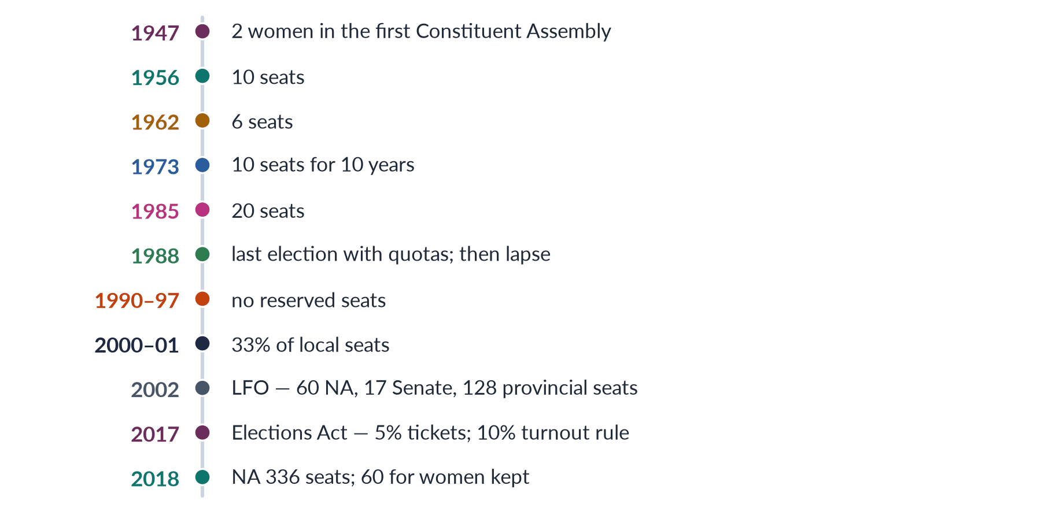
Figure 24 · Women's quotas in Pakistan.
Draw it in: the history of quotas (2025), and as background to 2016, 2021 and 2024.
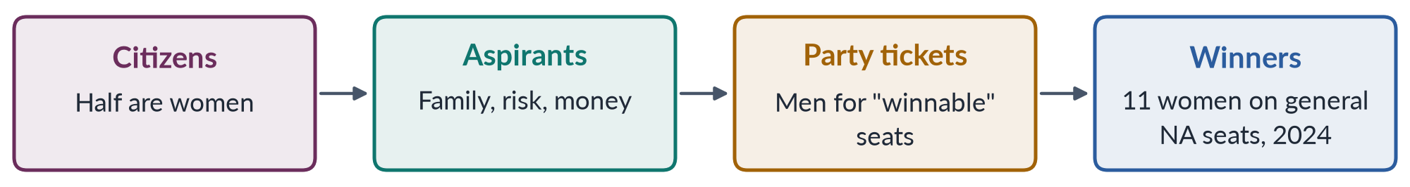
Figure 25 · The candidate pipeline — where women leak out.
Draw it in: issues of women representatives (2022) and any question on why quotas are still needed.
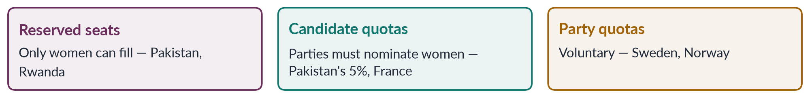
Figure 26 · Three types of political gender quota.
Draw it in: pros and cons of quotas (2016) and the results of quotas (2021).
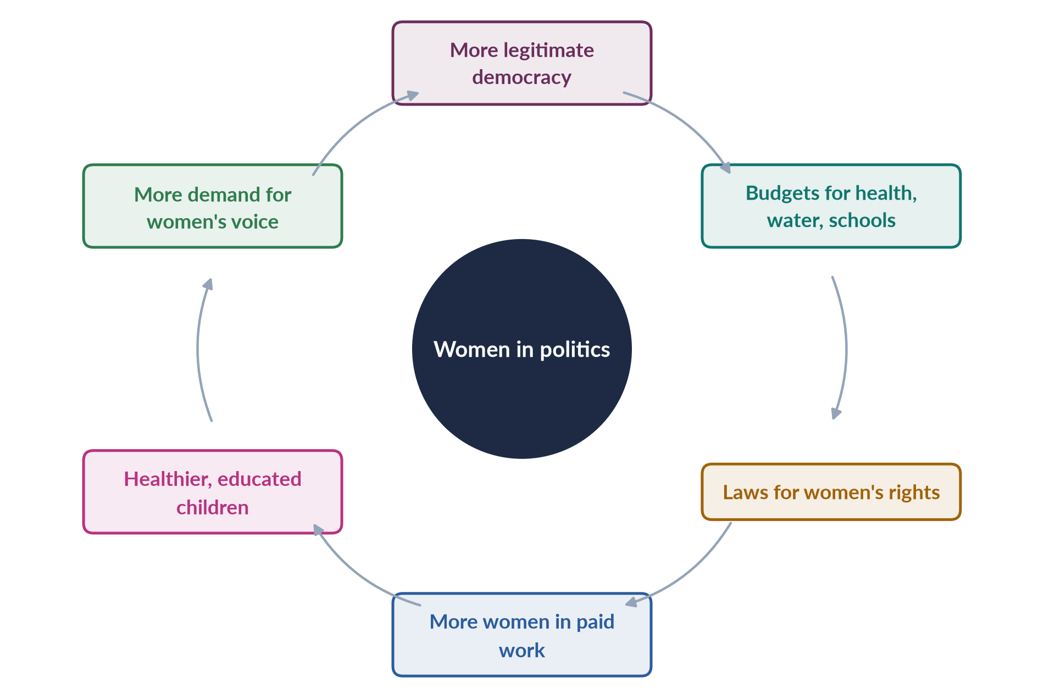
Figure 27 · Women in politics strengthen democracy and development.
Draw it in: democracy and development (2017), "half the sky" (2018) and participation as a human right (2024).

Every past question as an answer plan
Use these plans in the last fortnight: read the question, say the plan aloud from memory, then check. Each plan is the skeleton of the full model answer in T6QA.
2016 Q4 — Pros and cons of gender quota; impact in Pakistan. Quota defined; CEDAW 4(1), Art. 25(3); 130+ countries. Types: reserved seats (60; Bangladesh 50), candidate quotas (5% 2017; France 2000), party quotas. Pros: fast track (Dahlerup; Pakistan 1990s 2–6 women vs 20%+ in 2002); barriers not merit; descriptive representation (Pitkin 1967); policy (Chattopadhyay and Duflo 2004); role models; critical mass (Kanter 1977; 30%). Cons: merit and tokenism (answer: merit distorted; Sweden's "mediocre men"); proxies (biwi-beti-behen), stigma, elite capture; ceiling; root causes. Compare figure. Pakistan gains: LFO 2002 (60, 17, 128), 36,000 councillors, caucus 2008 laws (2010, 2011, 2012, 2016), FAFEN activity. Limits: party lists, no constituency, 11 general-seat women (2024), no ministers (2025), local cuts after 2013. View: design not principle; reforms (direct election, winnable seats, sanctions, 33% local).
2017 Q4 — Women's active participation stabilises democracy and boosts development; Pakistani realities. Participation defined; "active" vs nominal; 46.1% of voters, 43% vs 52% turnout, 11 + 60. Democracy: legitimacy (UDHR 21, CEDAW 7); cross-party caucus; UNSCR 1325 (2000). Development: health, education, water (Chattopadhyay and Duflo); women's economic laws (2010, Sindh 2018, 2020); LFPR 24.4%. Cycle figure. Evidence: caucus laws, BISP 2008, 2001 councillors. Realities: literacy 53%, 9.94m voter gap; purdah, block votes, local bans; feudal and biradari power; dynasties; party dependence; military interventions (1985 and 2002 seats under military rulers); weak enforcement; zero ministers 2025. Reforms (CNICs, s. 9, direct election, party democracy, 33% local, education and work, safety, equal resources). Real participation, not token presence.
2018 Q7 — "Women cover half the sky": equal numbers in all public spheres, especially politics? Saying (Mao); SDG 5.5; Beijing Area G. Pakistan today: about one-fifth of NA, 11 general seats, zero ministers 2025, 10% job quota, Ayesha Malik 2022 — pyramid figure. For parity: justice (UDHR 21, CEDAW 7, Arts 25, 34; Jinnah 1944); interests (Phillips 1995); better decisions; evidence (2010, 2016 laws; India water); role models; critical mass; France 2000, Rwanda 60%+, Nepal 35% (2026). Against rigid parity: merit and choice; unfillable seats; women not one group; proxies. Politics matters most (sets all budgets and laws). Other spheres: bureaucracy, judiciary, boards (one woman director; Norway 40%), media. Position: equal opportunity, quotas as a bridge to parity, power not just numbers, diversity among women.
2019 Q8(a) — Short note: suffragist movement. (~555 words.) Suffrage = right to vote; suffragists vs suffragettes (Daily Mail 1906); separate spheres, coverture vs natural rights, democracy; Wollstonecraft 1792. USA: Seneca Falls 1848 (Stanton, Mott), 15th Amendment 1870, NWSA and AWSA 1869, NAWSA 1890, Wyoming 1869, Alice Paul, 19th Amendment 1920, VRA 1965. Britain: Mill 1866/1869, NUWSS 1897 (Fawcett), WSPU 1903 (Pankhurst), Cat and Mouse 1913, Davison 1913, 1918 (over 30), 1928 (21). Timeline figure. World: New Zealand 1893 (Sheppard), Finland 1906. South Asia: 1917 (WIA, Naidu), Madras 1921, 1935 Act, Pakistan 1947, Fatima Jinnah 1965, two women in the CA. Assessment: class and race limits; second wave; 9.94m gap; necessary but not sufficient.
2020 Q5 — "Pull each other up": useful or preferential treatment? Definition; useful if fair. Gap: zero ministers 2025; leaky pipeline (women majority of medical graduates). Barriers: glass ceiling, labyrinth (Eagly and Carli 2007), old boys' networks, double bind, care. Useful: role models (Beaman 2012); mentoring, sponsorship (over-mentored, under-sponsored), networks — mapping figure; ending tokenism (Kanter; 30%); changing policies (harassment, childcare); caucus laws. Objection: merit, resentment, nepotism fears. Doubts: unfair burden, solidarity assumed, queen bee (1974). Pakistan: Benazir (women's police stations 1994; double bind), caucus, 10% quota, Ayesha Malik 2022, Tehmina Janjua 2017. Line: corrective, not preferential — within transparent procedures, plus quotas, childcare and harassment enforcement.
2021 Q8 — Is the 17% quota showing results? How quotas can mainstream women. Quota and mainstreaming defined (Beijing 1995 gender mainstreaming). LFO 2002: 60 of 342 ≈ 17%; PR by province; 336 after 2018. Results: numbers (2–6 in 1990s → one-fifth; 36,000 councillors; fast track); laws (2010, 2011, 2012, 2016, provincial DV 2013–21); agenda, FAFEN/PILDAT activity, symbols (Fahmida Mirza 2008, Maryam Nawaz 2024). Grid figure. Limits: party dependence and no constituency (2024–25 reserved-seat dispute); 11 general seats (4%), 5% rule weak, ceiling; soft portfolios, zero ministers 2025, elite capture, local cuts after 2013. Rethink: rotating or dual-member constituencies; interim districts with funds; candidate quota to 33% in winnable seats; party elections for lists; 33% local pipeline; equal resources; Nepal 35%, India's panchayats. Results real but partial; design for mainstreaming.
2022 Q5 — Main issues faced by women as representatives. Opinion: present but not powerful. Entry: 336/60, 11 general (2024), Senate 17, provinces 132. Structural: "nominated" label; no constituency, no route to general seats. Party: dependence and discipline (2024–25 dispute); relatives on lists, elite capture (rural, home-based, minority women absent). Institutional: unequal funds and offices; soft portfolios (Hina Rabbani Khar 2011 exception); few committee chairs; zero ministers 2025. Social: sexism in the House, online abuse, rare discipline; family duties, no day-care; capacity. Grid figure. Response: caucus 2008 (Fahmida Mirza) → 2010, 2011, 2012, 2016 laws; FAFEN activity. Reforms: direct election, transparent lists, equal funds, key committees and ministries, codes of conduct, day-care, research support. Opinion: dependence is the deepest issue.
2024 Q7 — Participation a human right? Obstacles for women politicians; impact of quotas. Yes: UDHR 21 (1948), ICCPR 25 (1966; Pakistan 2010), CEDAW 7 and 4(1) (Pakistan 1996), General Comment 25 (1996), SDG 5.5; Arts 17, 25, 32, 34, 51, 59, 106; Elections Act ss. 206 and 9; the state must remove obstacles. Obstacles to careers: party gatekeeping and electables (306 contested, 11 won; 5% says nothing on winnable seats); money and ignored spending limits; norms, consent, care, double bind; violence (Benazir 2007), online abuse (PECA 2016); FPTP and dynasty as the only route. Flow figure. Quota impact: entry (1990s vs 2002; 36,000 councillors; 5%); careers — positive (experience, caucus laws) and negative (party lists, no constituency, ceiling, stigma, zero ministers 2025). Rights-based reforms.
2025 Q5 — Historical context and evolution of women's quota in Pakistan. Symbolic → substantial → not yet empowering. Context: exclusion; CEDAW 4(1); Art. 25(3); women in the Pakistan Movement. 1935 Act (6 million women; reserved seats; Jahanara Shahnawaz, Round Table, Punjab 1937). 1947: 2 women in the CA. 1956: 10 (5 + 5). 1962: 6, indirect (Ayub; Fatima Jinnah 1965). 1973: 10 for ten years or three elections — "temporary" bridge removed too soon. 1985: 20 (Zia; Hudood 1979, Evidence 1984, WAF 1981). 1988–2002 lapse: 1990, 1993, 1997, 2–6 women, 97% male, even under Benazir. 2000–02: Devolution/LGO 2001 33%, 36,000; LFO 2002 (342; 60; 17; 128), 17th Amendment 2003; NCSW 2000, National Policy 2002; under 3% → over 20%. 2008 caucus; 2010 18th Amendment; 2013+ local cuts; 2017 Elections Act (5%, 10%); 2018 25th Amendment (336, 60 kept). Timeline figure. Gains vs gaps (2024–25 dispute). Next: direct election, 33% candidate quota, 33% local, transparent lists; Nepal 35% (2026).

Topic 7 · Gender-Based Violence and the Three Case Studies
AT A GLANCE · TOPIC 7 AT A GLANCE
Heads VIII and IX of the syllabus: 10.5 visits (nine full questions and three short notes, 2016–2026), plus 12 of the 140 MCQs. Four families: forms and strategies (2016 sites and forms, 2017 workable strategies, 2023 practical strategies — three near repeats; 2024 the Punjab Act 2016 and consequences); theory (2020 power and control; 2025 root causes and how they intersect; 2026 note on masculinity studies); law and honour (2017 note on honour killing; 2018 note on government initiatives); and the case studies (Mukhtaran Mai 2019, Sharmeen Obaid-Chinoy 2020, Malala 2025). Every answer needs a definition, current data (PDHS, SSDO, HRCP), theory, the named forms or laws, and five-P strategies. Never yet asked in full: acid attacks, workplace harassment, cyber violence, the ecological model, a comparison of the three case studies.

1. Defining gender-based violence (2017, 2023, 2024)
- Violence (WHO 2002) — intentional use of physical force or power, threatened or actual, causing or likely to cause injury, death, psychological harm, maldevelopment or deprivation.
- Gender-based violence (GBV) — harm directed at a person because of their gender, rooted in gender inequality, abuse of power and harmful norms (UNHCR, UN Women); physical, sexual, psychological, economic; threats included; public or private life. MCQ 2025: violence based on sex or gender. Falls mainly on women and girls; can also target men, boys and sexual minorities.
- DEVAW (UN General Assembly, 20 Dec 1993) — Art. 1: "any act of gender-based violence that results in, or is likely to result in, physical, sexual or psychological harm or suffering to women, including threats of such acts, coercion or arbitrary deprivation of liberty, whether occurring in public or in private life". Art. 2: three sites — family (battering, sexual abuse of girls, dowry violence, marital rape, harmful traditional practices), community (rape, harassment at work and in schools, trafficking, forced prostitution), State (perpetrated or condoned).
- Milestones — CEDAW 1979 (silent on violence) → GR 19 (1992): GBV is discrimination → Vienna 1993 ("women's rights are human rights") → DEVAW 1993 → UN Special Rapporteur and Belém do Pará (1994) → Beijing 1995, Critical Area D → 25 November designated 1999; 16 Days of Activism (25 Nov–10 Dec) → UNSCR 1325 (2000) → Istanbul Convention 2011 (prevention, protection, prosecution, integrated policies) → SDG 5.2 (end violence) and 5.3 (end child marriage, 2015) → GR 35 (2017).
- Scale — WHO 2021: about 1 in 3 women (≈736 million) experience physical or sexual violence (MCQ 2024). UNODC/UN Women 2024: 85,000 women and girls killed intentionally in 2023; 51,100 (60%) by partners or family — 140 a day, one every 10 minutes.
- Pakistan — PDHS 2017–18: 28% of ever-married women physical violence since 15; 6% sexual; 34% spousal physical, sexual or emotional; 56% never sought help. SSDO 2024: 32,617 GBV cases (kidnapping 24,439; rape 5,339; domestic violence 2,238; honour killing 547); conviction ≈ 0.5% rape and honour, 1.3% DV, 0.1% kidnapping. HRCP 2024: 405 honour killings; 3,300+ beatings; 14,425 cases documented.
- Punjab Act 2016, s. 2(r) — "violence" = any offence against the body of the aggrieved person incl. abetment, domestic violence, sexual violence, psychological abuse, economic abuse, stalking, cybercrime.
- Classify GBV — by nature (physical, sexual, psychological, economic); by site (home, community/workplace, public spaces, online, state/custody); by perpetrator (partner, family, acquaintance, stranger, state); by life cycle (sex selection → neglect of girls, child abuse → child marriage, vani, harassment → DV, marital rape, honour killing, acid, dowry → neglect of widows, denial of inheritance).
- Continuum — Liz Kelly (Surviving Sexual Violence, 1988): everyday harassment to rape and femicide are connected by men's power and women's fear.
- Why it matters — human rights (Arts 9, 14, 25), public health ("epidemic proportions", WHO), development (SDG 5; costs ≈ 2% of world GDP), democracy (fear keeps women out of public life).
- GBV or VAW? — define GBV; explain it falls mainly on women; use DEVAW for VAW.

2. Theories of violence against women (2020, 2025)
- Biological — testosterone, evolution, mate-guarding. Critique: ignores variation across countries and time; most men non-violent; abusers control violence elsewhere; excuses violence.
- Psychological — personality, anger, mental illness, alcohol and drugs, childhood trauma. Critique: most abusers not ill; violence planned and selective; alcohol a trigger, not cause; victim-blaming ("provocation").
- Social learning — Albert Bandura: Bobo doll experiments (1961), Aggression: A Social Learning Analysis (1973); violence learned by observing and when rewarded/unpunished; intergenerational transmission (sons copy fathers, daughters accept); media models. MCQs: domestic violence is learned behaviour (2023); violence is socially constructed (2024). Critique: many from violent homes are not violent; does not explain why men target women. PDHS: large shares of women and men say wife-beating justified for some reason.
- Resource and exchange — William Goode (1971): force is a resource used when others (money, status) fail; exchange: violence when rewards exceed costs (no police, no sanction). Explains job loss, wives earning more, low costs. Critique: rich men abuse; does not explain male entitlement.
- Feminist — Dobash and Dobash, Violence Against Wives (1979): wife-beating = expression of male authority and entitlement, supported by law, religion, custom; patriarchy the root; violence functional (keeps women subordinate); "the personal is political"; institutions complicit. Susan Brownmiller, Against Our Will (1975): rape keeps "all women in a state of fear" — power, not sex. Critique: may overlook women's violence, same-sex violence, class and race; Crenshaw, "Mapping the Margins" (1991) — intersectionality.
- Power and control — Duluth wheel (Domestic Abuse Intervention Project, 1981; Ellen Pence, Michael Paymar): hub power and control; spokes intimidation, emotional abuse, isolation, minimising/denying/blaming, using children, male privilege, economic abuse, coercion and threats; rim physical and sexual violence; "co-ordinated community response".
- Cycle of violence — Lenore Walker, The Battered Woman (1979): tension building → acute battering → loving contrition ("honeymoon") → repeat; explains why women stay; "learned helplessness" (criticised).
- Coercive control — Evan Stark (2007): pattern of isolation, intimidation, surveillance, degradation; like a hostage; crime in England and Wales (2015). Michael Johnson (1995, 2008): intimate terrorism (control, mostly men) vs situational couple violence (both sexes, less severe).
- Ecological model — Lori Heise (1998), adopted by WHO: individual (witnessed violence, alcohol, low education) → relationship (male control of money and decisions, conflict, dowry) → community (poverty, jirgas, isolation, peer approval) → society (male entitlement, honour norms, acceptance of violence, impunity).
- Galtung — direct (visible, a perpetrator), structural (1969: built into structures; "social injustice"; potential below actual), cultural (1990: beliefs that legitimise the other two).
- Line — ecological, feminist approach: patriarchal norms and impunity (society), jirgas (community), learned behaviour and economic stress (relationship, individual).

3. Power and control (2020)
- Instrumental violence — not just anger; a way to get and keep control over movement, money, friends, sexuality, marriage, thoughts; the threat governs life even without frequent beatings.
- Pakistani tactics — intimidation (threats of talaq or second marriage; smashing goods); emotional abuse (taunts about dowry, sons, her family); isolation (no visits to parents, phone taken, purdah as control); minimising/blaming ("a husband may discipline"); using children (custody threats); male privilege (husband and in-laws decide work, school, health, contraception); economic abuse (salary or dowry taken, inheritance denied, no paid work); coercion and threats (acid, honour killing, harm to family).
- Punjab Act 2016 recognises economic and psychological abuse, stalking and cybercrime — not only assault.
- Commenting — strengths: explains selective, patterned, gendered violence; non-physical abuse is real; fits honour killing, acid, forced marriage (punishing choice); guides practice (Duluth model, perpetrator programmes). Limits: focus on intimate partners; may underplay alcohol, illness, poverty; mixed results of programmes; misses situational violence. Line: best single explanation, inside an ecological frame.

4. Structural and direct violence; Mukhtaran Mai (2019)
- Direct — beating, rape and gang rape, acid, honour killing, stove burning, harassment, forced marriage, abduction; 32,617 reported cases (2024).
- Structural — female literacy ≈53%; MMR 186; LFPR 24.4%; denial of inheritance; laws that let honour killers be pardoned (before 2016); Hudood 1979 (rape victims risked zina charges); slow courts, ≈0.5% convictions; jirgas; police refusal.
- Cultural — honour (izzat, ghairat) in women's bodies; husband may "discipline"; daughters as paraya dhan; misused religion; dramas romanticising control.
- Vicious circle — cultural beliefs justify structural arrangements → vulnerability to direct violence → impunity confirms beliefs.
- Mukhtaran Mai — direct (gang rape on panchayat order), structural (clan hierarchy, parallel justice, slow courts, acquittals, poverty), cultural (woman as honour debt; silence or suicide expected; victim-blaming).

5. Root causes and how they intersect (2025)
- Root cause vs trigger — root causes (patriarchy, inequality, impunity) explain why violence is common and gendered; triggers (dowry quarrel, unemployment, drugs, a daughter's choice) explain when.
- Patriarchy — male authority and guardianship; honour; son preference; control of sexuality and marriage (forced marriage, watta satta); Saima Waheed (SC 2004): adult woman may marry without wali.
- Economic dependence — LFPR 24.4%; little land or inheritance (Property Rights Act 2020); cannot leave; poverty, unemployment and dowry raise tensions (resource theory).
- Impunity — SSDO 2024: rape 0.5%, honour 0.5%, DV 1.3%, kidnapping 0.1%; Punjab 225 honour killings, 2 convictions; Sindh 0 convictions for rape and honour; FIR refusal; poor forensics; witness pressure; slow trials; pardons (Qandeel Baloch acquittal 2022).
- Customs and parallel justice — jirgas and panchayats order vani, swara, kari killings, punishment rape (Mukhtaran Mai); Supreme Court declared rights-violating jirgas illegal; Anti-Women Practices Act 2011.
- Ideas — low literacy and awareness; misinterpreted religion (mainstream scholars reject honour killing); media stereotypes; social media triggers.
- Crisis — militancy (Malala 2012; schools destroyed), displacement, 2022 floods, COVID-19 lockdowns (2020).
- Intersection of causes — norms × economy (honour keeps women home; dependence keeps them silent); economy × law (poor women cannot afford justice; rich abusers buy settlements); law × custom (where courts fail, jirgas rule); ideas × institutions (police see "family matters" as private).
- Intersection of identities — rural and poor women; Hindu and Christian girls (abduction, forced conversion and marriage, Sindh and Punjab); women with disabilities; child domestic workers; khawaja siras (despite the Transgender Act 2018).
- Ecological levels — society, community, relationship, individual; strategies at all four.
- Line — patriarchy is the root; impunity and economic dependence keep it producing violence; attack norms, independence and justice together.

6. Sites and forms in Pakistan (2016, 2017, 2023)
- Sites — home (most dangerous: DV, marital rape, honour killing, dowry, stove burning); community (jirgas, vani/swara, rape, acid, abduction); workplace (harassment; domestic and home-based workers); public spaces and transport (street harassment, stalking); online (cyber-harassment, blackmail, image abuse); state and custody (custodial abuse, police inaction, discriminatory laws).
- Domestic violence — beating, burning, starvation, marital rape, threats, confinement, economic abuse; dowry violence (Dowry and Bridal Gifts Act 1976 unenforced); stove burning; DV laws Sindh 2013, Balochistan 2014, Punjab 2016, KP 2021, ICT 2025.
- Rape — 5,339 cases (2024), 0.5% conviction; gang rape as punishment; Zainab Ansari (Kasur, Jan 2018) → Zainab Alert Act 2020; motorway gang rape (Sept 2020; victim-blaming by a senior officer) → Anti-Rape Act 2021; Zina Ordinance 1979 → 2006 Act → 2016 DNA amendment.
- Acid attacks — revenge for refused proposals or advances, family disputes; blindness, disfigurement, isolation; Acid Act 2011 (ss. 336A, 336B; 14 years to life, fine ≥ Rs 1 million); Saving Face (2012).
- Harassment — workplace (2010 Act; inquiry committees, code of conduct, ombudspersons; amended 2022); public (s. 509 PPC, 2010); education; MCQ 2023.
- Custom-based — vani/swara (s. 310A), denial of inheritance (498A), forced marriage (498B), marriage to the Qur'an (498C) — Anti-Women Practices Act 2011; watta satta; child marriage (1929 Act; Sindh 2013 and ICT 2025 = 18).
- Forced conversion of Hindu and Christian girls — abduction, conversion, marriage to older men; no national law yet.
- Trafficking and abduction — 24,439 kidnapping cases (2024; some filed against daughters who marry by choice); Trafficking in Persons Act 2018.
- Cyber violence — PECA 2016 (ss. 20–21 dignity and modesty; 24 cyber-stalking); Digital Rights Foundation helpline (2016); Qandeel Baloch (2016); Sana Yousaf (17, Islamabad, 2 June 2025, after refusing advances).
- State violence — custodial abuse, police refusal, discriminatory laws (Hudood; old Qisas and Diyat pardons).
- Answering — group by site or nature; data for three forms; a law for each; two or three cases.

7. Honour killing (2017 note)
- Definition — murder of a woman (sometimes a man) by family or community claiming she brought shame; "offences": choosing a husband, divorce, relationships, being raped, talking to a man, refusing marriage, "immodesty", social media.
- Names — karo-kari (Sindh), siyahkari (Balochistan), tor tora (KP), kala kali (Punjab).
- Scale — HRCP 405 (2024); SSDO 547 (2024), ≈0.5% convictions; Punjab 225 → 2 convictions; hidden as suicide or accident.
- Causes — honour and patriarchy (cultural violence); control of marriage and property; false karo-kari accusations to grab land or settle disputes; community pressure (be-ghairat); jirga approval; impunity; misused religion (CII and scholars condemn).
- Law — PPC 1860 "grave and sudden provocation"; Qisas and Diyat Ordinance 1990 (Act 1997): murder compoundable; heirs (often the killers' family) forgive; 2004 Criminal Law (Amendment) Act: honour crimes defined, penalties raised, loophole open; 2016 Criminal Law (Amendment) (Offences in the name or pretext of Honour) Act (joint sitting, October 2016): heirs may forgive qisas but court must award life imprisonment (25 years) as ta'zir — MCQ 2026; bill moved by Sughra Imam (2014). Weakness: motive must be proved; re-labelling; hostile witnesses.
- Cases — Samia Sarwar (1999, shot in lawyers' office — Hina Jilani and Asma Jahangir — mother present; family unpunished); Qandeel Baloch (strangled by brother Waseem, Multan, July 2016; life 2019; LHC acquittal Feb 2022 after parental pardon); Saba Qaiser (19, Gujranwala, 2014, shot by father and uncle, survived, "forgave" under pressure; A Girl in the River); Bano Satakzai and Ehsanullah Samalani (Degari, Balochistan, June 2025, tribal chief's orders; viral video July 2025; arrests).
- Strategies — fully non-compoundable; investigate every suspicious death; prosecute jirgas; shelters and protection for couples; scholars' statements; education and media; economic independence.
- Assessment — 2016 law necessary; impunity continues through settlements, weak investigation and social approval.

8. Laws, the Punjab Act 2016 and government initiatives (2018, 2024)
- Framework — Arts 9, 14, 25, 35, 37; CEDAW (1996), GR 19 and 35; Beijing Area D; ICCPR and CAT (2010); SDG 5.2/5.3; GSP+ (2014; 27 conventions).
- Main laws — 2006 Protection of Women Act (rape to PPC; end of four-witness rule; MCQ 2016); 2010 workplace harassment (+ s. 509); 2011 Acid; 2011 Anti-Women Practices; 2013–2025 provincial DV laws; 2016 honour; 2016 anti-rape (DNA, in-camera trials, penalties for obstructing police); 2016 PECA; 2018 Trafficking; 2020 Zainab Alert; 2020 Property Rights; 2021 Anti-Rape (Investigation and Trial) Act (assent 1 Dec 2021; Special Sexual Offences Investigation Units, Anti-Rape Crisis Cells, special courts, in-camera, ≈4 months, sex-offenders register); 2022 harassment amendment; 2025 ICT DV Act (Sharmila Farooqui; NA 13 Nov, Senate 28 Nov) and ICT child-marriage law (18).
- Punjab Act 2016 — passed 24 Feb 2016, gazetted 29 Feb; aim: "protection, relief and rehabilitation"; mainly civil. Forms (s. 2(r)): abetment, domestic violence (by a person she lives/lived with, related by blood, marriage or adoption), sexual violence, psychological abuse (oppressive behaviour or restricted movement causing depression, anorexia or suicide attempt, certified by a panel), economic abuse (denial of food, clothing, shelter; taking her income), stalking, cybercrime. Procedure: Family Court; first hearing within 7 days; decision within 90 days. Orders: interim (s. 6); protection (s. 7: no contact, stay away, distance, GPS bracelet for grave violence, move out, surrender weapons); residence (s. 8: no eviction, stay in house or shelter, rent for alternative accommodation); monetary (s. 9: compensation for economic abuse, lost earnings, medical costs, damage, maintenance). System: toll-free helpline (s. 3); District Women Protection Committees (s. 11); Protection Centres = Violence against Women Centres (s. 13: one-stop — FIR, medical, forensics within 24 hours, legal aid, counselling, mediation; first Multan 2017); shelter homes; Women Protection Officers (s. 14). Penalties: breach up to 1 year, Rs 50,000–200,000; repeat 1–2 years; false complaint up to 3 months or Rs 50,000–100,000. Reaction: praised as first to recognise economic and psychological abuse, stalking, cybercrime; CII and religious parties called it un-Islamic; mediation risks; slow implementation.
- Institutions — NCSW 2000 (Act 2012); provincial commissions; NCHR 2012; harassment ombudspersons (2010); women's police stations (1994); gender desks; VAWC Multan (2017); Punjab Women Protection Authority (2017); Anti-Rape Crisis Cells; Dar-ul-Aman shelters; helplines 1043 (Punjab women), 1099 (human rights), 15 (police); family courts; GBV courts (Punjab pilot 2017); special courts (2021); National Policy 2002; BISP 2008.
- Enforcement gap — low awareness; family pressure; FIR refusal; poor investigation and forensics; slow courts, hostile witnesses; ≈0.5% convictions; few shelters; uneven provinces after the 18th Amendment.

9. Consequences (2024)
- Physical — injury, disability, acid disfigurement, death (51,100 partner/family femicides worldwide, 2023).
- Sexual and reproductive — unwanted pregnancy, unsafe abortion, miscarriage, low birth weight, STIs/HIV, fistula, maternal death.
- Mental — depression (almost 2× risk, WHO), anxiety, PTSD, low self-esteem, substance use, suicide; Punjab Act's psychological violence.
- Economic — lost work and income, forbidden work, fear of harassment cuts participation (LFPR 24.4%), poverty after leaving.
- Children — trauma, poor schooling, intergenerational cycle; child marriage ends schooling.
- Society and development — fear limits public life and politics; costs ≈ 2% of world GDP; weak rule of law; SDGs 3, 4, 5, 8, 16.
- Silence — 56% never sought help (PDHS).

10. Strategies to eliminate GBV (2016, 2017, 2023)
- Principles — attack root causes; all ecological levels; survivor-centred; realistic.
- Framework — Istanbul's "four Ps" (prevention, protection, prosecution, policies) → Pakistani "five Ps": Prevention, Protection, Prosecution, Provision, Partnership.
- Prevention — gender equality and consent in schools; keep girls in school; engage men and boys (Rozan); religious scholars and khutbas; responsible media; women's economic empowerment (jobs, inheritance, BISP); 18-year marriage age and registration.
- Protection — 24-hour helplines (1043, 1099, DRF); enforce protection orders; dignified shelters; one-stop centres in every district; safe transport, lighting, CCTV, safe cities; protect couples and witnesses.
- Prosecution — compulsory FIRs and action against police who refuse; more women police; training; DNA labs and women medico-legal officers; special courts (2021 Act), fast in-camera trials; non-compoundable GBV crimes; act against jirgas.
- Provision — free legal aid, medical care, counselling, vocational training, economic support; local languages; rural, minority and disabled women.
- Partnership — co-ordinated community response (Duluth); national GBV database; funding; NGOs (Aurat Foundation, Shirkat Gah, Rozan, War Against Rape, Acid Survivors Foundation); provincial harmonisation.
- By level — society (laws, campaigns, scholars, economic rights); community (jirgas, mobilisation, transport, LHWs as first responders); relationship (registration, counselling, women's control of income); individual (girls' schooling, boys' life skills, perpetrator programmes, survivor support).
- Workable — quick wins (FIRs, special courts, helplines, centres) + long-term prevention (norms, masculinity).

11. Masculinities and violence (2026 note)
- Masculinity studies — how manhood is socially constructed and ranked; grew in the 1980s; masculinities, not one masculinity.
- Connell (Gender and Power 1987; Masculinities 1995) — hegemonic masculinity (honoured ideal legitimising male dominance), complicit, marginalised, subordinated; patriarchal dividend.
- How it explains violence — proof of manhood; ghairat before other men (honour killing); entitlement (acid attacks on women who refuse; Sana Yousaf 2025); emotional restriction (anger the only permitted emotion); "crisis of masculinity" under unemployment (resource theory); peer groups, jirgas, police, media.
- Kaufman (1987) — triad: violence against women, other men, themselves. Kimmel — "aggrieved entitlement" (Guyland 2008; Angry White Men 2013).
- Pakistan — provider/protector ideal; sons free, daughters obedient; possessive heroes in dramas; marginalised men assert power at home; khawaja siras and "effeminate" men targeted.
- Role — focuses on men; violence learned and changeable; explains honour violence and male silence; points to solutions.
- Practice — Rozan (1998), MenEngage, White Ribbon (1991), HeForShe (2014), scholars modelling non-violence, fathers like Ziauddin Yousafzai.
- Limits — risk of diverting resources; mixed programme results; must not excuse violence; adapt Western concepts. Line: essential, but complements women-centred protection.

12. Case study I — Mukhtaran Mai (2019)
- Background — Mukhtaran Bibi ("Mukhtar Mai"), Tatla (Gujjar) clan, Meerwala, Muzaffargarh, South Punjab (MCQ 2016); powerful Mastoi (Baloch) clan; uneducated, taught the Qur'an.
- Event — 22 June 2002: brother Shakoor (≈12) accused of a relationship with a Mastoi woman; Mastoi-dominated panchayat ordered gang rape of Mukhtaran Mai as "punishment"; raped by four men; made to walk home publicly.
- Breaking silence — refused silence or suicide; imam's sermon, local journalist, national and international media; case registered.
- Legal journey — ATC D.G. Khan, Aug 2002: 6 sentenced to death, 8 acquitted; LHC Multan bench, 2005: 5 acquitted, Abdul Khaliq to life; Supreme Court, 21 April 2011: acquittals upheld; review later dismissed.
- Activism — compensation (≈Rs 500,000) → Mukhtar Mai Girls' Model School (village's first) and boys' school; Mukhtar Mai Women's Welfare Organisation (shelter, legal aid, helpline); Glamour Woman of the Year (2005); memoir In the Name of Honor (2006); married police constable Nasir Abbas Gabol (2009).
- State response — Exit Control List (2005), reversed; Musharraf's remark on women "crying rape" for visas — outrage; state worried about its image.
- Significance — exposed panchayat "justice"; fed the debate behind the 2006 Act; global symbol; education as resistance. Evaluation: courage vs structural injustice.

13. Case study II — Malala Yousafzai (2025)
- Background — born 12 July 1997, Mingora, Swat (MCQ 2016); father Ziauddin Yousafzai, teacher, Khushal Public School; named after Malalai of Maiwand.
- Taliban in Swat — TTP under Maulana Fazlullah from 2007; FM radio edicts; Dec 2008 order to close girls' schools from Jan 2009; 100+ girls' schools destroyed; military operation 2009.
- Early activism — BBC Urdu diary as "Gul Makai" (Jan 2009, age 11); NYT documentary Class Dismissed (2009); National Youth Peace Prize (2011); International Children's Peace Prize nomination (2011).
- Attack — 9 October 2012, school bus, "Who is Malala?", shot in the head; Shazia Ramzan and Kainat Riaz wounded; TTP claimed; treated in Peshawar, Rawalpindi and Birmingham.
- Global activism — UN Youth Assembly, 12 July 2013 ("Malala Day"; "One child, one teacher, one book and one pen can change the world"); Malala Fund (2013, with her father; Education Champions/Gulmakai Network; Pakistan, Afghanistan, Nigeria, India, Brazil, Ethiopia, Lebanon; ≈$14.6m in Pakistan by 2025); I Am Malala (2013, with Christina Lamb); We Are Displaced (2019); Sakharov Prize (2013); Nobel Peace Prize 10 Dec 2014 with Kailash Satyarthi — youngest at 17; UN Messenger of Peace (2017); Oxford PPE (graduated 2020).
- Local — Shangla school (Nobel money); grants to Pakistani groups; budget advocacy; Art. 25A; Islamabad, Jan 2025: Muslim World League "Girls' Education in Muslim Communities" — Afghan girls, "gender apartheid", Islamabad Declaration.
- Global context — SDG 4 (2015); Afghanistan since 2021; refugee girls.
- Criticism — "Western agent"; conspiracy theories; "I am not Malala" day (All Pakistan Private Schools Federation, 2014); selective attention (drone victims); lives abroad.
- Evaluation — greatest impact global and symbolic; local impact real but modest beside 25 million+ out-of-school children; individual courage needs state action.

14. Case study III — Sharmeen Obaid-Chinoy (2020)
- Profile — born 1978, Karachi; Smith College, Stanford; journalist turned documentary filmmaker (MCQ 2025); SOC Films; first Pakistani Oscar winner — two Oscars; Terror's Children (2002); Emmy for Pakistan: Children of the Taliban (2010); 3 Bahadur (2015); Ms. Marvel episodes (2022); Hilal-i-Imtiaz and TIME 100 (2012).
- Saving Face (Oscar, Feb 2012) — background: acid attacks, cheap acid (cotton areas of southern Punjab), revenge for refused proposals, impunity; co-director Daniel Junge; surgeon Dr Mohammad Jawad; survivors Zakia (attacked by husband; seeks justice) and Rukhsana (attacked by husband and in-laws; returns to live with them); linked to the Acid Act 2011.
- A Girl in the River: The Price of Forgiveness (Oscar, Feb 2016) — background: honour killings, Qisas and Diyat forgiveness loophole, stalled 2014 bill; Saba Qaiser, 19, near Gujranwala, married by choice (2014), shot by father and uncle, thrown into a river in a sack, survived; forgave under elders' pressure; father unrepentant; PM Nawaz Sharif: "There is no honour in honour killing"; after Qandeel Baloch (July 2016) → October 2016 law; Emmy.
- Themes — violence as social problem; impunity; survivors' agency; film as advocacy and law reform; Pakistan's cruelty and its reformers.
- Criticism — "washing dirty linen in public"; victim-only portrayal. Defence — silence protects abusers; films show reformers and survivors; laws changed.
- Evaluation — media turns hidden crimes into national debates; enforcement and social change must follow.
- The three compared — Mukhtaran Mai (survivor; panchayat rape; schools; 2006 debate; "image" worries; courage vs structural injustice); Malala (activist; Taliban attack; UN, Fund, Nobel; Art. 25A; "Western agent"; education as resistance); Sharmeen (filmmaker; acid and honour; Oscars; 2011 and 2016 laws; "defaming Pakistan"; media for change).

15. Debates in one line each
- More laws or enforcement? — close specific gaps (marital rape, forced conversion, age 16), but enforcement first.
- Mediation — only with free consent, never for serious violence, with safety checks.
- Forgiveness loophole — make all GBV murders non-compoundable; train courts to see honour motives.
- "Un-Islamic" objections — frame protection in Islamic and constitutional terms; work with scholars.
- Engaging men — protect women now, change men for the future.
- "Image" of Pakistan — the problem is the violence, not its exposure.
- Social media — enforce PECA against abusers; protect women's online freedom; viral exposure can force action.

The key diagrams
Four diagrams carry most of Topic 7. Learn to draw each one from memory in under two minutes. A diagram placed early in an answer shows the examiner the whole argument at a glance and earns credit in its own right.
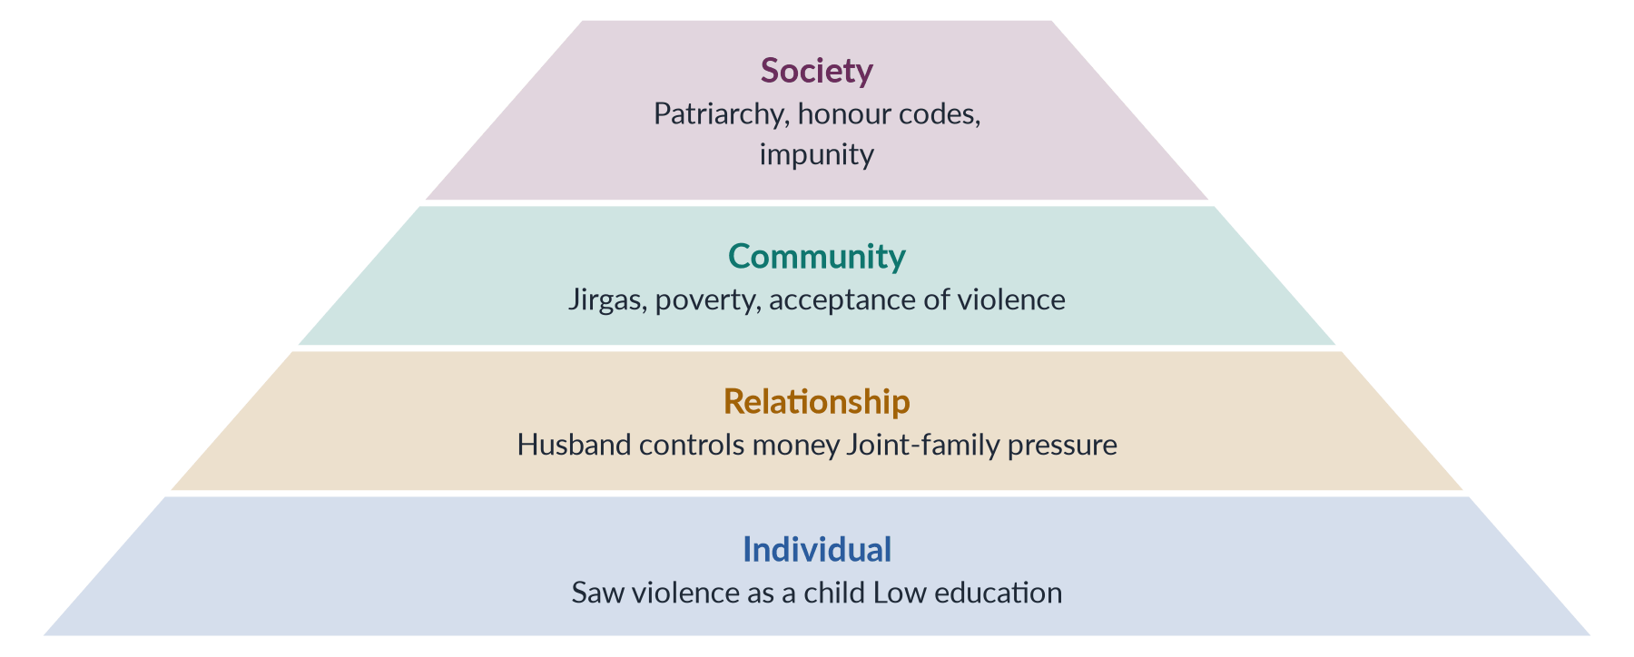
Figure 28 · The ecological model (Heise, 1998), applied to Pakistan.
Draw it in: root causes and how they intersect (2025). It also gives any strategies answer its structure.
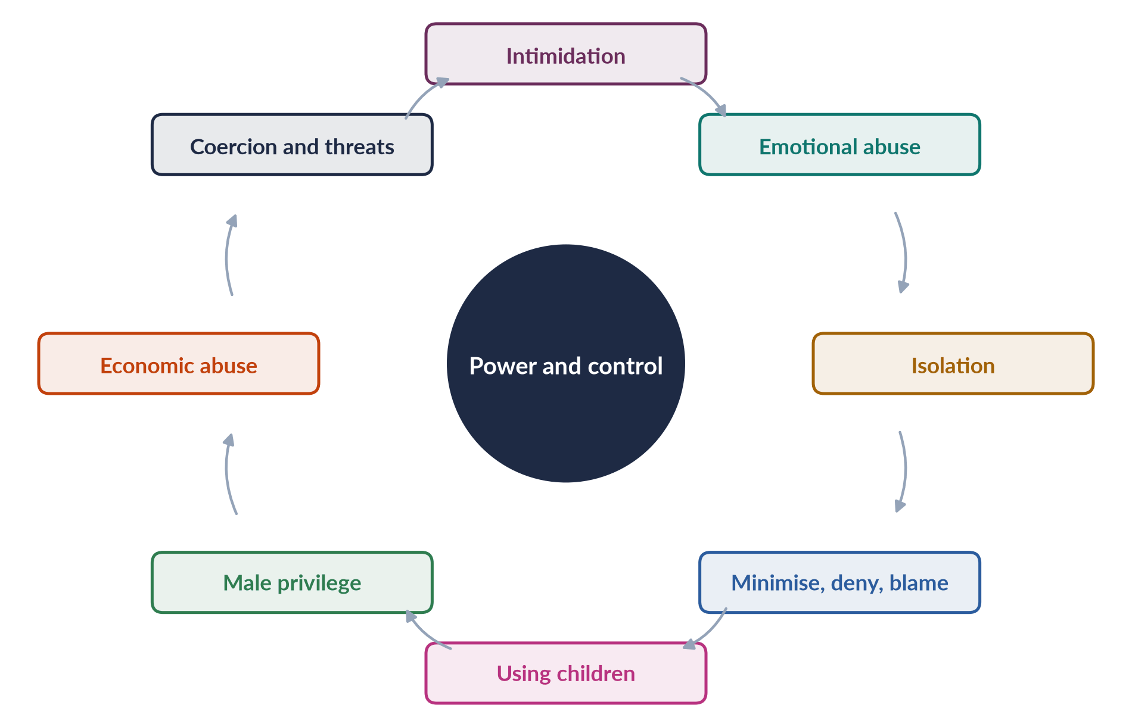
Figure 29 · The Duluth Power and Control Wheel.
Draw it in: power and control (2020). Say it: the hub is power and control, the spokes are tactics, and the rim — physical and sexual violence — holds the wheel together.
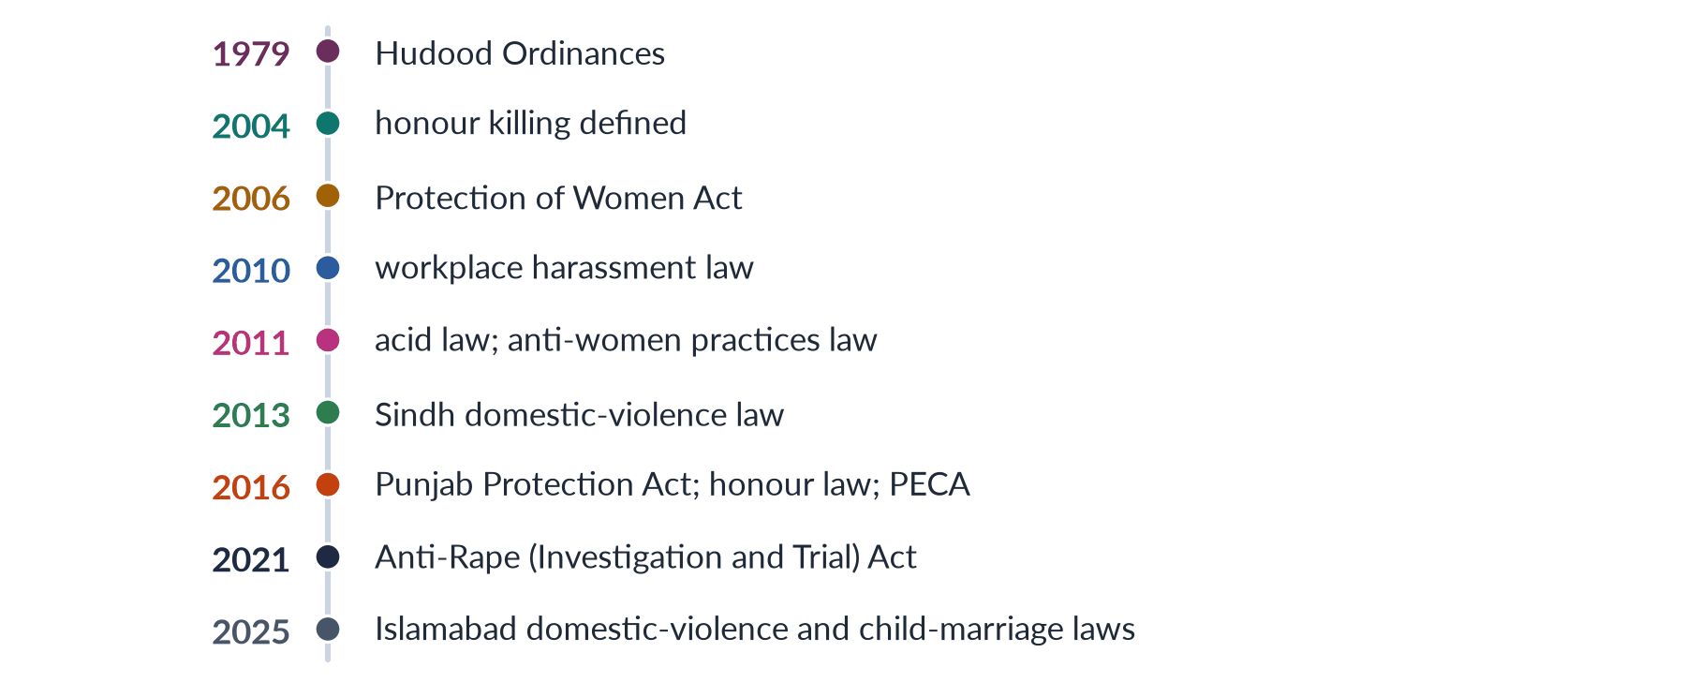
Figure 30 · Pakistan's laws against violence — the anchors.
Draw it in: the honour-killing note (2017), government initiatives (2018) and the Punjab Act 2016 (2024).
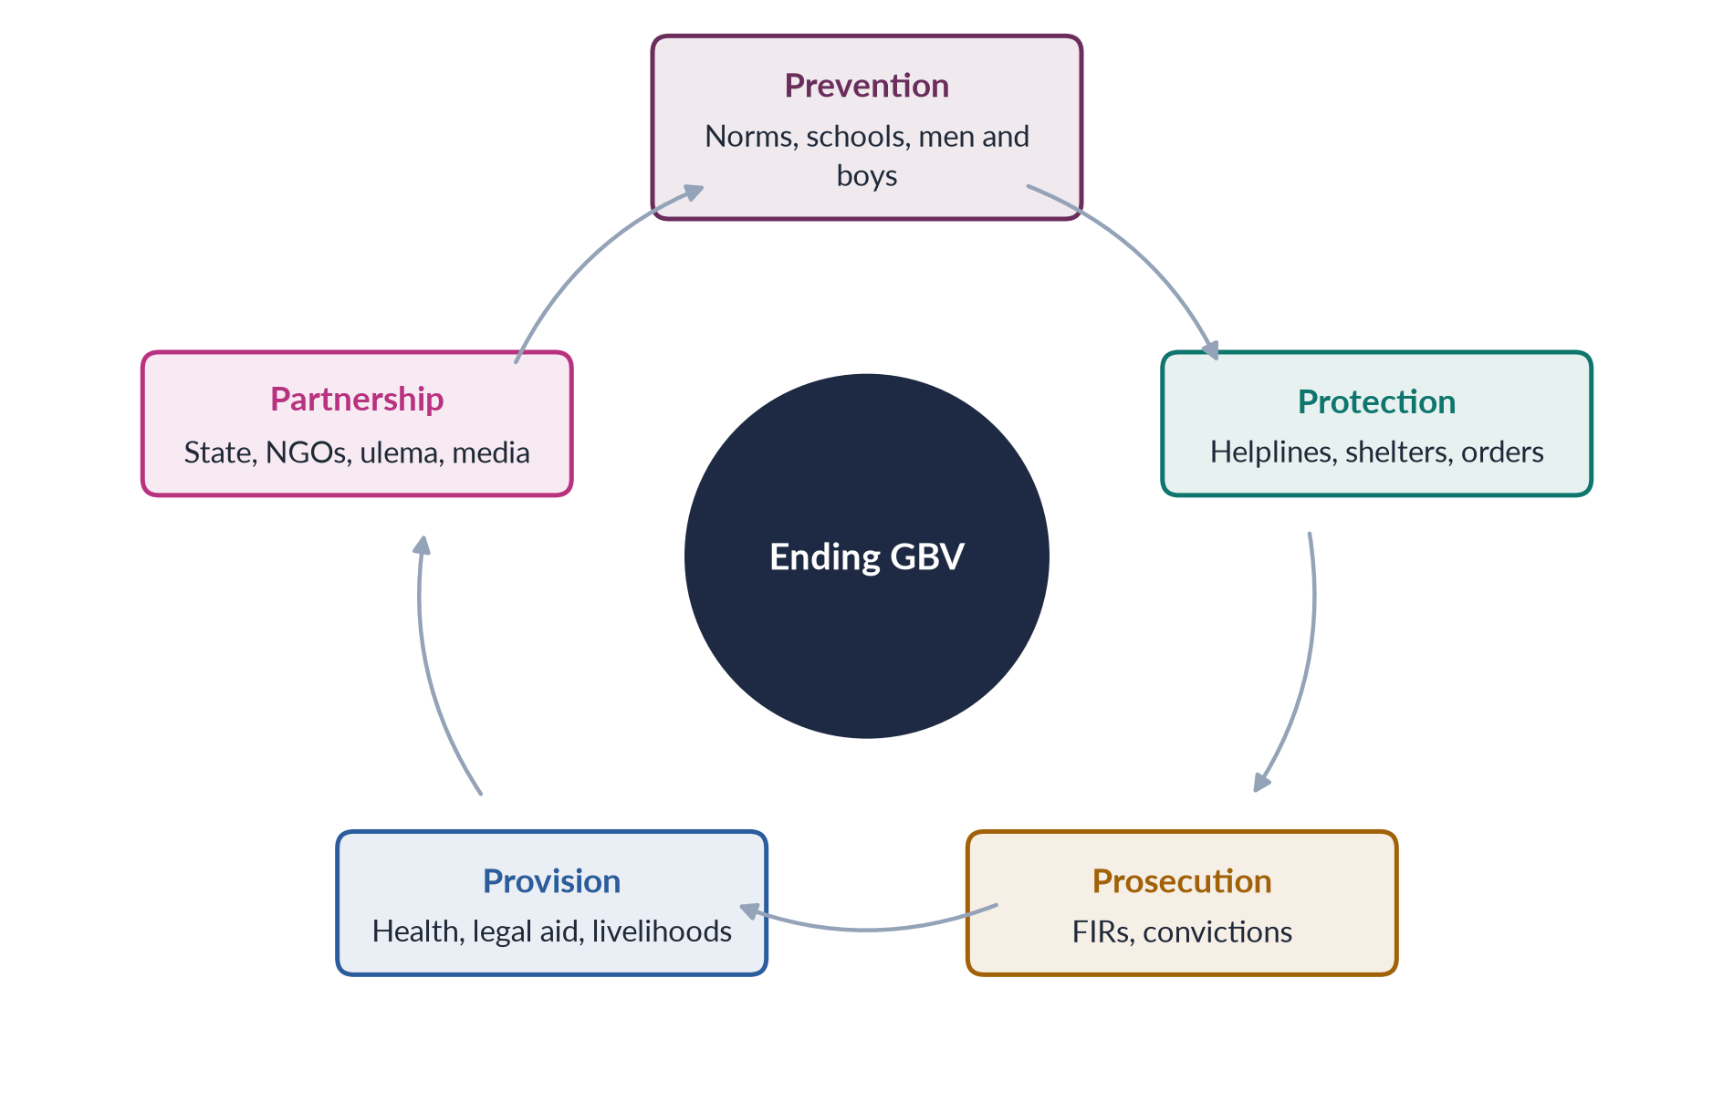
Figure 31 · The five Ps — strategies to end GBV.
Draw it in: workable strategies (2017), practical strategies (2023) and the strategies half of 2016.

Every past question as an answer plan
Use these plans in the last fortnight: read the question, say the plan aloud from memory, then check. Each plan is the skeleton of the full model answer in T7QA.
2016 Q3 — Sites and forms of violence against women in Pakistan; how to eliminate it. DEVAW 1993; argument: every site, three causes, combined strategy. Scale: PDHS 28%, 34%, 56% silent; SSDO 32,617 (2024); WHO 1 in 3. Sites: home (DV, marital rape, economic abuse; dowry violence, stove burning; honour killing — HRCP 405, Qandeel Baloch 2016); community (jirgas, vani/swara, Mukhtaran Mai 2002; rape 5,339 and abduction 24,439; Zainab 2018; acid — 2011 Act); workplace (harassment; domestic workers; 2010 Act, amended 2022); public spaces (s. 509) and online (PECA 2016); state (custody, police refusal, Zina Ordinance 1979 → 2006 Act). Grid figure. Why it persists: patriarchy, dependence (24.4%), impunity (0.5%). Elimination: prevention (schools, Rozan, scholars, media, BISP); protection (1043, shelters, VAWC Multan 2017, Punjab Act orders); prosecution (FIRs, women police, DNA, special courts 2021, non-compoundable); services and partnership. Five-P cycle figure. From impunity to accountability.
2017 Q3 — Forms of GBV; workable strategies. GBV defined; argument: use existing laws better. Theory: power and control (Duluth 1981), social learning, ecological model (Heise 1998). Forms by nature: physical (28%; acid; honour 405; stove burning); sexual (rape 5,339, 0.5%; harassment; child and forced marriage — 18 only in Sindh 2013, ICT 2025); psychological (threats, taunts, isolation; Punjab Act); economic (salary, dowry, inheritance; 2020 Act); custom-based (vani, swara, Qur'an marriage, watta satta — 2011 Act) and cyber (PECA). Tree figure. "Workable" = realistic, built on existing laws, measurable, acceptable; the gap is implementation (0.5%). Strategies: enforce laws (compulsory FIRs, women police, SSOIUs and special courts, DNA, witnesses, no pardons); services in every district (VAWC model, 1043, dignified shelters); prevention through schools, mosques, Rozan, media; economic independence (2020 law, BISP). Pakistan lacks enforcement, not laws.
2017 Q8(a) — Short note: honour killing. (~600 words.) Definition; men killed too; karo-kari, siyahkari, tor tora, kala kali. Scale: HRCP 405, SSDO 547, ≈0.5% convictions; hidden as suicide. Causes: honour, ghairat, control of marriage and property, jirgas, impunity; power and control; masculinity. Law timeline: Qisas and Diyat 1990/1997 (heirs forgive) → 2004 (defined) → October 2016 Act (life imprisonment even after forgiveness; Sughra Imam 2014; MCQ 2026). Cases: Samia Sarwar 1999 (Hina Jilani, Asma Jahangir); Saba Qaiser 2014 (A Girl in the River; Nawaz Sharif); Degari 2025; Qandeel Baloch 2016 (acquittal 2022). Assessment: re-labelling, hostile witnesses; remedies: non-compoundable, training, investigate every death, prosecute jirgas, protect couples, scholars, economic independence, shelters.
2018 Q8(c) — Short note: government initiatives. (~600 words.) Framework: Arts 9, 14, 25; CEDAW 1996, GR 19/35; SDG 5.2; GSP+ 2014; National Policy 2002. Laws: 2006, 2010 (+ s. 509; 2022), 2011 Acid and Anti-Women Practices, DV laws 2013–2025, 2016 honour, rape and PECA, 2021 Anti-Rape. Institutions: NCSW 2000/2012; women's police stations 1994; ombudspersons; PWPA 2017 (committees, officers); Ministry of Human Rights 2015. Grid figure. Services and courts: VAWC Multan 2017; 1043, 1099; Dar-ul-Aman; special courts and SSOIUs; GBV courts; BISP 2008; Zainab Alert Act 2020. Assessment: violence made public; but 0.5% convictions, FIR refusal, settlements, few centres, uneven provinces, "un-Islamic" attacks, 56% silent; make existing initiatives work.
2019 Q7 — Structural and direct violence; Mukhtaran Mai. Galtung 1969 (direct vs structural; potential), 1990 (cultural); iceberg triangle. Direct: DV (28%, 34%), rape (5,339, 0.5%), acid (2011 Act), honour (405), harassment, forced marriage, vani; 32,617 cases. Structural: literacy 53%, MMR 186, LFPR 24.4%, inheritance; Zina Ordinance and old pardons; FIR refusal, slow courts; jirgas (SC declared illegal). Cultural: honour, discipline, paraya dhan, misused religion. Pyramid figure. Case: Tatla clan, Meerwala, Muzaffargarh, South Punjab; Mastoi panchayat; brother Shakoor; 22 June 2002 gang rape; imam and journalists; ATC Aug 2002 (6 death), LHC 2005 (5 acquitted), SC 21 April 2011 (Abdul Khaliq life); ECL 2005. Outcome: schools, welfare organisation, In the Name of Honor (2006); 2006 Act; 2011 Act. Ending direct violence requires dismantling structures.
2020 Q7 — Power-and-control relationship in GBV. Definition; argument: best single explanation within an ecological frame. Instrumental violence; threat governs life. Dobash and Dobash 1979; Duluth 1981 (Pence, Paymar). Hub, spokes, rim. Cycle figure (Pakistani examples). Spokes: intimidation, emotional abuse, isolation, minimising and blaming; children, male privilege, economic abuse, coercion and threats. Walker 1979 cycle; Stark 2007 coercive control. Pakistan: honour, purdah as isolation, dowry and money, inheritance; Punjab Act recognises economic and psychological abuse and stalking. Strengths: selective, patterned, gendered; non-physical abuse; honour violence; Duluth practice. Limits: partners only; individual and structural factors (Heise 1998); Johnson 1995; mixed programmes; joint families and mothers-in-law. Policy: orders, independence, shelters, co-ordinated response, Rozan, scholars.
2020 Q8 — Background of Sharmeen Obaid-Chinoy's two Oscar-winning documentaries. Karachi 1978; Smith, Stanford; Terror's Children 2002; Emmy 2010; SOC Films; first Pakistani Oscar. Saving Face: acid attacks (cheap acid, southern Punjab; revenge for refusals); no specific law, unregulated acid; Acid Survivors Foundation; Daniel Junge; Dr Mohammad Jawad; Zakia and Rukhsana; Oscar Feb 2012; Acid Act 2011 (336A/B; 14 years–life; Rs 1m); Hilal-i-Imtiaz, TIME 100. Compare figure. A Girl in the River: honour killings (405 in 2024); Qisas and Diyat loophole; stalled 2014 bill; Saba Qaiser, 19, Gujranwala, 2014, father and uncle, river, survived, forgave; Oscar Feb 2016; Nawaz Sharif "no honour in honour killing"; Qandeel Baloch; October 2016 Act. Themes: impunity, agency, film as advocacy, two faces of Pakistan. Criticism ("dirty linen") and response. Evaluation: media's power; enforcement must follow.
2023 Q8 — Define GBV; forms in Pakistan; practical strategies. DEVAW Art. 1; Punjab Act s. 2(r); WHO 1 in 3. Theory: Duluth, social learning, Heise. Forms: physical (28%, 34%; acid; honour 405/547); sexual (5,339; Zainab 2018 → 2020 Act; motorway 2020 → 2021 Act; harassment; child marriage); psychological and economic; custom-based (2011 Act), cyber (PECA; Qandeel, Sana Yousaf 2025), state. Grid figure. Practical = target causes (norms, dependence, impunity 0.5%). Justice (FIRs, women police, SSOIUs; DNA labs, special courts, witnesses; non-compoundable; prosecute jirgas). Services (VAWC model in every district, 1043, shelters, orders, Lady Health Workers). Prevention (schools, scholars, dramas, 16 Days, Rozan, 2020 law, BISP, age 18). Priority pyramid figure. National GBV database; enforce existing laws.
2024 Q6 — What is GBV; forms under the Punjab Act 2016; consequences. Definition (UN; DEVAW); scale (WHO; PDHS). Act: passed 24 Feb, gazetted 29 Feb 2016; "protection, relief and rehabilitation"; Art. 25; civil. s. 2(r) forms: domestic violence (lives/lived with, blood, marriage, adoption), sexual violence, psychological abuse (anorexia, suicide attempt, depression from oppression or confinement, panel-certified), economic abuse (food, clothing, shelter; taking income), stalking, cybercrime, abetment. Grid figure. Provisions: Family Court, 90 days; interim, protection (GPS bracelet), residence, monetary orders; helpline, DWPCs, WPOs, shelters, VAWC Multan 2017; penalties (1 year; repeat 2; false complaint 3 months). Consequences: physical and reproductive (51,100 femicides 2023; miscarriage, STIs, fistula); mental (2× depression, PTSD, suicide); economic (LFPR 24.4%, poverty); children (cycle), social (stigma; 56% silent), development (2% GDP; SDGs). Cycle figure. Assessment: progressive; CII opposition; mediation risks; slow implementation.
2025 Q2 — Root causes of GBV; how they intersect in Pakistan. Root vs trigger; ecological model; power and control. Patriarchy (discipline; honour — 405; paraya dhan; Saima Waheed 2004). Dependence (24.4%; inheritance; resource theory). Impunity (SSDO 0.5%, 1.3%, 0.1%; Punjab 225 → 2; Qandeel 2022). Customs (jirgas; vani; Mukhtaran Mai; Degari 2025; 2011 Act). Ideas (literacy 53%; social learning; misused religion; dramas). Crises (Malala 2012; floods 2022; COVID 2020). Cycle figure. Intersection of causes (norms × economy; economy × law; law × custom; ideas × institutions). Identities (Crenshaw 1989/1991: rural, Hindu and Christian girls, disabled, domestic workers, khawaja siras — 2018 Act). Ecological table and worked example. Break the cycle: impunity, independence, norms.
2025 Q8 — Malala's achievements and activism, local and global — critical evaluation. Argument: global symbol; local impact real but modest; state action needed. Background: 12 July 1997, Mingora; Ziauddin, Khushal School; TTP, Fazlullah, Dec 2008 ban, 100+ schools; 2009 operation. Early: BBC Urdu "Gul Makai" Jan 2009 (age 11); NYT documentary; National Youth Peace Prize 2011. Attack 9 Oct 2012 (Shazia Ramzan, Kainat Riaz; Birmingham). Global: UN 12 July 2013, Malala Day, "one child, one teacher…"; Malala Fund 2013 (Education Champions; countries); I Am Malala 2013; We Are Displaced 2019; Sakharov 2013; Nobel 10 Dec 2014 with Satyarthi, 17; Messenger of Peace 2017; Oxford 2020. Timeline figure. Global context: SDG 4; Afghanistan 2021, gender apartheid; refugees. Local: Shangla school; $14.6m in Pakistan; flood grants; Art. 25A advocacy; Islamabad Jan 2025, Islamabad Declaration; 25m+ out of school, literacy 53%. Criticism: Western agent, conspiracy, "I am not Malala" 2014, selective attention, distance. Evaluation and conclusion.
2026 Q8(b) — Short note: masculinity studies and violence against women. (~590 words.) Constructed, ranked masculinities; 1980s; Connell 1987/1995 — hegemonic, patriarchal dividend. Explanations: proof of manhood; entitlement (Kimmel's aggrieved entitlement); emotional restriction (Kaufman 1987 triad). Pyramid figure. Pakistan: ghairat, izzat; honour killings (405) as performance before men; acid attacks; Sana Yousaf June 2025; socialisation; dramas; marginalised men; jirgas police norms. Role: focus on men (against victim-blaming); learned and changeable; men's silence; solutions (Rozan 1998, White Ribbon, HeForShe 2014, Ziauddin Yousafzai). Limits: no excuses, funds for survivors, adapt concepts, mixed programmes. Complements protection and justice.

